**Egyptian E-Learning University**

Faculty of Computers & Information Technology

**I HEALTH RECOMMENDATION**

**SYSTEM**

**By**

|  |  |
| --- | --- |
| **Sama Ayman Hanafy** | **21-01555** |
| **Renad Abdulrahman Ibrahim** | **21-01500** |
| **Abdulrahman Adel Ezz El-din** | **21-00272** |
| **Musab Mahmoud abdulrahman** | **21-01298** |
| **Mennaallah galal elsaid** | **21-01073** |
| **Mohamed waheed mahame** | **21-01138** |
| **Arwa essam mohamed** | **21-00517** |

Supervised by

**Prof.Samar Hesham**

Assistant

Eng. **Al-Mohannad Alaa El-din**

[Sohag]-2025

Abstract

Healthcare chatbots are revolutionizing the healthcare industry by **leveraging artificial intelligence (AI) and natural language processing (NLP)** to provide accessible, efficient, and personalized assistance to users.

These virtual assistants are designed to engage with users in a conversational way, **either through text or voice interfaces, mimicking human-like interactions.**

By analyzing user inputs, **healthcare chatbots can offer relevant medical information, suggest possible diagnoses,** recommend treatment options, and provide healthcare guidance.

Integrated into digital platforms such as websites and mobile applications, healthcare chatbots ensure **24/7 availability, allowing users to receive immediate support and information, thus improving overall healthcare accessibility and support.**

Acknowledgments

First, we express our gratitude to **God** for His grace and unwavering support throughout our journey in college and the completion of our graduation project. His guidance has been the cornerstone of our success, and we are immensely thankful for His blessings.

We extend our heartfelt appreciation to **Prof.Samar Hesham** and Eng. **Al Mohannad Alaa El-din** for their invaluable mentorship, guidance, and support throughout the development of our healthcare chatbot. Their expertise, encouragement, and dedication have been instrumental in shaping our project and ensuring its success. Their mentorship has not only enriched our academic experience but has also inspired us to strive for excellence in our endeavors.

We are also grateful for the support and encouragement provided by **colleagues and the broader academic community**. Their feedback and insights have been invaluable in refining our healthcare chatbot and enhancing its capabilities.

Contents

Abstract 2

Acknowledgments 3

Introduction 5

Literature Review / Related Work 13

Proposed system 16

Implementation 21

Testing & Evaluation 142

Results & Discussion 146

Conclusion & Future Work 150

References 154

Appendices (Optional) **Error! Bookmark not defined.**

Chapter 1

Introduction

**1.1 Introductio:**

The integration of artificial intelligence (AI) and natural language processing (NLP) in healthcare has given rise to innovative solutions that address critical gaps in healthcare service delivery.

One such innovation is the development of healthcare chatbots-intelligent systems that simulate human conversation and offer medical assistance based on user-input data.

These chatbots aim to provide instant access to medical knowledge, symptom analysis, and guidance, particularly in regions lacking adequate healthcare infrastructure or during off-clinic hours.

This project explores the development and implementation of a symptom-based healthcare chatbot .

The chatbot utilizes a machine learning model to identify potential diseases based on user-reported symptoms and offers tailored advice or precautions. This system serves as an accessible, scalable, and efficient tool for improving healthcare awareness, early diagnosis, and overall public health.

**1.2 Background and Motivation**

Over the past decade, healthcare systems around the world have faced increasing pressure due to rising patient numbers, limited resources, and growing geographical disparities in medical service availability. Remote areas often lack timely access to healthcare professionals, leaving many individuals without the ability to consult a doctor when symptoms first appear.

With recent advances in artificial intelligence, particularly in machine learning and NLP, it has become possible to analyze large amounts of medical data and simulate diagnostic reasoning. This motivated our team to explore how AI can bridge the healthcare accessibility gap by providing a reliable, automated first point of contact.

**Key motivation points:**

Accessibility: Enable 24/7 access to healthcare advice without needing a physical visit.

Empowerment: Educate users about their health and promote self-awareness.

Early Detection: Encourage early intervention through symptom monitoring.

Healthcare Chatbots Market Size was valued at USD 0.2billionin 2022.

Healthcare Support: Assist healthcare workers by filtering and managing simple inquiries digitally.

**Statistics:**

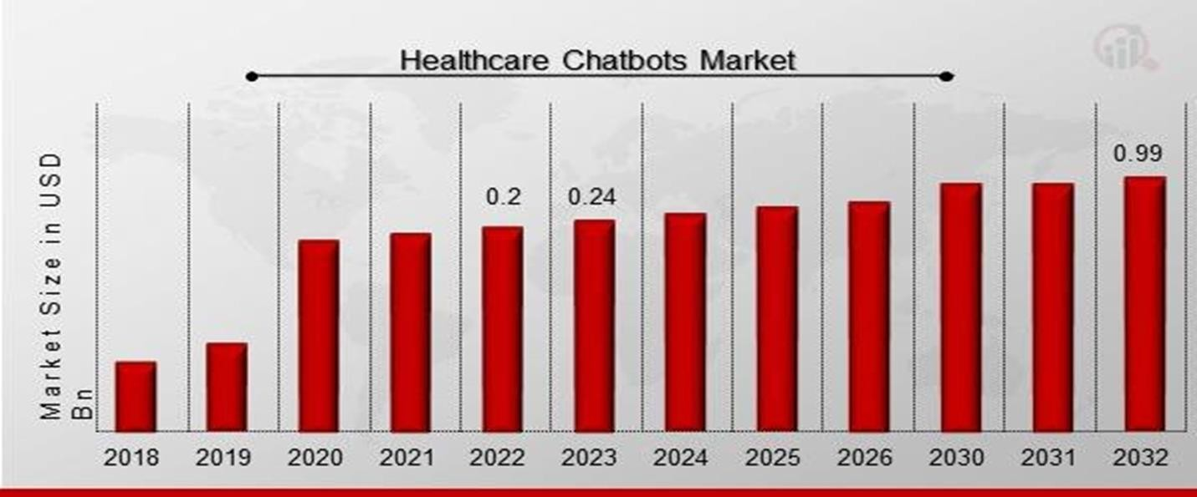

###### Figure 1: Chatbot Market

Healthcare Chatbots Market Size was valued at USD **0.2billion**in **2022**.

The healthcare chatbots market industry is projected to grow from USD **0.24 Billion** in **2023** to USD **0.99** billion by **2032**, exhibiting a compound annual growth rate (CAGR) of **19.5 %** during the forecast period (**2023 - 2032**).

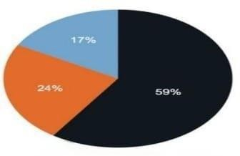

###### Figure 2: Trustworthiness of AI

The chart indicates that **59%** of the population supports AI's role in human assistance, while **24%** lack knowledge about AI's functions and **17%** are clueless.

**1.3 Importance** **:**

Delays in diagnosis and treatment contribute to a significant portion of preventable diseases and complications. For many individuals, especially those living in rural or underserved communities, these delays stem from the lack of medical professionals, transportation issues, or long hospital queues.

Moreover, many people rely on unverified information from the internet or social media when experiencing symptoms, which can lead to misdiagnosis or unnecessary panic. By offering a medically informed, AI-based chatbot, users can receive preliminary guidance that is both accessible and trustworthy.

This project addresses a critical public health need—developing a tool that provides quick, relevant, and understandable medical advice in the user's preferred language, thereby improving health outcomes and reducing the burden on healthcare institutions.

**1.4 Problem Statement**

There is a lack of accessible, language-inclusive, AI-powered systems capable of delivering real-time health insights based on symptomsentered by the user.

This problem is worth solving because it directly impacts public health, enhances digital health literacy, and contributes to reducing strain on existing healthcare infrastructure.

**1.5 Objectives**

**Main Objective:**

To design and implement an intelligent healthcare chatbot that uses machine learning techniques to classify diseases based on user-provided symptoms and deliver accessible, multilingual medical assistance.

**Specific Objectives:**

1. To collect, clean, and annotate a dataset containing diseases and associated symptoms.
2. To collaborate with medical professionals for validation of disease- symptom relationships.
3. To select and train an appropriate ML algorithm for disease
   1. classification.
4. To build an interactive chatbot capable of processing natural language input.
5. To evaluate the system’s accuracy, usability, and performance through testing.

**1.6 Brief overview of the proposed solution**

The proposed solution is a web-based (or mobile) chatbot system

powered by artificial intelligence and natural language processing.

Users will interact with the chatbot by describing their symptoms

in natural language (text-based).

The chatbot then processes this input, maps it to known symptoms,

and uses a machine learning model trained on a medical dataset

to predict potential diseases.

Chapter 2

Literature Review / Related Work

**Summary of Existing Research and Technologies**

Existing research on healthcare chatbots highlights the increasing

reliance on AI and machine learning to assist in medical diagnosis

and patient support.

Technologies such as Decision Trees, Naive Bayes,

and Support Vector Machines have been effectively used for disease

prediction based on symptoms.

Chatbot development platforms like Dialogflow, Rasa, and Microsoft Bot Framework support building conversational interfaces, while NLP techniques enable understanding of user queries.

Systems like Babylon, Ada Health, and Woebot demonstrate the practical applications of chatbots in areas like symptom checking and mental health.

**Gaps in Current Solutions**

Despite these advancements, several key limitations persist:

* **Limited adaptability**: Many current chatbots are rule-based and do not incorporate advanced ML models for disease classification.
* **Insufficient cultural and regional customization**, especially for Middle Eastern health concerns.
* **Low accessibility** in remote or underserved areas where medical consultation is limited.

**Summary**

In summary, while existing healthcare chatbots and ML-based diagnostic tools have demonstrated value, they fall short in inclusivity, adaptability, and cultural relevance.

Our project addresses these gaps by introducing a machine learning-powered chatbot capable of disease prediction based on user symptoms , tailored for broader accessibility and localized healthcare support.

Chapter 3

Proposed system

* 1. **Approach used to solve the problem**

To address the difficulty of accessing accurate and rapid medical diagnosis, especially in areas lacking specialized healthcare, our application relies on an AI-based diagnostic approach. It uses a Support Vector Machine (SVM) model trained on real medical data to predict disease based on symptoms entered by the user. It then recommends the appropriate lifestyle, doctor's specialty, and medication by linking multiple datasets containing disease names, medications, and treatment descriptions.

It also includes additional features such as a dictionary containing detailed information about diseases (description, symptoms, causes, treatment, etc.), text-to-speech conversion for ease of use, an interactive map of the nearest hospital or pharmacy, and the ability to add user reviews about their experience.

* 1. **System architecture**

The system consists of two core modules that work together seamlessly:

1. A backend pipeline built with Python and TensorFlow for training and evaluating the AI model.
2. A mobile frontend developed using Flutter and Dart, offering users an intuitive interface for disease diagnosis and medication suggestions.

* **Use Case**

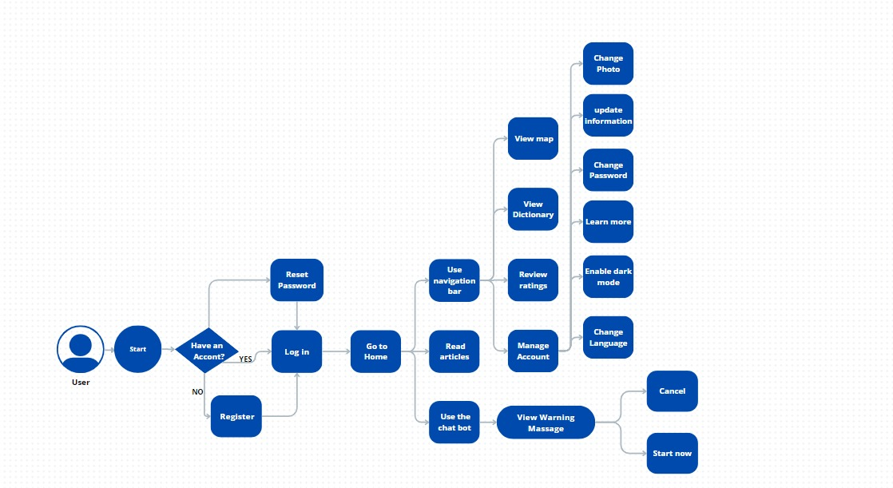

* **Flowchart**

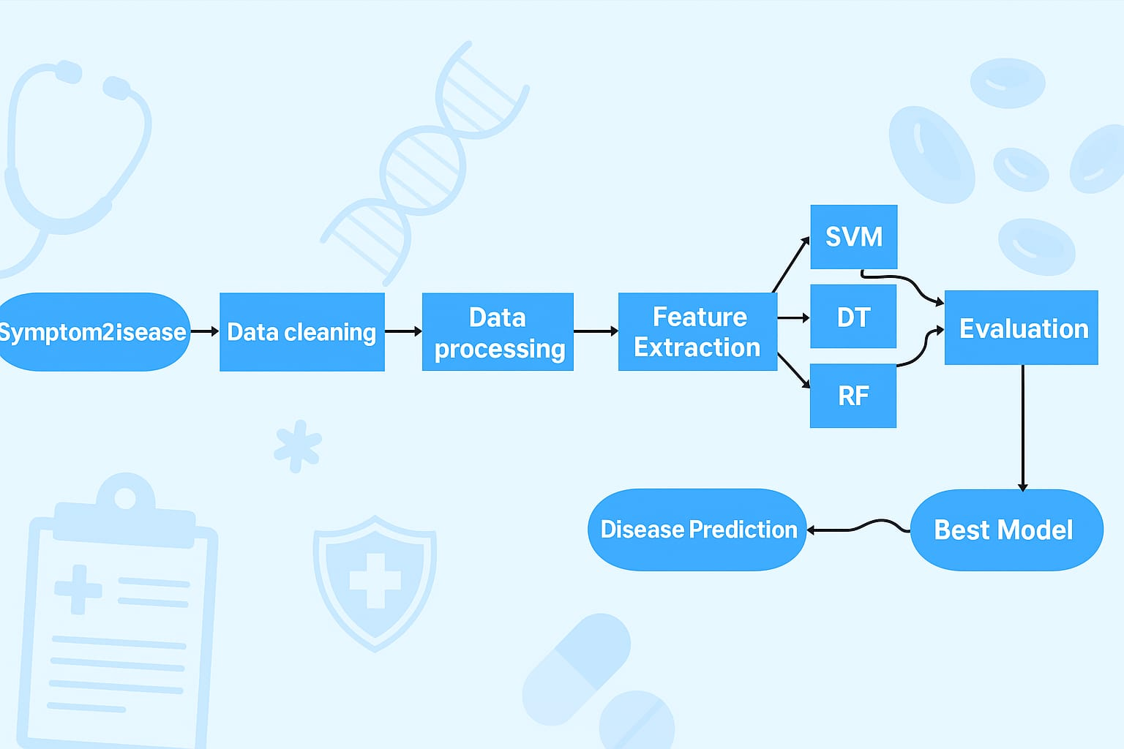

**3.3Algorithms or frameworks used**

**A**variety of technologies and development tools were utilized in building and deploying the i health mobile application to ensure efficiency and user engagement

|  |  |
| --- | --- |
| **Technology / Algorithm** | **Purpose** |
| **Support Vector Machine (SVM)** | Main classification algorithm used to predict diseases based on symptoms with high accuracy. |
| **TF-IDF Vectorizer** | Converts symptom text into numerical features suitable for ML model training and prediction. |
| **Pandas & NumPy** | Data preprocessing, handling missing values, and efficient numerical operations. |
| **Scikit-learn** | Model training, evaluation, and performance metrics (e.g., accuracy, confusion matrix). |
| **NLTK** | Natural Language Processing for cleaning and preparing symptom text (tokenization, lemmatization, etc.). |
| **Flutter (Dart)** | Building the user-friendly cross-platform mobile application. |
| **TTS Plugin (Flutter)** | Reads out disease descriptions to improve accessibility for users. |
| **Google Maps API** | Displays the nearest hospitals and pharmacies based on the user's location. |
| **Firebase Authentication** | Secure login and registration using email. |
| **SharedPreferences** | Local storage for user preferences, saved symptoms, and reviews. |

Chapter 4

Implementation

**4.1 Technologies, Tools, and Programming Languages Used**

The development of our healthcare chatbot required the integration of various technologies, tools, and programming languages to achieve accurate disease prediction and user-friendly interaction. The following were used:

* **Python**: The primary programming language for implementing machine learning models and natural language processing (NLP) tasks.
* **Dart & Flutter**: Used to develop a cross-platform mobile application supporting both Arabic and English interfaces.
* **Flask**: A micro web framework used to serve the machine learning model and connect it with the mobile app.
* **scikit-learn**: Employed for building and evaluating machine learning models such as Decision Tree, Random Forest and SVM.
* **NLTK (Natural Language Toolkit)**: Utilized for NLP operations such as tokenization, lemmatization, stopword removal, and text normalization.
* **joblib**: For saving and loading the trained models and vectorizers efficiently.
* **Google Maps API**: Integrated into the mobile application to locate nearby hospitals.
* **Firebase**: Provided backend support for user authentication and data storage.
* **Jupyter Notebook & VS Code**: Used as development environments for testing and implementing models and backend functionalities.

**4.2 Key Components/Modules of the System**

The system was architecturally divided into the following key components to facilitate modular development and efficient functionality:

1. **NLP Preprocessing Module**  
   Cleans user-input text using steps like lowercasing, punctuation removal, tokenization, stopword removal, and lemmatization to standardize the input for classification.
2. **Symptom2DiseaseDataset Module**  
   Provides the training data consisting of symptom descriptions and their associated diseases. The dataset was expanded using paraphrasing tools like Quillbot.
3. **MachineLearning Module**  
   Includes the training and evaluation of multiple ML models (Decision Tree, Random Forest and SVM) using TF-IDF vectorization and hyperparameter tuning via GridSearchCV.
4. **Model Selection & Evaluation Module**  
   Automatically selects the best-performing model based on cross-validation accuracy and evaluates it using metrics such as accuracy, confusion matrix, and classification report.
5. **Flask API Module**  
   Acts as an intermediary between the mobile application and the ML model, handling predictions and language translation.
6. **Flutter MobileApplication**  
   Provides an interactive GUI for users, with features including:
   * Symptom input (text or voice)
   * Disease prediction display
   * Precaution suggestions
   * Google Maps for hospital location
7. **Voice Interaction Module**  
   Enables users to interact with the chatbot using speech-to-text and text-to-speech features for better accessibility.

##### **What is “Symptom2Disease” Dataset?**

The healthcare chatbot project utilizes the "Symptom2Disease Dataset," a meticulously curated dataset, which provides essential details about the disease, here are some **important details about this dataset**:

1. **Size**: The Symptom2Disease dataset comprises 1200 datapoints, each containing information about a specific symptom description and its corresponding disease label.
2. **Structure**: The dataset is divided into two columns: "label" and "text", where the "label" column contains the disease label associated with each symptom description.
3. **Disease Variety**: The dataset includes 24 diseases with 50 symptom descriptions, providing a comprehensive overview of common health conditions.

##### **Data Configuration:**

1. **Data Augmentation:** We utilized data augmentation techniques like Paraphrase online and Quill bot to expand the dataset size, resulting in 3600 datapoints, enhancing its diversity and granularity.
2. **Quality Assurance:** The data augmentation process involved rigorous quality assurance measures to ensure accuracy and relevance, preserving the semantic meaning and clinical relevance of original symptom descriptions.
3. **Training and Validation:** The Symptom2Disease Dataset is used to train and validate machine learning models, enhancing the efficacy and reliability of our healthcare chatbot by accurately classifying diseases based on user-input symptoms.

##### Sample of Dataset:

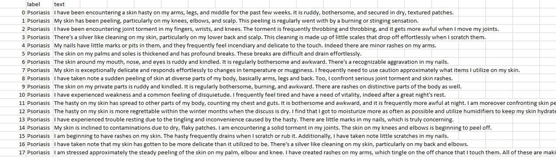

**Table 1: Sample of Data Set**

**Import&NLP**

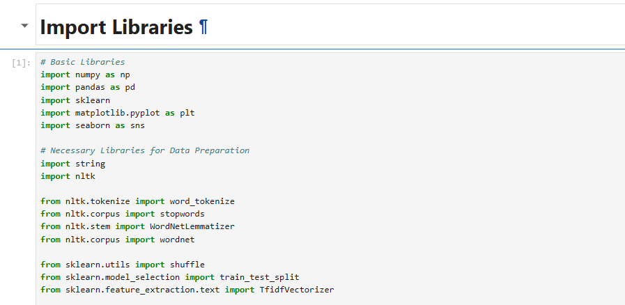

* **numpy: Used for numerical operations and handling arrays NumPy library, which provides support for mathematical operations on arrays and matrices. NumPy is widely used for numerical computing tasks..**
* **pandas: Provides data structures and functions needed to manipulate structured data (e.g., dataframes) Pandas library, which provides data structures and data analysis tools. Pandas is commonly used for handling structured data, such as tabular data..**
* **sklearn: A machine learning library that offers simple and efficient tools for data mining and analysis .**
* **matplotlib.pyplot: Used for plotting graphs and visualizations.**
* **seaborn: Built on top of Matplotlib, it provides a high-level interface for drawing attractive and informative statistical graphics.**
* **string: Provides functions and constants related to string operations.**
* **nltk: Natural Language Toolkit, used for text processing tasks such as tokenization, stemming, and stopword removal.**
* **word_tokenize: Splits a sentence or paragraph into individual words (tokens).**
* **stopwords: A list of common words (e.g., "the", "and", "is") that are often removed in text preprocessing.**
* **WordNetLemmatizer: Reduces words to their base or dictionary form (lemma).**
* **wordnet: A lexical database used to support lemmatization.**
* **shuffle: Randomly reorders elements in datasets, often used before splitting data.**
* **train_test_split: Splits datasets into training and testing subsets.**
* **TfidfVectorizer: Converts a collection of raw documents into a matrix of TF-IDF features, which helps in representing text data numerically.**

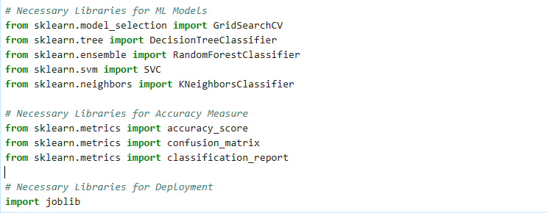

**Libraries for Machine Learning Models**

* **from sklearn.model_selection import GridSearchCV: GridSearchCV is used for hyperparameter tuning, where it exhaustively searches through a specified parameter grid to find the best parameters for a given estimator. This is crucial for optimizing the performance of machine learning models.**
* **from sklearn.tree import DecisionTreeClassifier: DecisionTreeClassifier is a popular machine learning model used for classification tasks, where it creates a decision tree to predict the target variable based on input features.**
* **from sklearn.ensemble import RandomForestClassifier: RandomForestClassifier is an ensemble learning method that constructs multiple decision trees during training and outputs the mode of the classes (classification).**
* **from sklearn.svm import SVC: SVC stands for Support Vector Classifier, which is a type of SVM (Support Vector Machine) model used for classification tasks. SVMs are powerful classifiers that work well with both linear and non-linear data.**
* **from sklearn.neighbors import KNeighborsClassifier: KNeighborsClassifier is a simple and effective algorithm for classification tasks, where it classifies instances based on the majority vote of its k nearest neighbors in the feature space.**
* **Libraries for Model Evaluation**
* **from sklearn.metrics import accuracy_score: accuracy_score function is used to evaluate the accuracy of classification predictions by comparing them to the true labels.**
* **from sklearn.metrics import confusion_matrix: confusion_matrix function is used to compute a confusion matrix, which summarizes the performance of a classification algorithm by tabulating the number of true positive, true negative, false positive, and false negative predictions.**
* **from sklearn.metrics import classification_report: classification_report function is used to generate a text report showing the main classification metrics, such as precision, recall, and F1-score, for each class in a classification problem. This report is useful for evaluating the performance of a classification model on a dataset.**
* **import joblib: This imports the joblib library, which provides utilities for saving and loading Python objects, particularly machine learning models, efficiently. It is commonly used to persist trained models to disk, allowing them to be reused later without needing to retrain.**

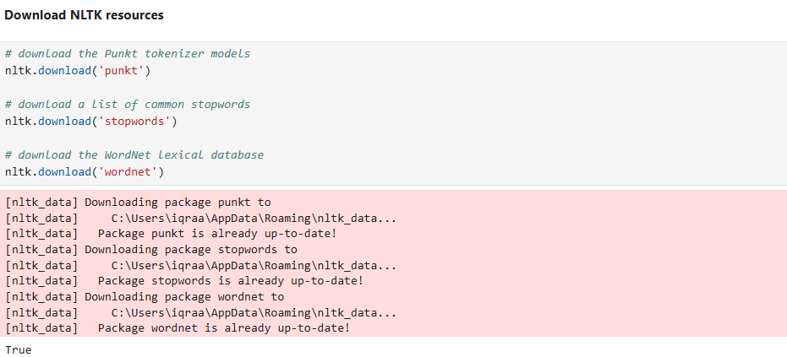

* **Downloading NLTK Resources**
* **nltk.download('punkt'): The Punkt tokenizer models are pre-trained unsupervised machine learning models that split text into words and punctuation marks. It's commonly used for tokenization tasks in NLP.**
* **nltk.download('stopwords'): Stopwords are commonly used words (e.g., "the", "is", "and") that are often removed from text data during preprocessing because they typically do not contribute much to the meaning of the text.**
* **nltk.download('wordnet'): This downloads the WordNet database. WordNet is a lexical database of English words organized into synsets (sets of synonyms), with each synset representing a distinct concept. It's widely used in NLP for tasks like synonymy detection, semantic similarity, and word sense disambiguation.**

**Read Data**



* **-This line of code reads data from a CSV file into a Pandas.**

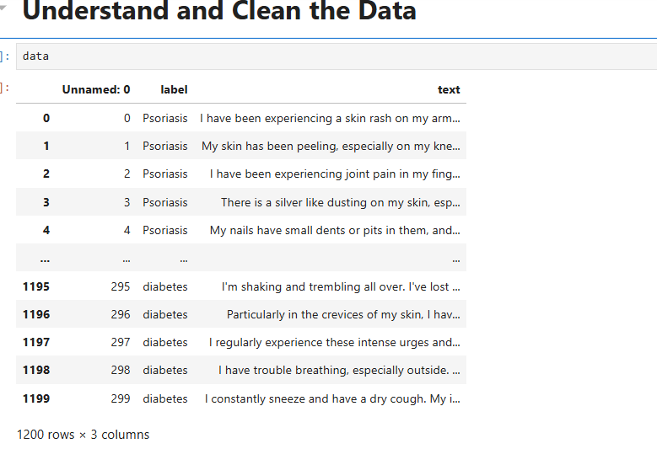

**-View the data format**

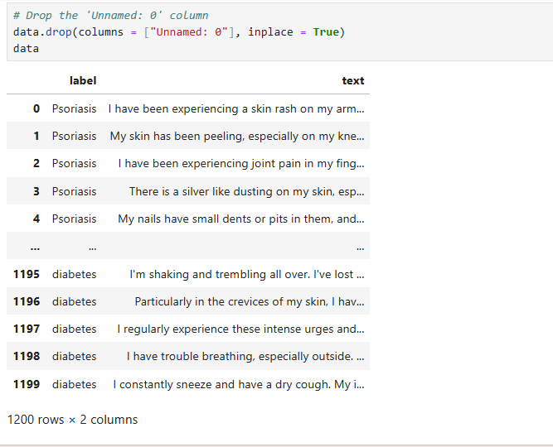

* **-This code snippet removes a specific column named "Unnamed: 0" from the previously loaded Pandas DataFrame:**
* **data.drop: The drop method is used to remove specified columns from the DataFrame.**
* **columns = ["Unnamed: 0"]: parameter indicates the name of the column to be dropped.**
* **inplace=True: This argument ensures that the changes are made directly and once to the existing DataFrame (data) without the need to create a new DataFrame.**

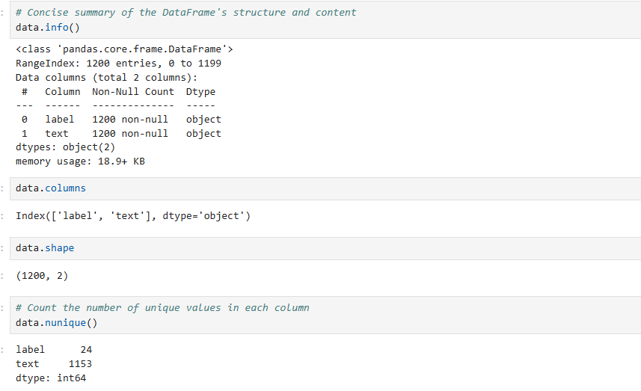

* **Data.info(): method provides a concise summary of the Pandas DataFrame, offering insights into its structure and content. The output includes details such as the column names, data types (integers, floats, objects), the number of non-null entries in each column, and the total memory usage of the DataFrame.**
* **data.columns: attribute is used to retrieve the names of the columns in the Pandas DataFrame.**
* **data.shape: attribute is employed to retrieve the dimensions of the Pandas DataFrame.**

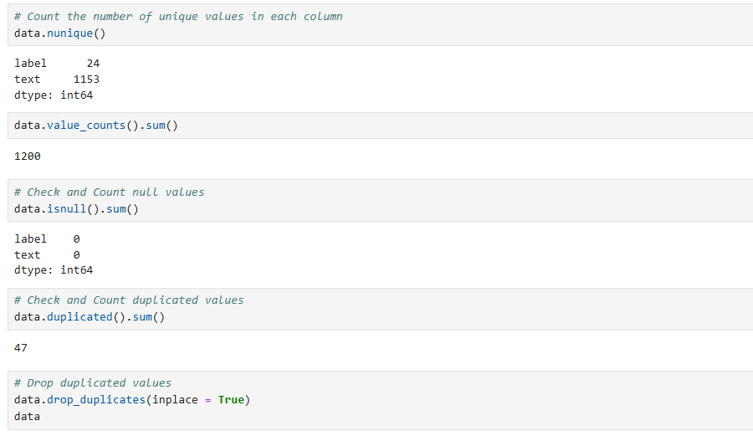

* **data.nunique(): method is utilized to count the number of unique values in each column of the Pandas DataFrame.**
* **data.value_counts().sum(): expression is used to calculate the total number of rows in the Pandas DataFrame.**
* **data.isnull().sum(): expression is used to count the number of missing (null) values in each column of the Pandas DataFrame.**
* **data.duplicated().sum(): expression is used to count the number of duplicated rows in the Pandas DataFrame.**

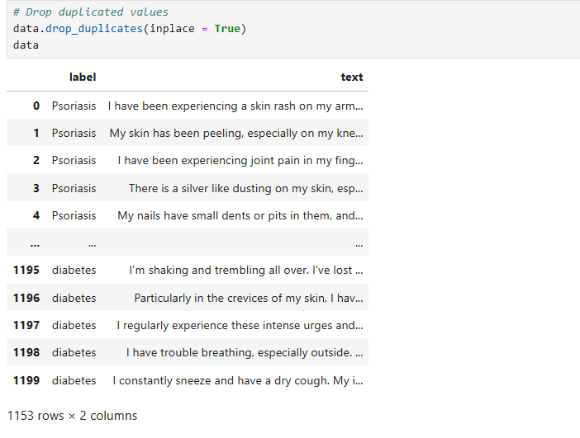

* **data.drop_duplicates(inplace=True): expression is employed to remove duplicated rows from the Pandas DataFrame.**

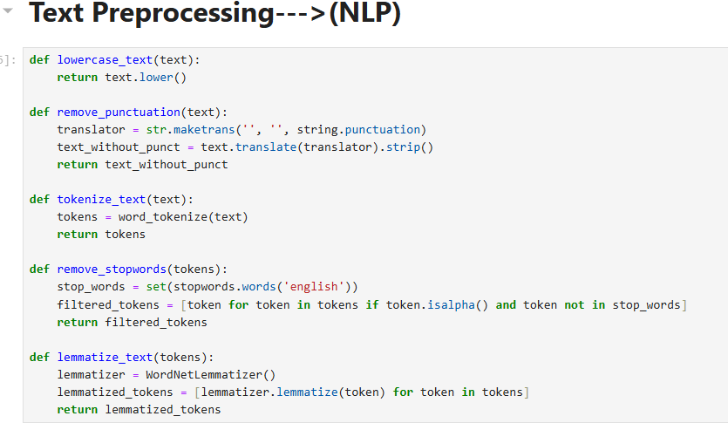

* **lowercase_text: This function converts all text to lowercase. It's important because it ensures that words are treated consistently regardless of their original capitalization. For example, "Hello" and "hello" would be considered the same word after lowercasing.**
* **remove_punctuation: This function removes punctuation from the text. Punctuation marks like periods, commas, and exclamation marks often don't carry much meaning in text classification tasks and can be safely removed without losing important information.**
* **tokenize_text: This function tokenizes the text, meaning it splits the text into individual words or tokens. Tokenization is a fundamental step in natural language processing tasks because it breaks down the text into units that can be processed by algorithms.**
* **remove_stopwords: Stopwords are common words in a language that often occur frequently but don't carry much semantic meaning (e.g., "the", "is", "and"). Removing stopwords can help reduce noise in the data and improve the performance of machine learning algorithms by focusing on more meaningful words.**
* **lemmatize_text: Lemmatization reduces words to their base or root form, which helps in standardizing words with similar meanings. For example, "feeling" and "felt" would both be lemmatized to "feel". This process reduces the dimensionality of the feature space and can improve the generalization of the model.**
* **Preprocessing is a crucial step in text analysis tasks as it helps remove noise and irrelevant information, leading to more accurate and efficient machine learning models.**

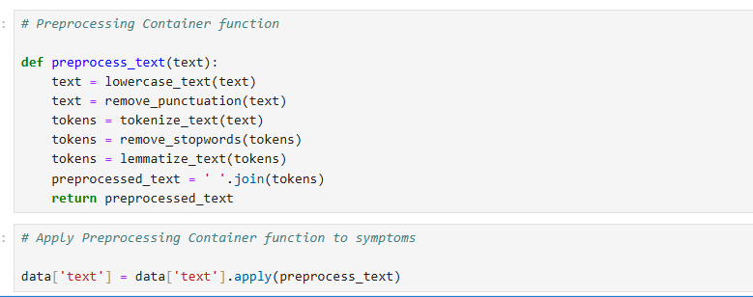

* **preprocess_text: function combines the preprocessing steps into a single function.**
* **DataFrame Manipulation: 'data' is a pandas DataFrame, this code accesses the 'text' column using data['text'].**
* **apply(): method in pandas DataFrame allows to apply “preprocess_text” function to each element in the 'text' column.**
* **Data Transformation: After applying the “preprocess_text” function, the text data in the 'text' column will be transformed into preprocessed text, which is then stored back into the same 'text' column. The original text data will be replaced with the preprocessed text.**

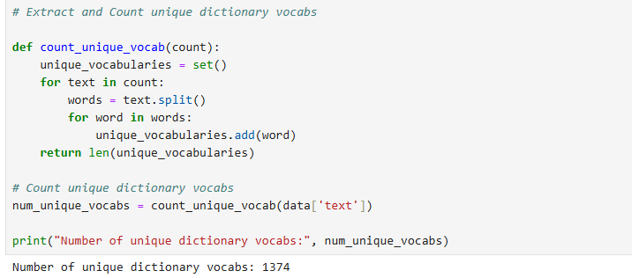

* **count_unique_vocab: This function takes a list of texts (from the 'text' column of a DataFrame) as input. It initializes an empty set called ‘unique_vocabularies’ to store unique words. It iterates over each text in the input list. For each text, it splits the text into individual words using whitespace as the delimiter. It then iterates over each word and adds it to the set of unique vocabularies.**
* **Finally, it returns the count of unique vocabularies.**
* **num_unique_vocabs=count_unique_vocab(data['text']): This line calls the count_unique_vocab function with the 'text' column of the DataFrame data as input to Calculate the Number of Unique Vocabularies. The result is stored in the variable.**
* **num_unique_vocabs. Text Representation: In natural language processing tasks, the size of the vocabulary impacts the dimensionality of feature representations (e.g. TF IDF), which in turn affects the performance of machine learning models.**

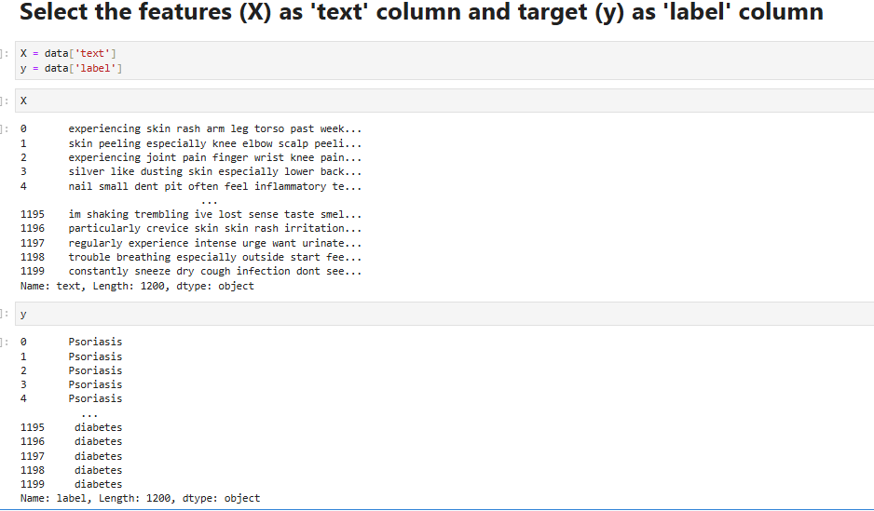

* **-Select the features (X) as 'text' column and target (y) as 'label' column and display them.**

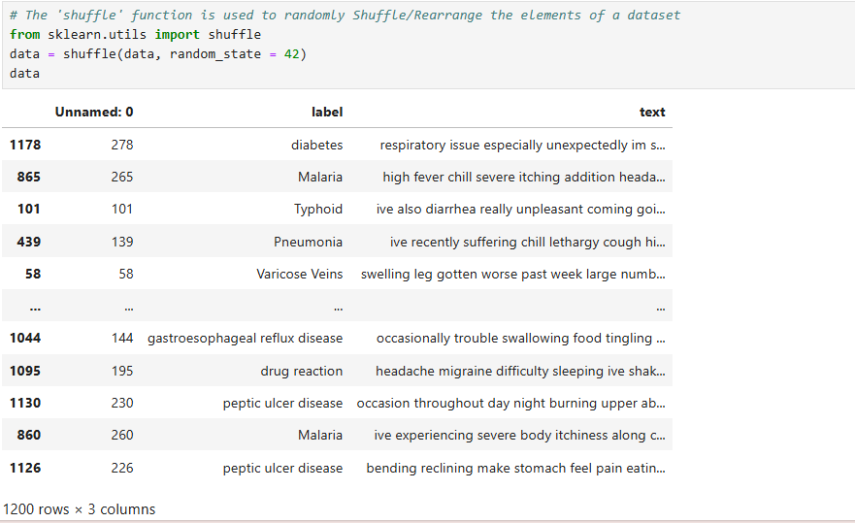

* **data = shuffle(data, random_state=42): -This line shuffles the DataFrame data. The shuffle function is applied to the DataFrame data, randomizing the order of its rows. The random_state parameter is set to 42 to ensure reproducibility; setting random_state to a fixed value ensures that the shuffling produces the same result each time the code is running.**
* **data: -This line simply prints the shuffled DataFrame data after shuffling.**

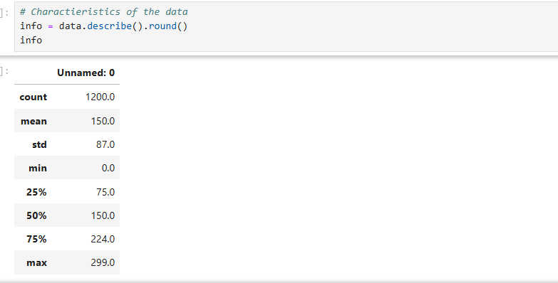

* **info = data.describe().round(): -This line calculates descriptive statistics or readings for the DataFrame data using the describe() method. The describe() method computes various summary statistics, such as count(total number of entries or observations in the dataset), unique(the number of distinct categories or values within a specific column), top(the most frequent value or category within a specific column) and freq(the frequency or number of occurrences of the top value), for each column in the DataFrame. -The round() function is then applied to round the calculated statistics to the nearest integer(If there are any decimal values).**
* **info: -This line prints the summary statistics stored in the variable info.**

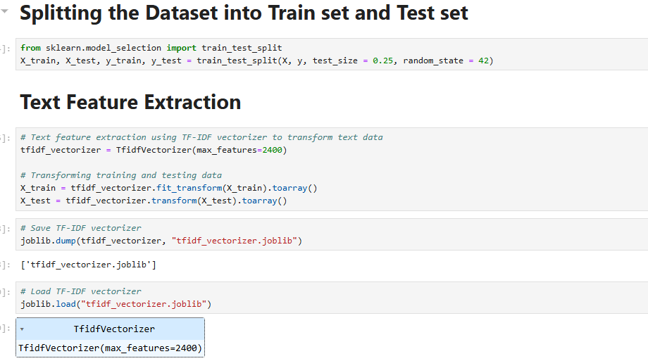

* **X_train, X_test, y_train, y_test = train_test_split(X, y, test_size=0.25, random_state=42):**
* **-This line splits the input data (X) and corresponding labels (y) into training and testing sets: -X_train and y_train will contain the training data and labels respectively, while X_test and y_test will contain the testing data and labels respectively.**
* **-The test_size parameter is set to 0.25, indicating that 25% of the data will be allocated for testing, and the remaining 75% will be used for training.**
* **-The random_state parameter; setting random_state to a fixed value ensures that the shuffling produces the same result each time the code is running.**

## **tfidf_vectorizer = TfidfVectorizer(max_features=2400):**

* **-This line initializes a TF-IDF (Term Frequency-Inverse Document Frequency) vectorizer object using the TfidfVectorizer class from scikit learn. TF-IDF is a numerical statistic/representation that reflects the importance of a term(word) in a document(sentence) relative to a collection of documents(sentences).**
* **- “max_features=2400” sets the maximum number of features (vocabulary size) to 2400. This parameter controls the maximum number of unique words or terms considered during vectorization, meaning only the top 2400 most frequent terms will be considered as features. This can help in reducing the dimensionality of the data.**
* **X_train = tfidf_vectorizer.fit_transform(X_train).toarray()**
* **- “fit_transform(X_train)”: This method fits the TfidfVectorizer to the training data (X_train) and transforms it into a TF-IDF matrix. This means it learns the vocabulary of the training data and computes the TF-IDF values for each term in the documents.**
* **- “toarray()”: converts the sparse matrix returned by fit_transform() into a dense NumPy array .**
* **joblib.dump(tfidf_vectorizer, "tfidf_vectorizer.joblib")**
* **-This line is using the joblib.dump() function to save the “tfidf_vectorizer” object to a file named "tfidf_vectorizer.joblib".**
* **-The tfidf_vectorizer object will be serialized and saved to the specified file location to load and deploy it later.**
* **joblib.load("tfidf_vectorizer.joblib")**
* **-This line of code is using the joblib.load() function to load the saved tfidf_vectorizer object from the file "tfidf_vectorizer.joblib" to load and deploy it later in Flask.**

## **Grid Search:**

* **Grid search is a powerful technique used in machine learning to find the optimal hyperparameters for a model (fine-tuning). It works by exhaustively searching through a specified subset of hyperparameter combinations and evaluating each combination using cross-validation. The hyperparameters that yield the best performance on the** validation set are then chosen as the optimal ones for the ML model.

**RANDOM FOREST ClASSIFIER**

**Definition:**  
Random Forest is a machine learning algorithm used for classification and regression. It builds a large number of decision trees and combines their outputs to improve accuracy and reduce overfitting.

**Advantages:**

* Reduces the risk of overfitting.
* Works well with large and complex datasets.

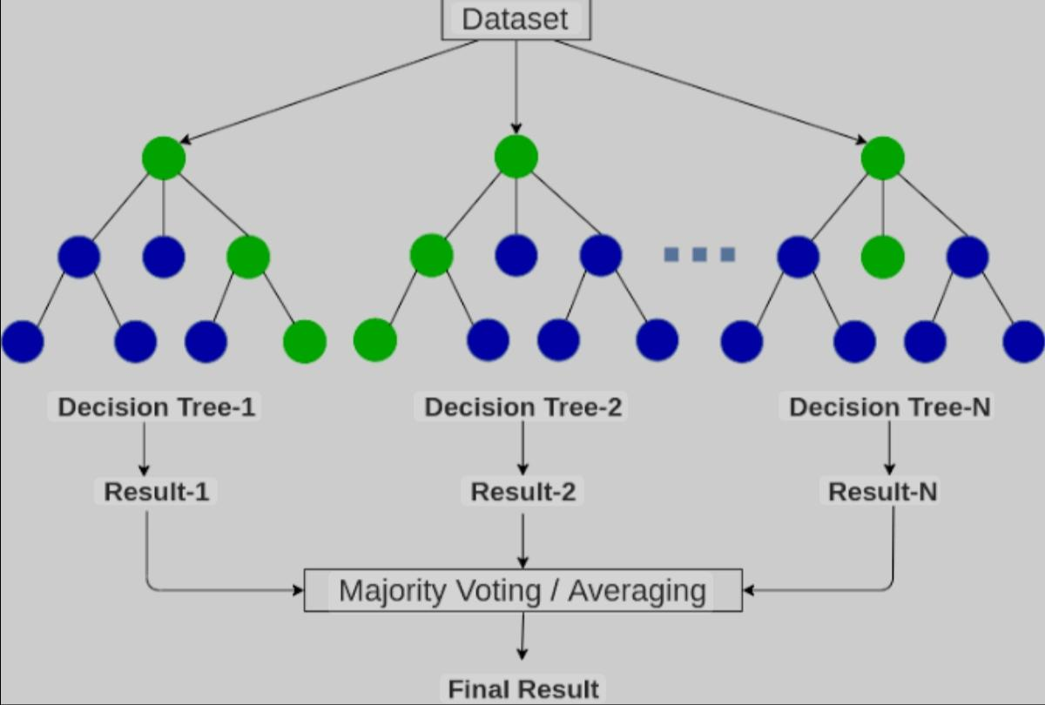

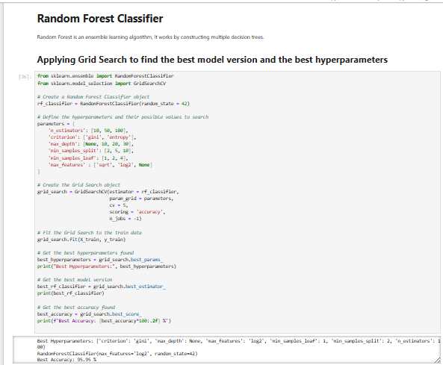

**from sklearn.ensemble import RandomForestClassifier**

**from sklearn.model_selection import GridSearchCV**

* **Imports RandomForestClassifier from sklearn.ensemble, which is used to create a Random Forest classification model.**
* **Imports GridSearchCV from sklearn.model_selection, a tool for performing hyperparameter tuning by testing different combinations.**

**rf_classifier = RandomForestClassifier(random_state=42)**

* **Creates an instance of RandomForestClassifier with random_state=42 to ensure reproducibility of results by controlling randomness.**

**parameters = { 'n_estimators': [10, 50, 100],'criterion': ['gini', 'entropy'],'max_depth':[None, 10, 20, 30], 'min_samples_split': [2, 5, 10], 'min_samples_leaf': [1, 2, 4],'max_features': ['sqrt', 'log2', None]}**

* **Defines a dictionary parameters containing the hyperparameters to be tested:** 
  + **n_estimators: Number of trees in the forest (10, 50, 100).**
  + **criterion: Splitting criterion for nodes (Gini or Entropy).**
  + **max_depth: Maximum depth of trees (None, 10, 20, 30).**
  + **min_samples_split: Minimum samples required to split a node (2, 5, 10).**
  + **min_samples_leaf: Minimum samples in a leaf node (1, 2, 4).**
  + **max_features: Number of features considered for splitting (square root, log2, or all features).**

**grid_search=GridSearchCV(estimator=rf_classifier,param_grid=parameters,cv=5,scoring='accuracy', n_jobs=-1)**

* **Creates a Grid Search object to test hyperparameters with 5-fold CV and accuracy scoring.**

**grid_search.fit(X_train, y_train)**

* **Fits the GridSearchCV object to the training data (X_train, y_train) to test all hyperparameter combinations and select the best based on accuracy.**

**best_hyperparameters = grid_search.best_params_**

**print("Best Hyperparameters:", best_hyperparameters)**

* **Retrieves the best hyperparameters that achieved the highest accuracy using best_params_ and prints them.**
* **Output: {'criterion': 'gini', 'max_depth': None, 'max_features': 'log2', 'min_samples_leaf': 1, 'min_samples_split': 2, 'n_estimators': 100}**

**best_rf_classifier = grid_search.best_estimator_print(best_rf_classifier)**

* **Retrieves the best Random Forest Classifier model with the optimal hyperparameters using best_estimator_ and prints it.**
* **Output: RandomForestClassifier(max_features='log2', random_state=42)**

**best_accuracy = grid_search.best_score_**

**print(f'Best Accuracy: {best_accuracy*100:.2f} %')**

* **Retrieves the best accuracy achieved using best_score_ and prints it as a percentage.**
* **Output: Best Accuracy: 95.95 %**

**best_rf_classifier = RandomForestClassifier(criterion='entropy', max_features='log2', random_state=42)**

* **Creates a Random Forest model with optimal hyperparameters (entropy criterion, log2 max features, fixed random seed).**

**best_rf_classifier.fit(X_train, y_train)**

* **Trains the model on the training data.**

**RandomForestClassifier(criterion='entropy', max_features='log2', random_state=42)**

* **Displays the created model with specified hyperparameters (just a representation, not executed).**

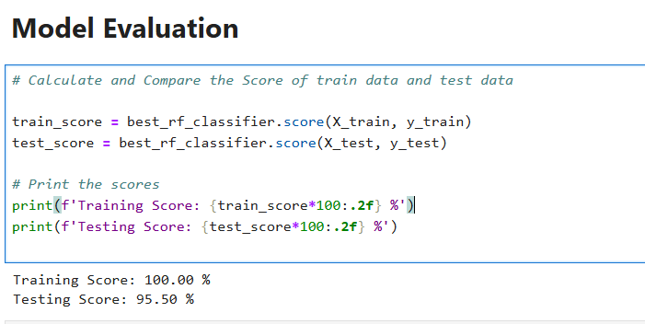

**train_score = best_rf_classifier.score(X_train, y_train)**

* **Calculates the model's accuracy on the training data using the score method.**

**test_score = best_rf_classifier.score(X_test, y_test)**

* **Calculates the model's accuracy on the test data using the score method.**

**print(f'Training Score: {train_score*100:.2f} %')**

* **Prints the training accuracy as a percentage with two decimal places.**

**print(f'Testing Score: {test_score*100:.2f} %')**

* **Prints the test accuracy as a percentage with two decimal places.**

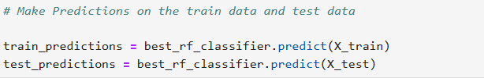**train_predictions = best_rf_classifier.predict(X_train)**

* **Predicts the outputs for the training data using the predict method and stores them in train_predictions.**

**test_predictions = best_rf_classifier.predict(X_test)**

* **Predicts the outputs for the test data using the predict method and stores them in test_predictions.**

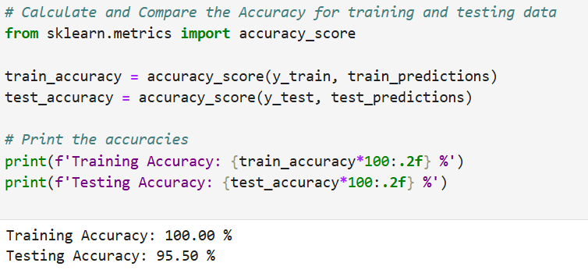

**from sklearn.metrics import accuracy_score**

* **Imports the accuracy_score function from sklearn.metrics to calculate accuracy.**

**train_accuracy = accuracy_score(y_train, train_predictions)**

* **Calculates the accuracy of training predictions by comparing y_train with train_predictions.**

**test_accuracy = accuracy_score(y_test, test_predictions)**

* **Calculates the accuracy of test predictions by comparing y_test with test_predictions**

**print(f'Training Accuracy: {train_accuracy*100:.2f} %')**

* **Prints the training accuracy as a percentage with two decimal places**

**print(f'Testing Accuracy: {test_accuracy*100:.2f} %')**

* **Prints the test accuracy as a percentage with two decimal places**

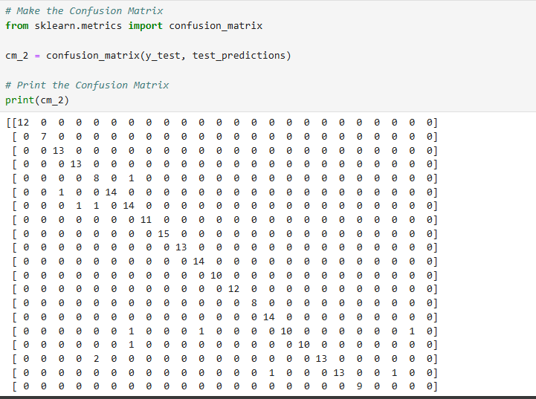

**from sklearn.metrics import confusion_matrix**

* **Imports the confusion_matrix function from sklearn.metrics to create a confusion matrix**

**cm_2 = confusion_matrix(y_test, test_predictions)**

* **Creates a confusion matrix by comparing actual values (y_test) with predictions (test_predictions) and stores it in cm_2**

**print(cm_2)**

* **Prints the confusion matrix**

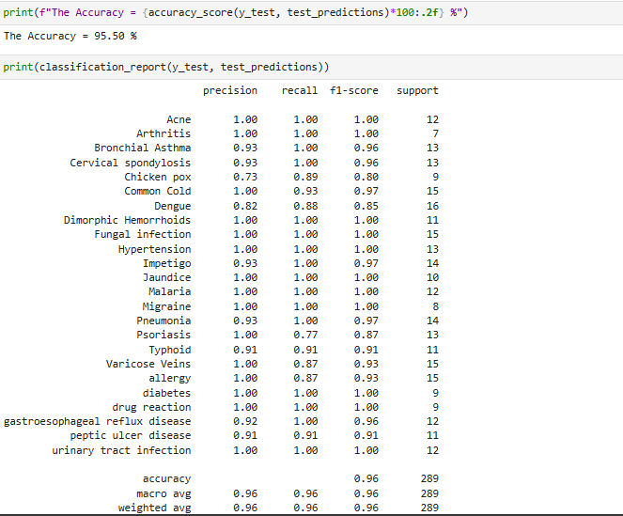

**print(f"The Accuracy = {accuracy_score(y_test, test_predictions)*100:.2f} %")**

* **Prints the model’s accuracy on test data as a percentage with two decimal places using accuracy_score.**

**(Output):**

* **The Accuracy = 95.50 %**
* **The overall accuracy of the model on test data is 95.50%.**

**print(classification_report(y_test, test_predictions))**

* **Prints a classification report containing performance metrics (Precision, Recall, F1-Score) for each class.**

**Acne:**

* **Precision: 1.00 (100% ).**
* **Recall: 1.00 (100%).**
* **F1-Score: 1.00.**
* **Support: 12.**

**Chicken Pox:**

* **Precision: 0.73 (73%).**
* **Recall: 0.89 (89%(.**
* **F1-Score: 0.80.**
* **Support: 9 .**

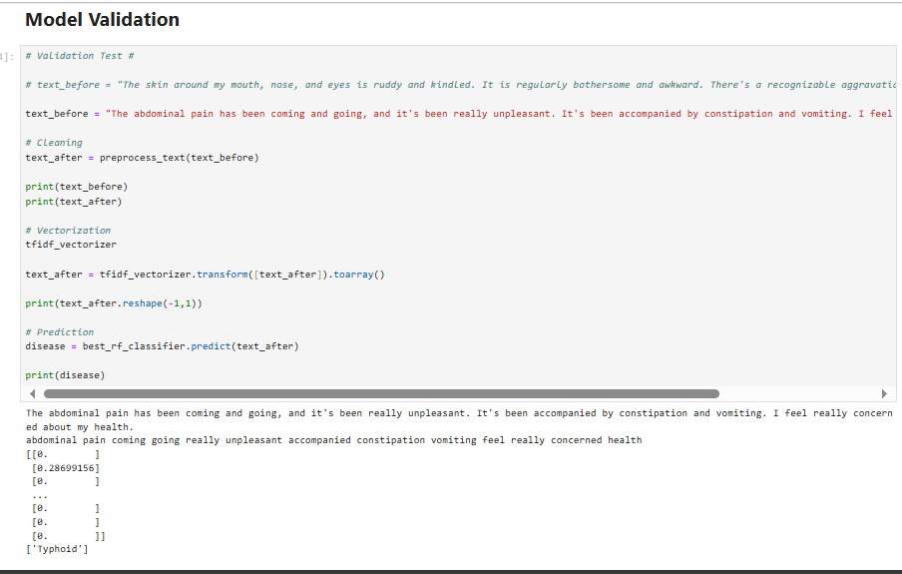

**text_before = "The abdominal pain has been coming and going, and it's been really unpleasant. It's been accompanied by constipation and vomiting. I feel really concerned about my health."**

* **Defines a text string containing symptom descriptions (abdominal pain, constipation, vomiting) for testing.**

**text_after = preprocess_text(text_before)**

* **Cleans the text using the preprocess_text function (not shown in the code) to remove unnecessary words or format the text.**

**print(text_before)**

* **Prints the original text before preprocessing**

**print(text_after)**

* **Prints the text after preprocessing.**

**tfidf_vectorizer**

• **Refers to the tfidf_vectorizer object (previously created) to convert text into numerical vectors using TF-IDF.**

**text_after = tfidf_vectorizer.transform([text_after]).toarray()**

* **Transforms the cleaned text into a numerical vector using tfidf_vectorizer and converts it to an array.**

**print(text_after.reshape(-1,1))**

* **Prints the numerical vector after reshaping it into a column format (likely for display purposes).**

**disease = best_rf_classifier.predict(text_after)**

* **Predicts the disease using the trained model (best_rf_classifier) based on the numerical vector.**

**print(disease)**

* **Prints the predicted disease name.**

##### **Support Vector Machine (SVM):**

A Support Vector Machine (SVM) is a powerful supervised machine learning algorithm for both linear and non-linear classification tasks. For classification, SVM aims to find a hyperplane that best separates the data into different classes.

SVM is effective in high- dimensional spaces and robust against overfitting.

-We used the following Hyperparameters:

**{C, Kernel, Gamma}**

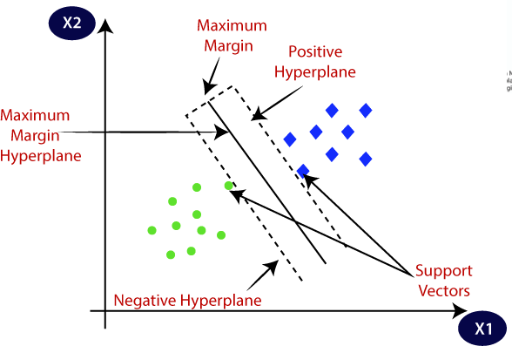

**Figure 6: SVM Algorithm**

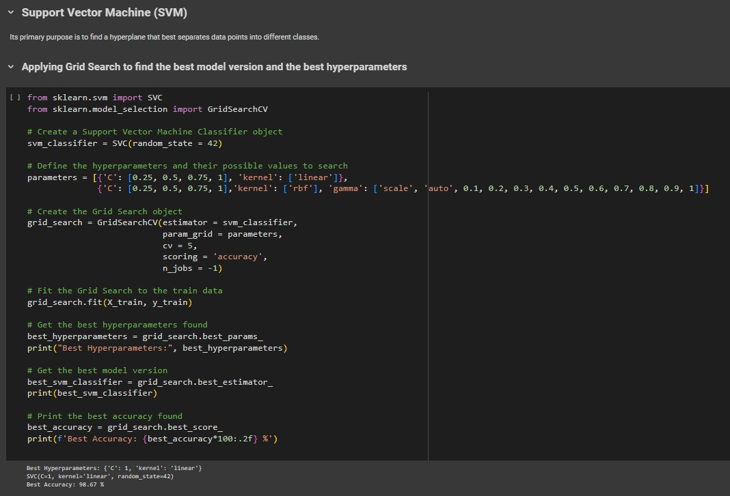**Applying Grid Search to find the best model version and the best hyperparameters:**

**svm_classifier = SVC(random_state=42)**

-Initialize an SVC object named svm_classifier.

-Set the random_state parameter to 42 for reproducibility.

###### parameters = {...}

-Define a dictionary named “parameters” containing different hyperparameters and their potential values. These hyperparameters will be tuned during the grid search process.

###### grid_search = GridSearchCV(estimator= svm_classifier, param_grid=parameters, cv=5, scoring='accuracy', n_jobs=-1)

-Initialize a GridSearchCV object named “grid_search”.

-Pass the following parameters:

**(estimator, param_grid, cv, scoring, n_jobs)**

###### grid_search.fit(X_train, y_train)

-Fit the grid_search object to the training data (X_train and y_train).

###### best_hyperparameters = grid_search.best_params_

-Retrieve the best hyperparameters found during the grid search and store them in the “best_hyperparameters” variable.

###### print("Best Hyperparameters:", best_hyperparameters)

-Print the best hyperparameters found during the grid search.

###### best_svm_classifier = grid_search.best_estimator_

-Retrieve the best SVC version found during the grid search and store it in the “best_svm_classifier” variable.

###### print(best_svm_classifier)

-Print the details of the best SVC version found during the grid search.

###### best_accuracy = grid_search.best_score_

-Retrieve the best mean cross-validated accuracy score found during the grid search and store it in the “best_accuracy” variable.

###### print(f'Best Accuracy: {best_accuracy*100:.2f} %')

-Print the best mean cross-validated accuracy score as a percentage with two decimal places.

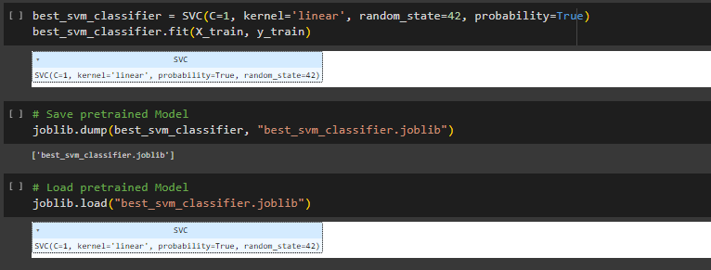

###### best_svm_classifier = SVC(C=1, kernel='linear', random_state=42, probability=True)

-Create an instance of SVC class called “best_svm_classifier”, with the best parameters (C=1, kernel='linear', random_state=42, probability=True).

###### best_svm_classifier.fit(X_train, y_train)

This line trains the best version of SVC on the training data (X_train) and (y_train).

###### joblib.dump(best_svm_classifier, "best_svm_classifier.joblib")

-This line is using the joblib.dump() function to save the “best_svm_classifier” object to a file named “best_svm_classifier.joblib”.

-The best_svm_classifier object will be serialized and saved to the specified file location to load and deploy it later.

###### joblib.load("best_svm_classifier.joblib")

-This line of code is using the joblib.load() function to load the saved best_svm_classifier object from the file “best_svm_classifier.joblib” to load and deploy it later in Flask.

###### Model Evaluation:

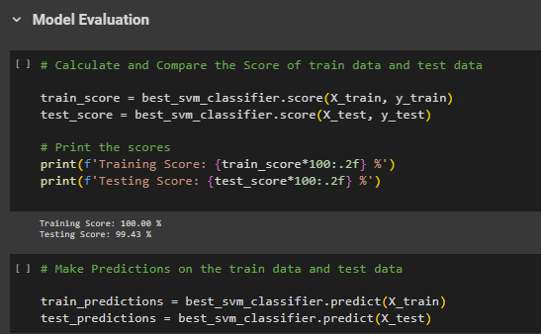

**train_score = best_svm_classifier.score(X_train, y_train)**

-Calculate the mean accuracy of the best SVC model (best_svm_classifier) on the train data (X_train, y_train).

-This measures the performance of the model on seen data.

###### test_score = best_svm_classifier.score(X_test, y_test)

-Calculate the mean accuracy of the best SVC model (best_svm_classifier) on the test data (X_test, y_test).

-This measures the performance of the model on unseen data.

###### print(f'Training Score: {train_score:.2f} %')

-Print the train accuracy score as a percentage with two decimal places.

###### print(f'Testing Score: {test_score:.2f} %')

-Print the test accuracy score as a percentage with two decimal places.

###### train_predictions = best_svm_classifier.predict(X_train)

-Predict the class labels for the training data (X_train) using the best SVC model (best_svm_classifier).

###### test_predictions = best_svm_classifier.predict(X_test)

-Predict the class labels for the testing data (X_test) using the best SVC model (best_svm_classifier).

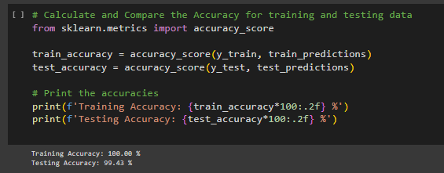

###### train_accuracy= accuracy_score(y_train, train_predictions)

-Calculate the accuracy classification score for the train data, by comparing the true labels (y_train) with the predicted labels (train_predictions).

-This measures the performance of the model on seen data.

###### test_accuracy = accuracy_score(y_test, test_predictions)

-Calculate the accuracy classification score for the test data, by comparing the true labels (y_test) with the predicted labels (test_predictions).

-This measures the performance of the model on unseen data.

###### print(f'Training Accuracy: {train_accuracy*100:.2f} %')

This line prints the training accuracy as a percentage with two decimal places.

###### print(f'Testing Accuracy: {test_accuracy*100:.2f} %')

This line prints the testing accuracy as a percentage with two decimal places.

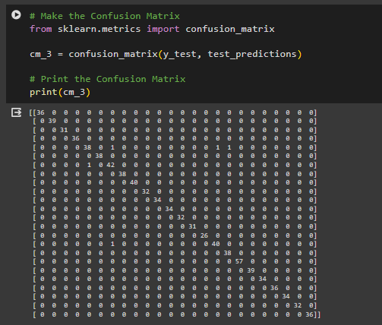

###### cm_3 = confusion_matrix(y_test, test_predictions)

-Calculate the confusion matrix based on the true labels (y_test) and the predicted labels (test_predictions).

###### print(cm_3)

-Print the computed confusion matrix.

-This confusion matrix printed as a 24x24 matrix (for multiclass classification), where each row represents the instances in an actual class, and each column represents the instances in a predicted class.

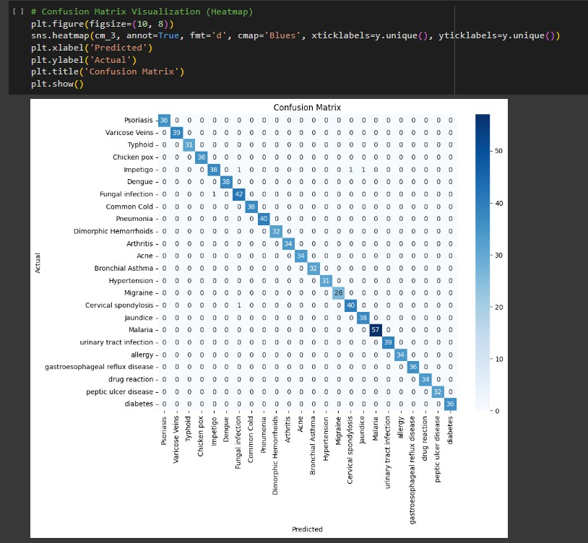

-This code generates a heatmap visualization of a confusion matrix using the matplotlib and seaborn libraries.

-The rows represent the actual classes, and the columns represent the predicted classes.

-The color intensity of each cell indicates the number of data points that belong to the corresponding combination of actual and predicted classes.

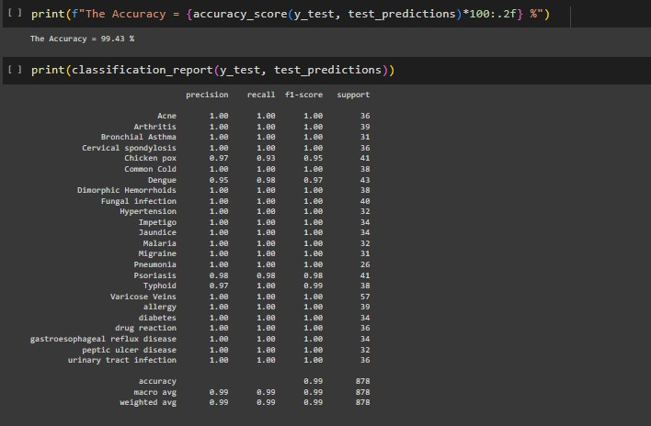

###### print(f"The Accuracy = {accuracy_score(y_test, test_predictions)*100:.2f} %")

-Print the accuracy classification score of SVC model on the test dataset as a percentage with two decimal places.

-Calculate the accuracy as the fraction of correctly predicted instances out of the total number of instances.

###### print(classification_report(y_test, test_predictions))

-Print the classification report for the predictions made by SVC model on the test dataset.

-The classification report includes various evaluation metrics such as **precision, recall, F1-score, and support** for each class, as well as averages across all classes.

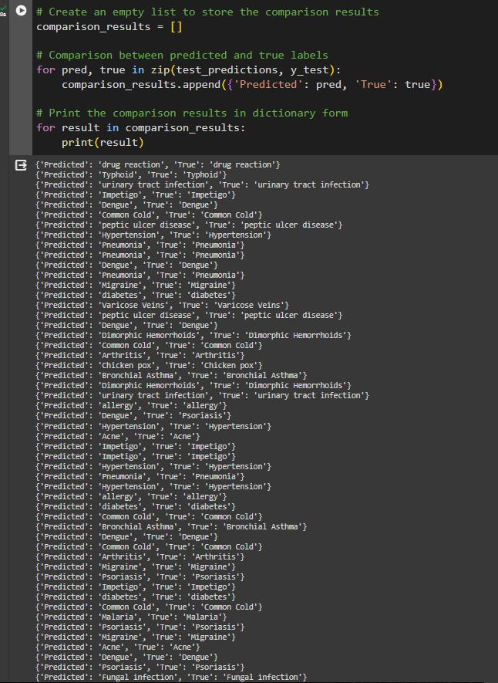

###### comparison_results = []

Initialize an empty list named “comparison_results” where the results of the comparisons will be stored.

###### for pred, true in zip(test_predictions, y_test):

Initiate a loop that iterates through each pair of elements from two lists, test_predictions (the predicted labels) and y_test (the true labels), simultaneously.

###### comparison_results.append({'Predicted': pred, 'True': true})

Inside the loop, a dictionary is created for each pair of predicted and true labels. This dictionary has two key-value pairs: 'Predicted' key with the value of the predicted label (pred), and 'True' key with the value of the true label (true). This dictionary is then appended to the “comparison_results” empty list.

###### for result in comparison_results:

Initiate another loop that iterates through each dictionary in the “comparison_results” list.

###### print(result)

Inside this loop, each dictionary (result) is printed. Since each dictionary contains the predicted and true labels, when printed, it will display the comparison result in a dictionary format.

###### Model validation:

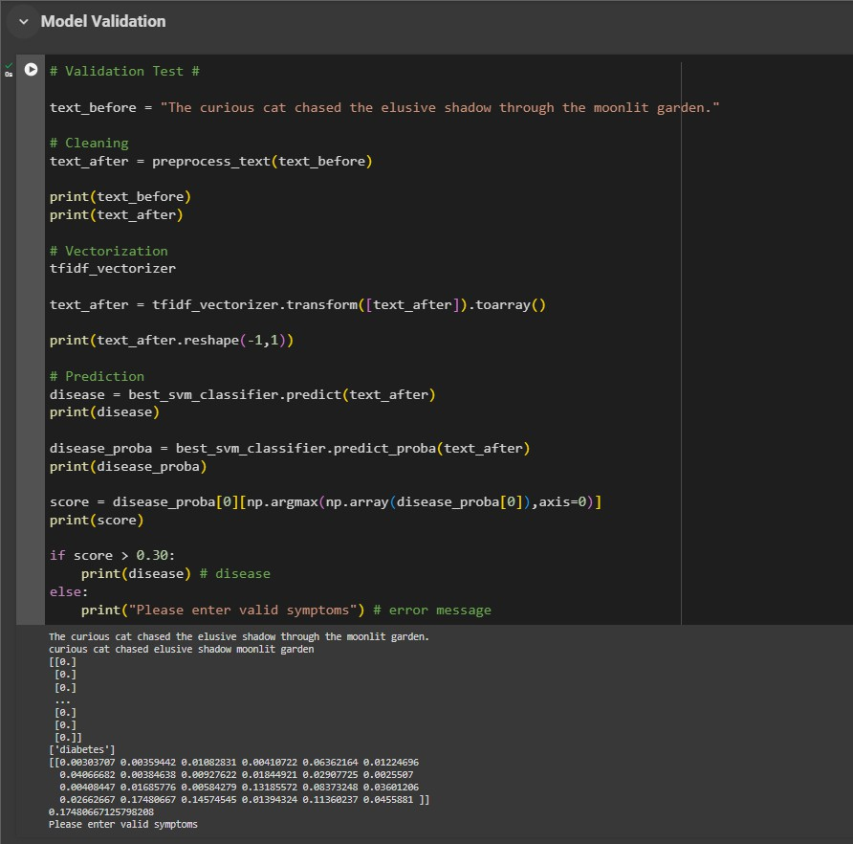

**text_before = "any symptoms description entered by user"**

-Assign the input text string to the variable “text_before”. This variable holds the original text before any preprocessing or prediction.

###### text_after = preprocess_text(text_before)

-Apply the “preprocess_text” function to the “text_before” string to perform NLP steps. The processed text is then assigned to the variable “text_after”.

###### print(text_before)

-Print the original text (text_before).

###### print(text_after)

-Print the processed text after applying NLP steps.

###### tfidf_vectorizer

-This line calls the “tfidf_vectorizer” object.

###### text_after = tfidf_vectorizer.transform([text_after]).toarray()

-Transform the processed text (text_after) into a TF-IDF vector representation using the tfidf_vectorizer object. The transform method converts the text into numerical features, and “toarray()” converts the resulting sparse matrix into a dense NumPy array.

###### print(text_after.reshape(-1,1))

-Print the TF-IDF vector representation of the processed text (text_after), and reshape(-1,1) method reshapes the array to have one column while maintaining the same number of rows.

###### disease = best_svm_classifier.predict(text_after)

-Predict the disease for the processed text (text_after) using the best SVC model (best_svm_classifier).

###### print(disease)

-Print the predicted label (disease) for the processed text.

###### disease_proba = best_svm_classifier.predict_proba(text_after)

- “predict_proba()” to obtain the probabilities of each class label/disease for the processed text (text_after) using the best SVC model (best_svm_classifier).

###### print(disease_proba)

-Print the 2-dimensional array containing the probabilities of each disease predicted by the SVC model for the processed text.

###### score=disease_proba[0][np.argmax(np.array(disease_proba[0]),a xis=0)]

* “np.array(disease_proba[0])” converts the 1-dimensional array “disease_proba[0]” into a NumPy array, disease_proba[0] selects the probabilities associated with the first instance (or sample) in the array.
* “np.argmax()” function returns the index of the maximum value in the array “disease_proba[0]” along a specified axis “axis=0”.
* Generally, this line calculates the highest probability of disease for the first instance in the “disease_proba” array, using the index obtained from “np.argmax()”, and assigns it to the variable “score”.

###### print(score)

-Print the highest probability of disease for the processed text.

###### print(disease) if (score > 0.30) else print("Please enter valid symptoms")

If the highest probability (score) is greater than 0.30, print the predicted disease. Otherwise, print an error message indicating that the symptoms are not valid.

###### **Decision Tree Classifier:**

A decision tree classifier is a popular supervised learning algorithm used for classification tasks. It builds a tree-like structure where each internal node represents a "decision" based on a feature, and each leaf node represents a class label. It works by recursively partitioning the dataset into subsets based on the most significant features.

-We used the following Hyperparameters: **{criterion , max_depth , min_samples_split, max_features, min_samples_leaf }**

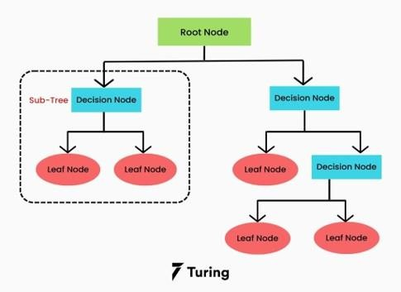

**Figure 4: Random Forest Algorithm**

###### Applying Grid Search to find the best model version and the best hyperparameters:

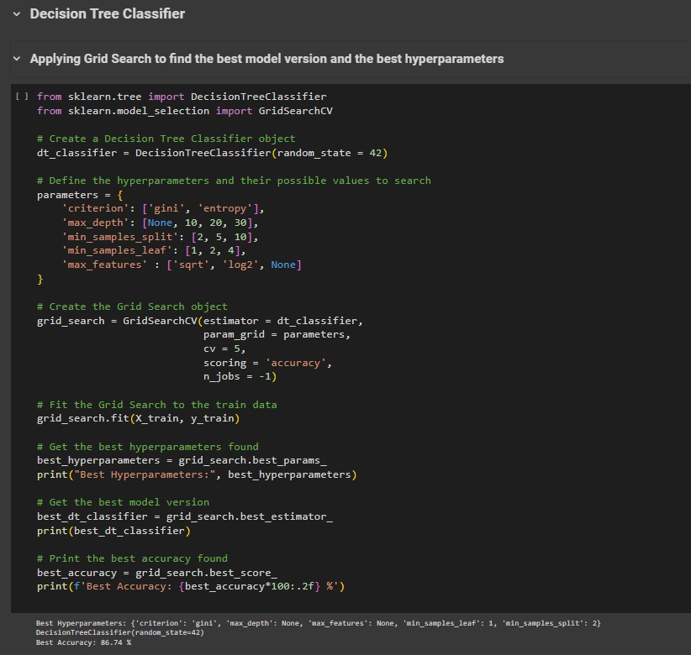

**dt_classifier = DecisionTreeClassifier(random_state=42)**

-Initialize a DecisionTreeClassifier object named dt_classifier.

-Set the random_state parameter to 42 for reproducibility.

###### parameters = {...}

-Define a dictionary named “parameters” containing different hyperparameters and their potential values. These hyperparameters will be tuned during the grid search process.

###### grid_search = GridSearchCV(estimator=dt_classifier, param_grid=parameters, cv=5, scoring='accuracy', n_jobs=-1)

-Initialize a GridSearchCV object named “grid_search”.

-Pass the following parameters:

**estimator:** The model to be tuned, in this case, dt_classifier, which is a DecisionTreeClassifier.

**param_grid:** The dictionary containing the hyperparameters and their possible values.

**cv:** Cross-validation strategy, here 5-fold cross-validation.

**scoring:** The evaluation metric used to compare models. Here it's set to 'accuracy'.

**n_jobs:** Number of parallel jobs to run (-1 indicates using all available processors).

###### grid_search.fit(X_train, y_train)

-Fit the grid_search object to the training data (X_train and y_train).

###### best_hyperparameters = grid_search.best_params_

-Retrieve the best hyperparameters found during the grid search and store them in the “best_hyperparameters” variable.

###### print("Best Hyperparameters:", best_hyperparameters)

-Print the best hyperparameters found during the grid search.

###### best_dt_classifier = grid_search.best_estimator_

-Retrieve the best DecisionTreeClassifier version found during the grid search and store it in the “best_dt_classifier” variable.

###### print(best_dt_classifier)

-Print the details of the best DecisionTreeClassifier version found during the grid search.

###### best_accuracy = grid_search.best_score_

-Retrieve the best mean cross-validated accuracy score found during the grid search and store it in the “best_accuracy” variable.

###### print(f'Best Accuracy: {best_accuracy*100:.2f} %')

-Print the best mean cross-validated accuracy score as a percentage with two decimal places.

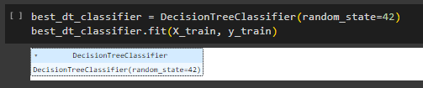

###### best_dt_classifier = DecisionTreeClassifier(random_state=42)

-Create an instance of DecisionTreeClassifier class called “best_dt_classifier”, with the best parameter(random_state=42).

###### best_dt_classifier.fit(X_train, y_train)

This line trains the best version of Decision Tree classifier on the training data (X_train) and (y_train).

###### Model Evaluation:

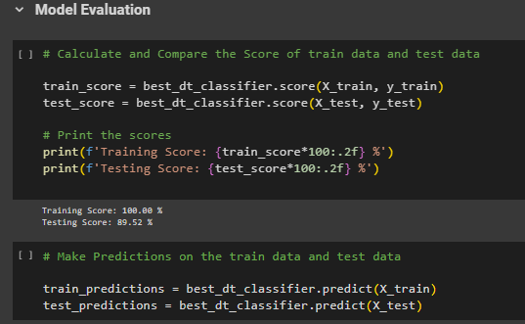

**train_score = best_dt_classifier.score(X_train, y_train)**

-Calculate the mean accuracy of the best DecisionTreeClassifier model (best_dt_classifier) on the train data (X_train, y_train).

-This measures the performance of the model on seen data.

###### test_score = best_dt_classifier.score(X_test, y_test)

-Calculate the mean accuracy of the best DecisionTreeClassifier model (best_dt_classifier) on the test data (X_test, y_test).

-This measures the performance of the model on unseen data.

###### print(f'Training Score: {train_score:.2f} %')

-Print the train accuracy score as a percentage with two decimal places.

###### print(f'Testing Score: {test_score:.2f} %')

-Print the test accuracy score as a percentage with two decimal places.

###### train_predictions = best_dt_classifier.predict(X_train)

-Predict the class labels for the training data (X_train) using the best DecisionTreeClassifier model (best_dt_classifier).

###### test_predictions = best_dt_classifier.predict(X_test)

-Predict the class labels for the testing data (X_test) using the best DecisionTreeClassifier model (best_dt_classifier).

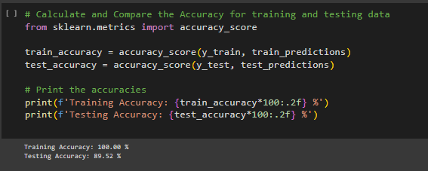

###### train_accuracy= accuracy_score(y_train, train_predictions)

-Calculate the accuracy classification score for the train data, by comparing the true labels (y_train) with the predicted labels (train_predictions).

-This measures the performance of the model on seen data.

###### test_accuracy = accuracy_score(y_test, test_predictions)

-Calculate the accuracy classification score for the test data, by comparing the true labels (y_test) with the predicted labels (test_predictions).

-This measures the performance of the model on unseen data.

###### print(f'Training Accuracy: {train_accuracy*100:.2f} %')

This line prints the training accuracy as a percentage with two decimal places.

###### print(f'Testing Accuracy: {test_accuracy*100:.2f} %')

This line prints the testing accuracy as a percentage with two decimal places.

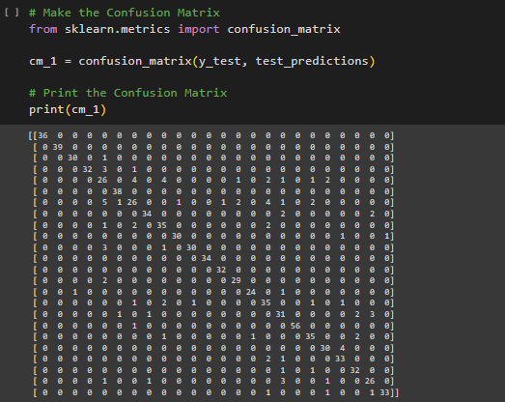

###### cm_1 = confusion_matrix(y_test, test_predictions)

-Calculate the confusion matrix based on the true labels (y_test) and the predicted labels (test_predictions).

###### print(cm_1)

-Print the computed confusion matrix.

-This confusion matrix printed as a 24x24 matrix (for multiclass classification), where each row represents the instances in an actual class, and each column represents the instances in a predicted class.

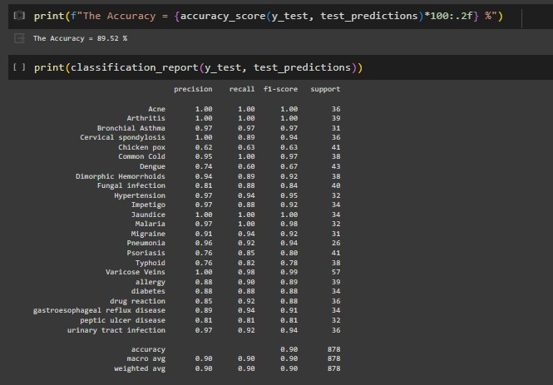

###### print(f"The Accuracy = {accuracy_score(y_test, test_predictions)*100:.2f} %")

-Print the accuracy classification score of DecisionTreeClassifier model on the test dataset as a percentage with two decimal places.

-Calculate the accuracy as the fraction of correctly predicted instances out of the total number of instances.

###### print(classification_report(y_test, test_predictions))

-Print the classification report for the predictions made by of DecisionTreeClassifier model on the test dataset.

-The classification report includes various evaluation metrics such as precision, recall, F1-score, and support for each class, as well as averages across all classes:

**Precision:** The proportion of true positive predictions among all predicted positive instances. It measures the model's ability to avoid false positives.

**Recall:** The proportion of true positive predictions among all actual positive instances. It measures the model's ability to capture all positives.

**F1-score:** The harmonic Mean of precision and recall. It provides a balanced measure of the model's performance.

**Support:** The number of occurrences of each class in the test dataset.

###### Model validation:

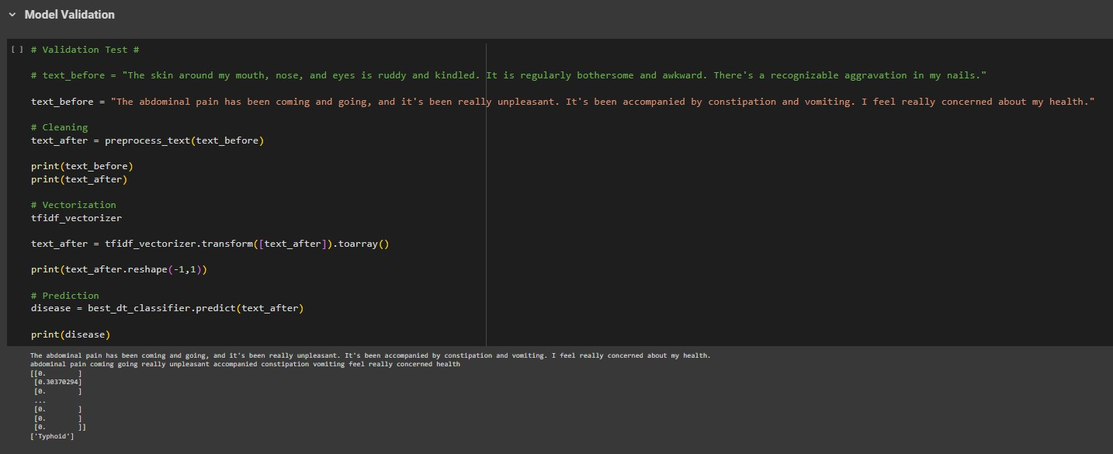

**text_before = "any symptoms description entered by user"**

-Assign the input text string to the variable “text_before”. This variable holds the original text before any preprocessing or prediction.

###### text_after = preprocess_text(text_before)

-Apply the “preprocess_text” function to the “text_before” string to perform NLP steps. The processed text is then assigned to the variable “text_after”.

###### print(text_before)

-Print the original text (text_before).

###### print(text_after)

-Print the processed text after applying NLP steps.

###### tfidf_vectorizer

-This line calls the “tfidf_vectorizer” object.

###### text_after = tfidf_vectorizer.transform([text_after]).toarray()

-Transform the processed text (text_after) into a TF-IDF vector representation using the tfidf_vectorizer object. The transform method converts the text into numerical features, and “toarray()” converts the resulting sparse matrix into a dense NumPy array.

###### print(text_after.reshape(-1,1))

-Print the TF-IDF vector representation of the processed text (text_after), and reshape(-1,1) method reshapes the array to have one column while maintaining the same number of rows.

###### disease = best_dt_classifier.predict(text_after)

-Predict the disease for the processed text (text_after) using the best DecisionTreeClassifier model (best_dt_classifier).

###### print(disease)

-Print the predicted label (disease) for the processed text.

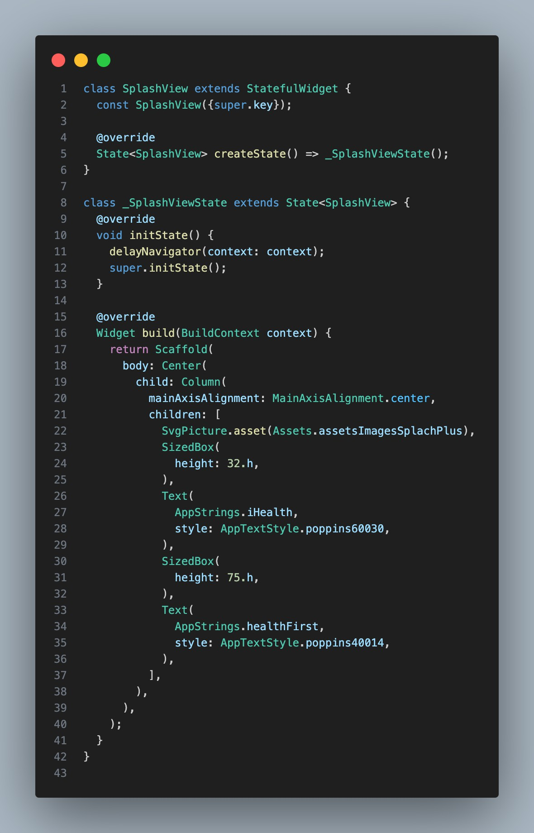

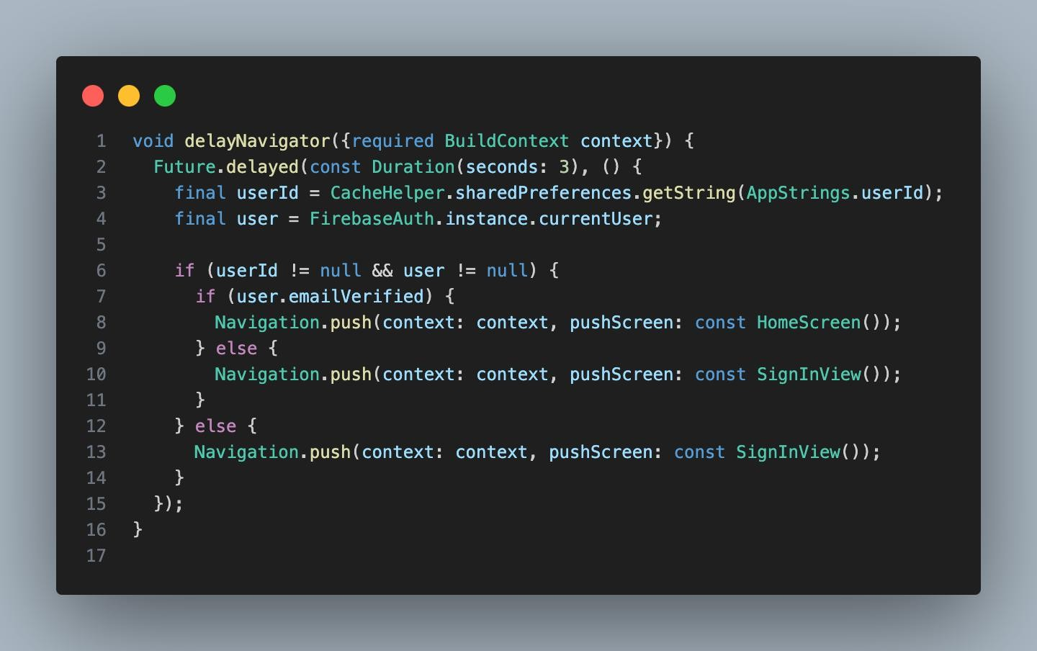

**SCREEN SPLASH**

# CHATPOT

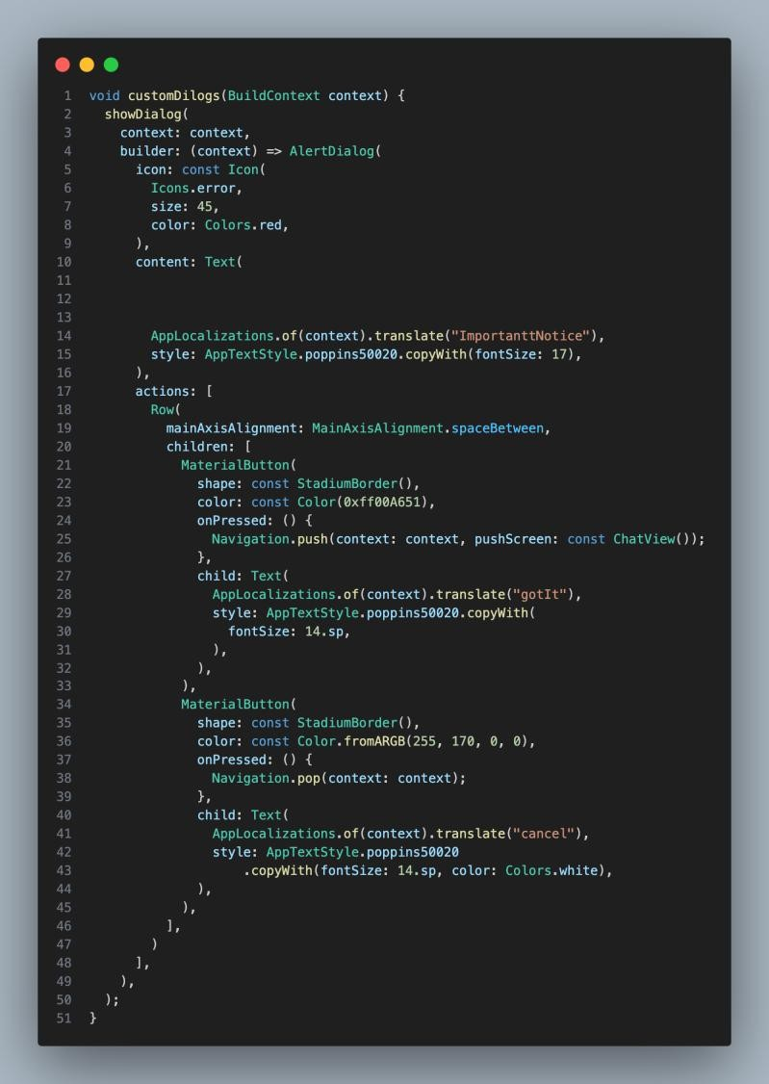

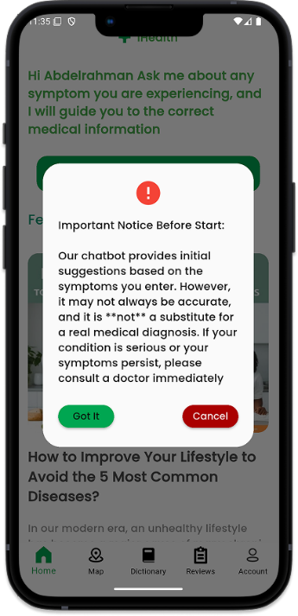

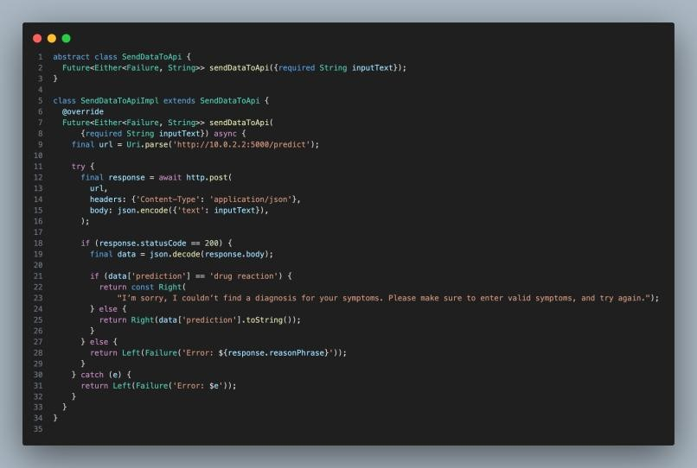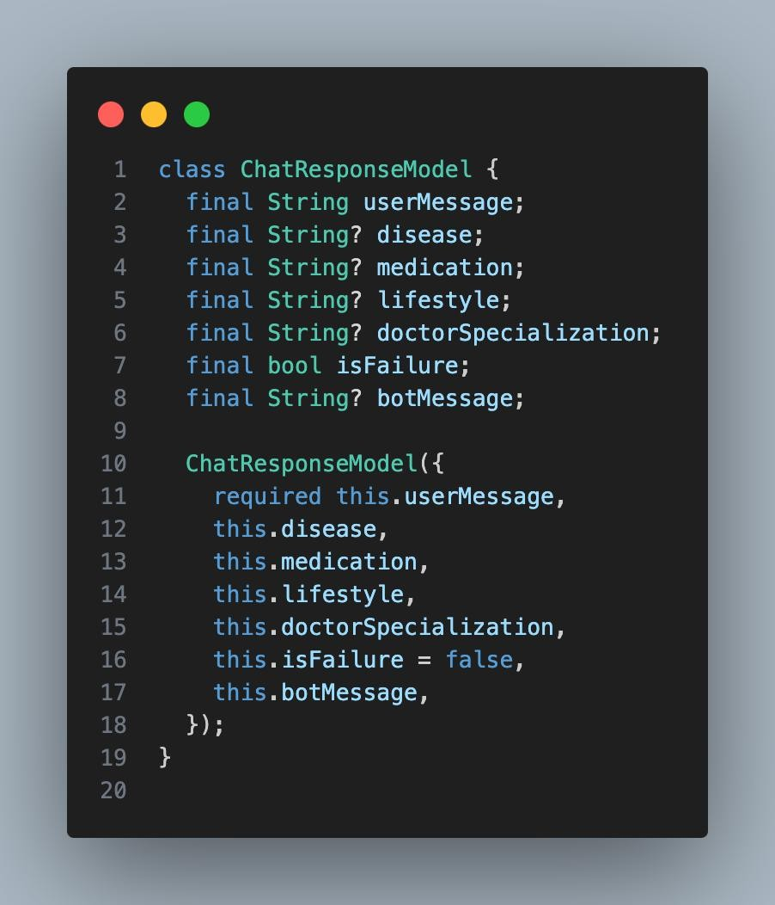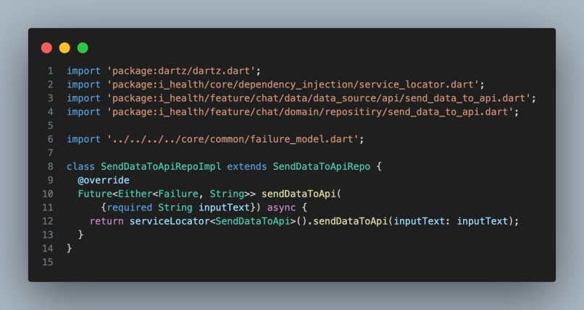

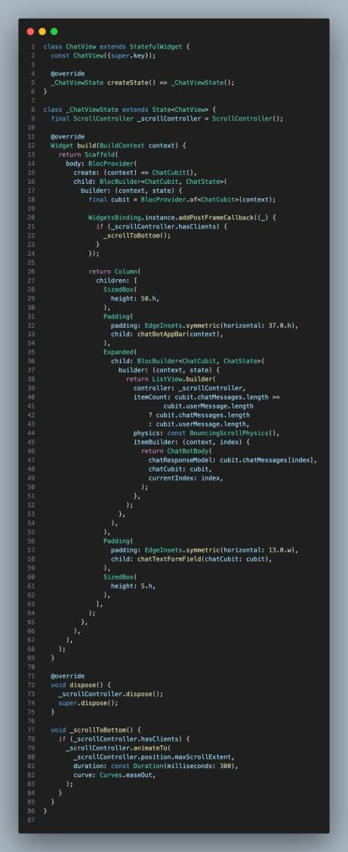

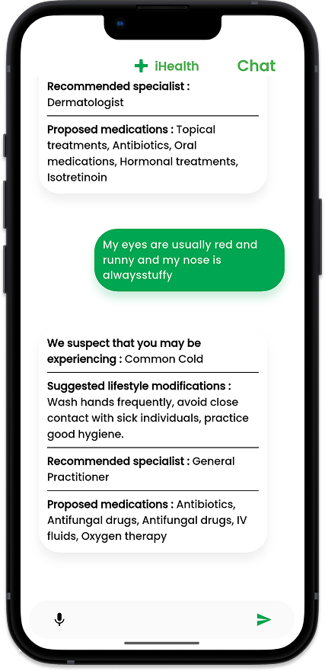

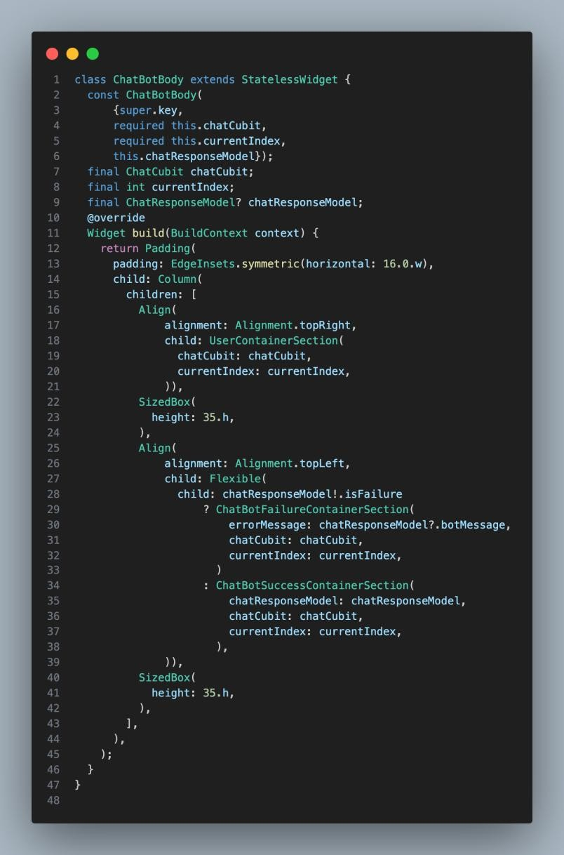

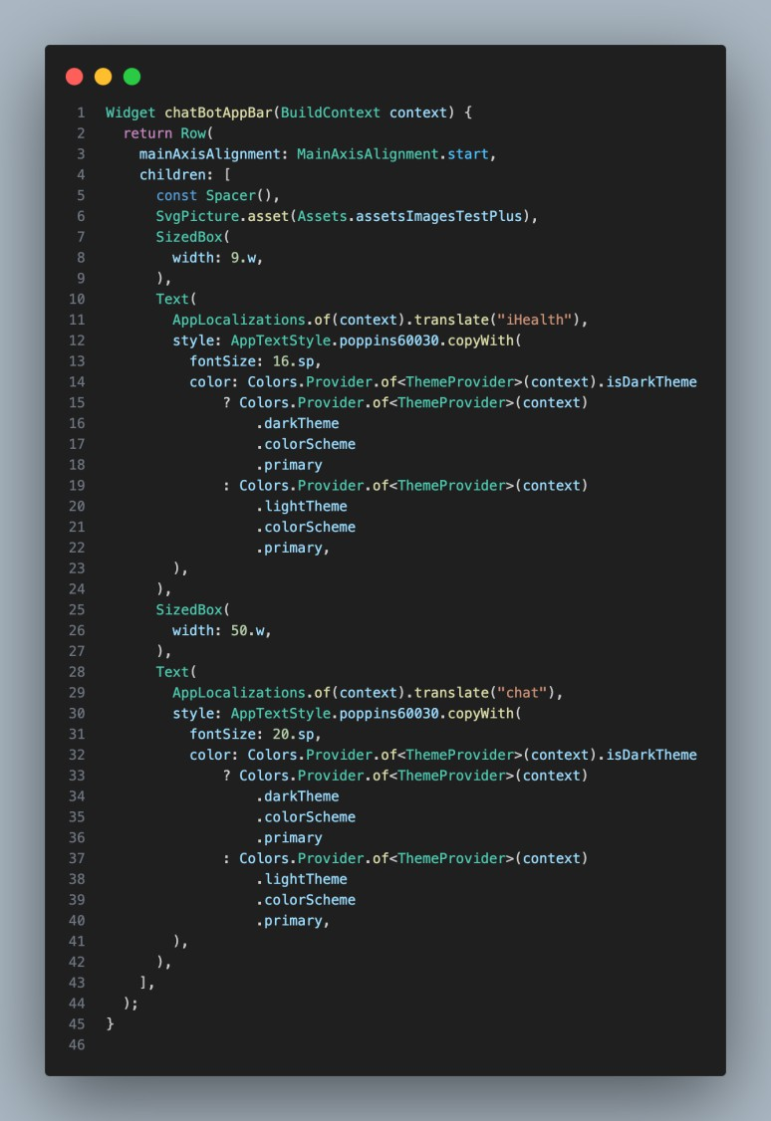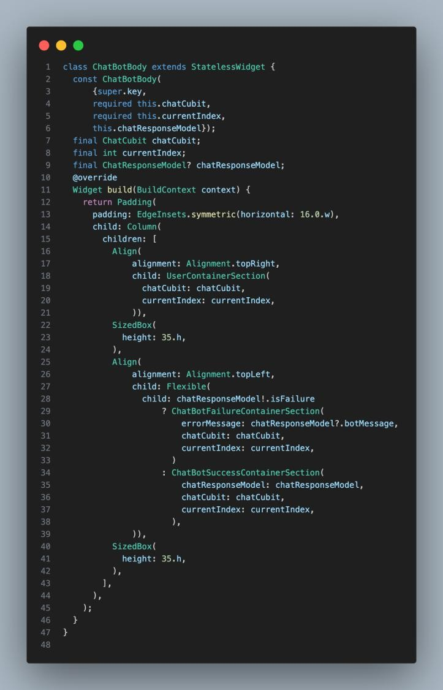

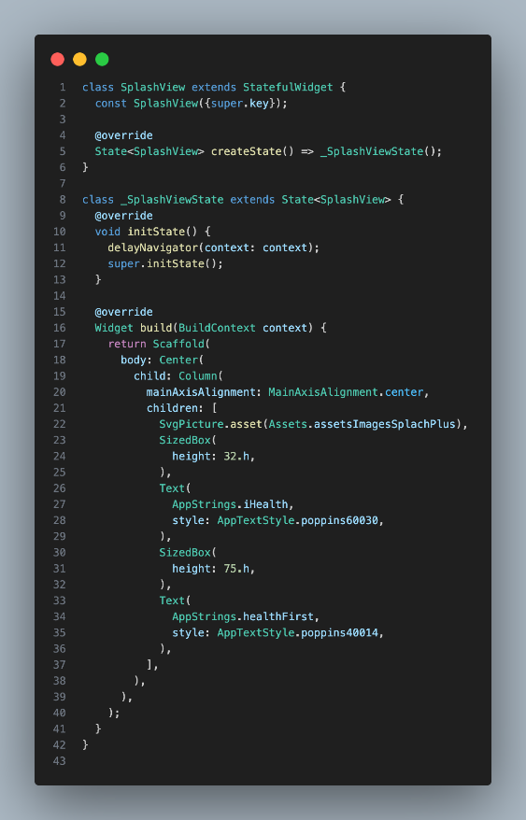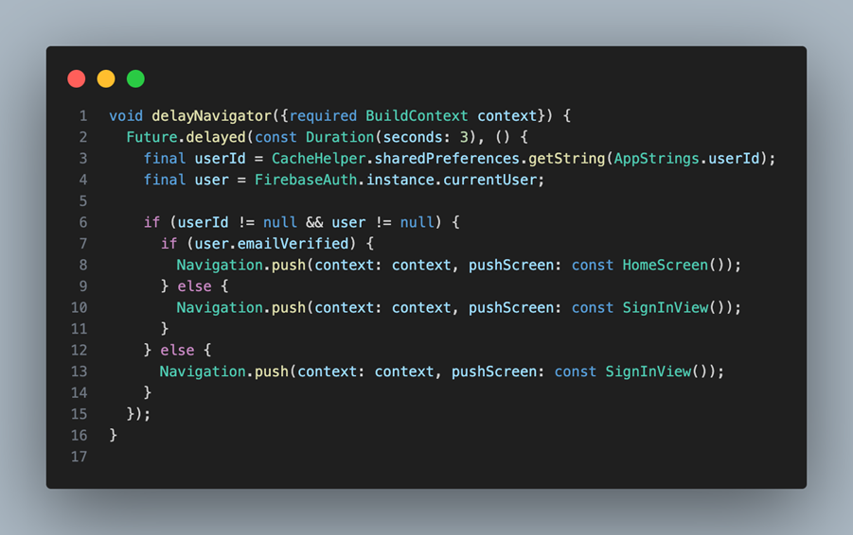Splash screen

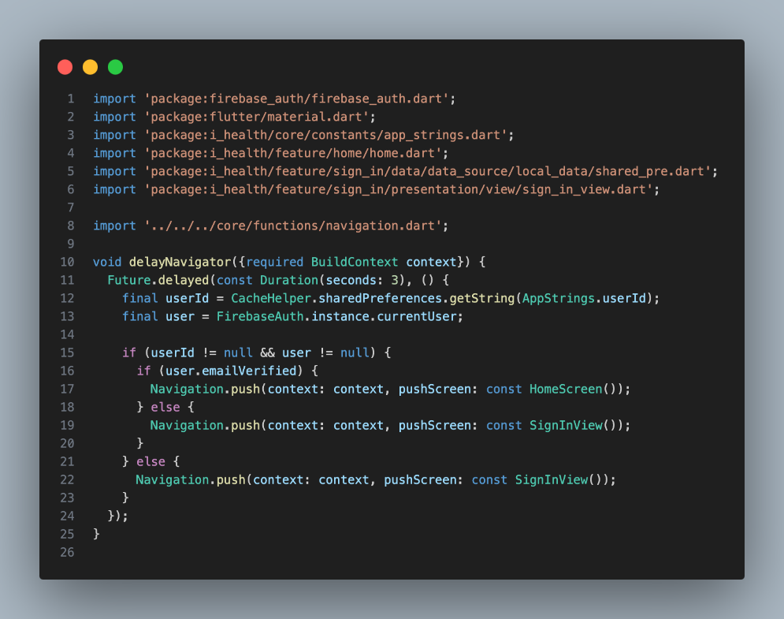

chatpot

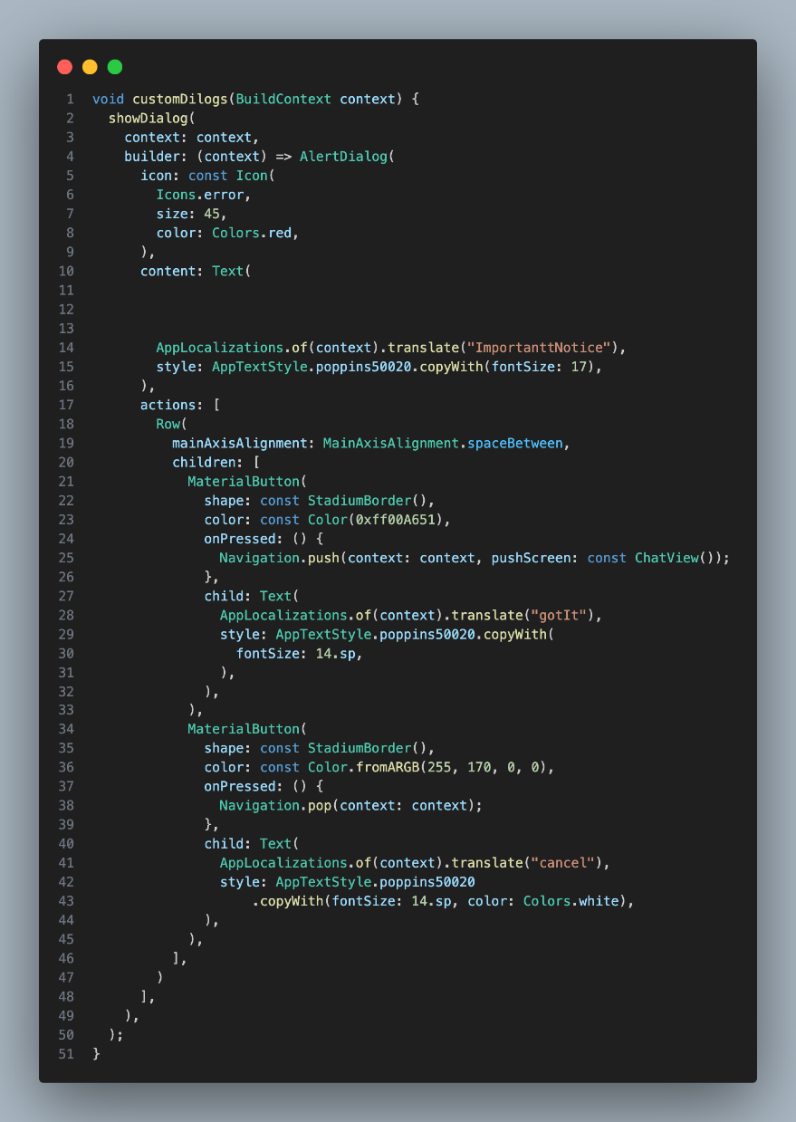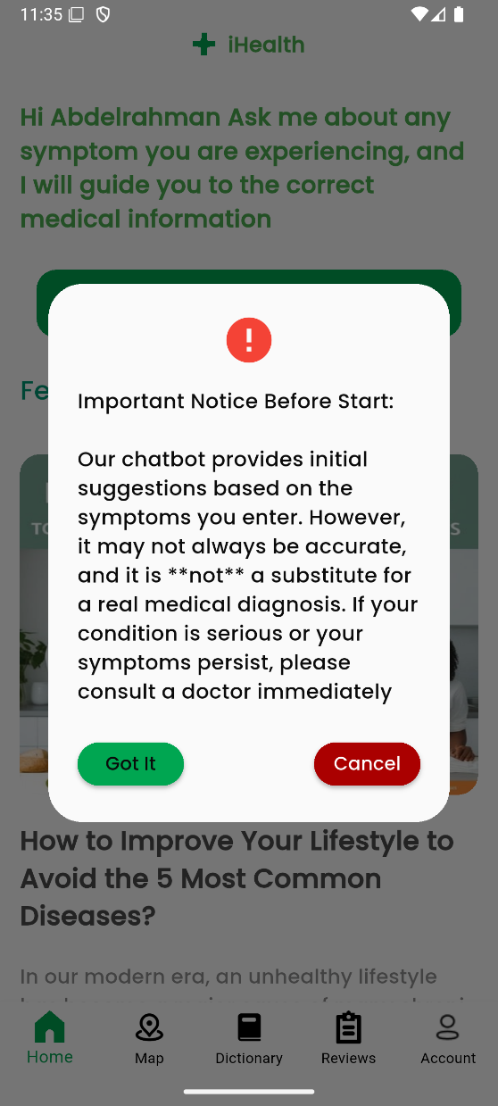

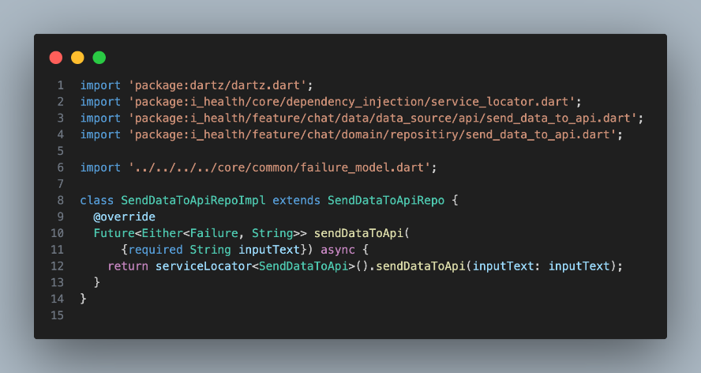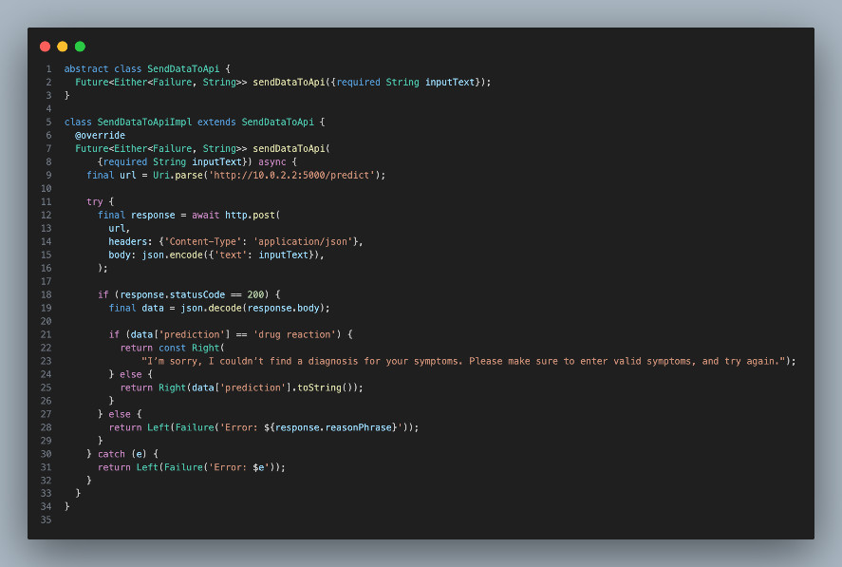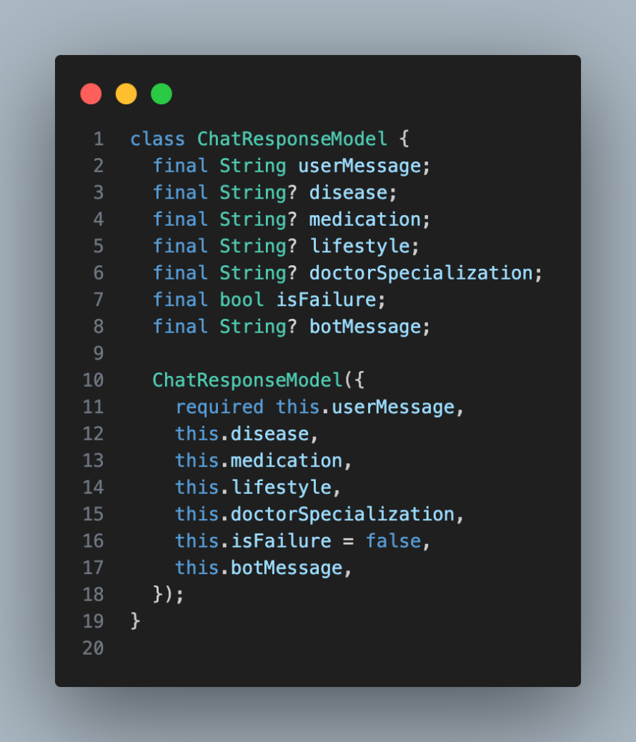

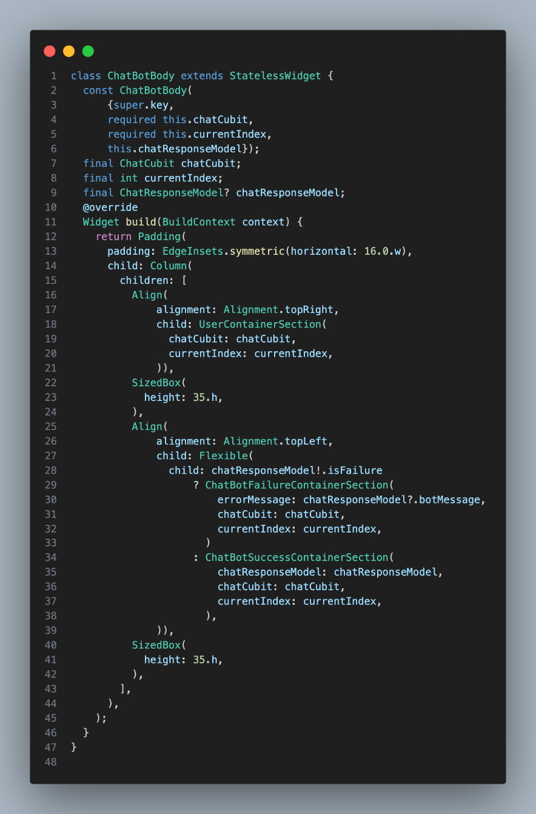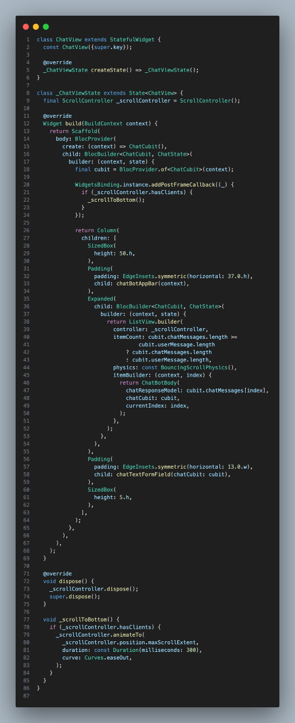

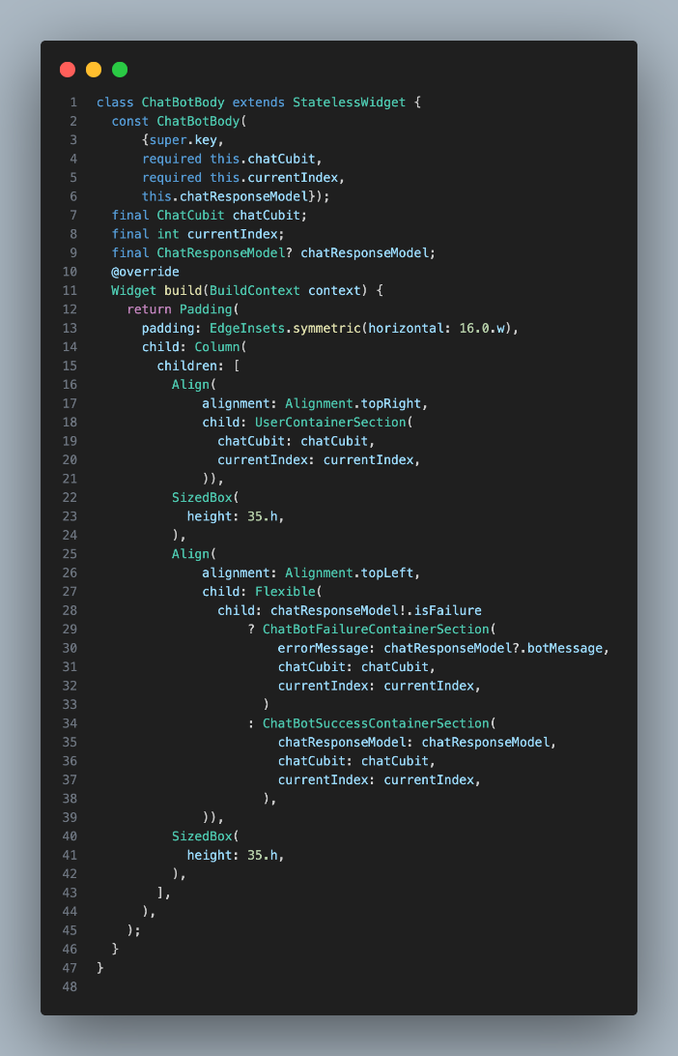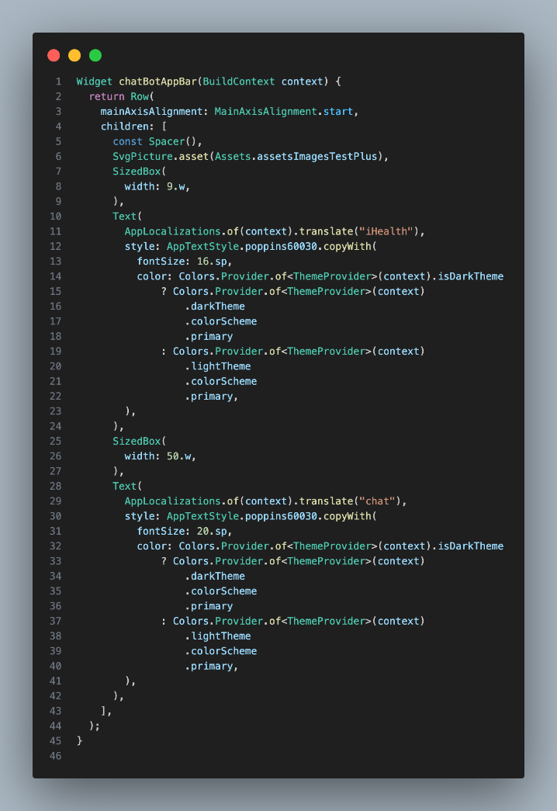

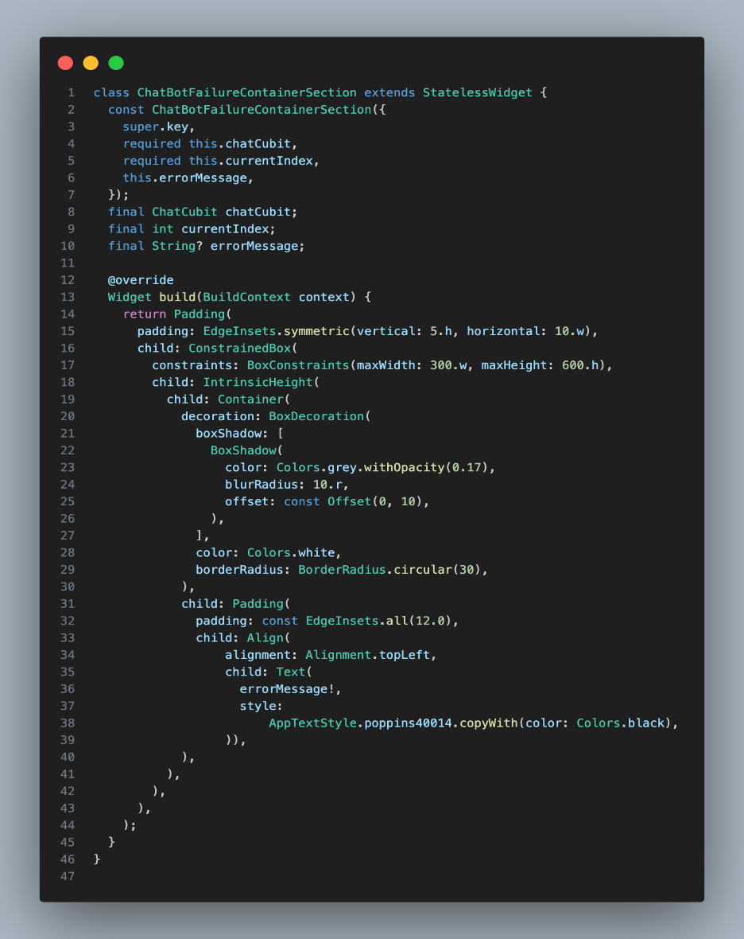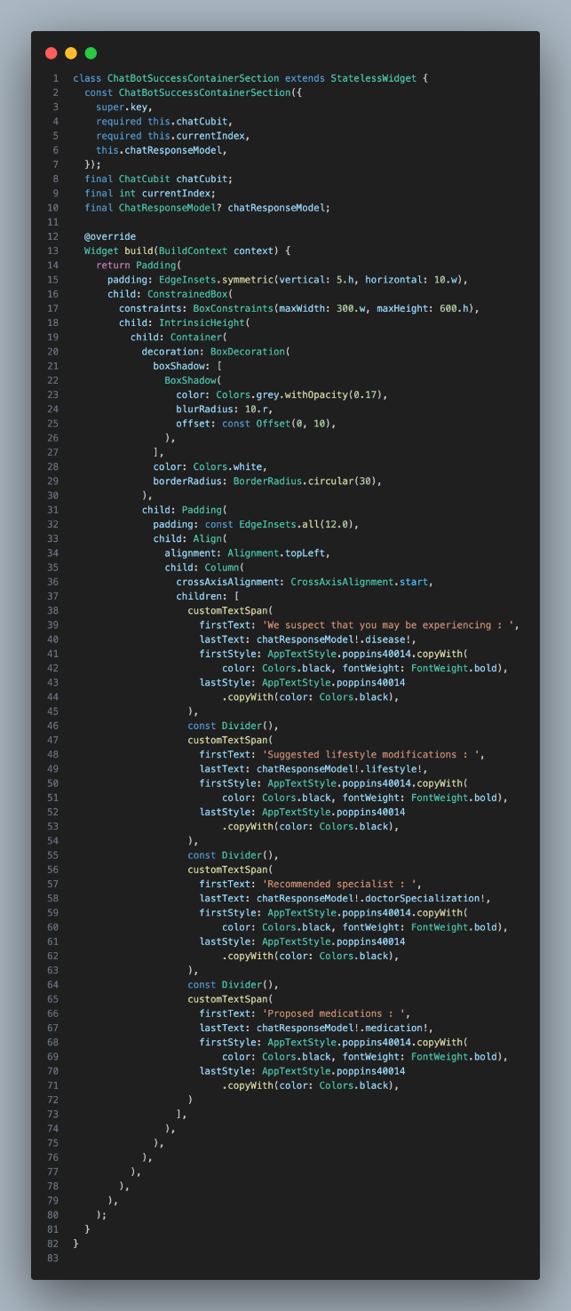

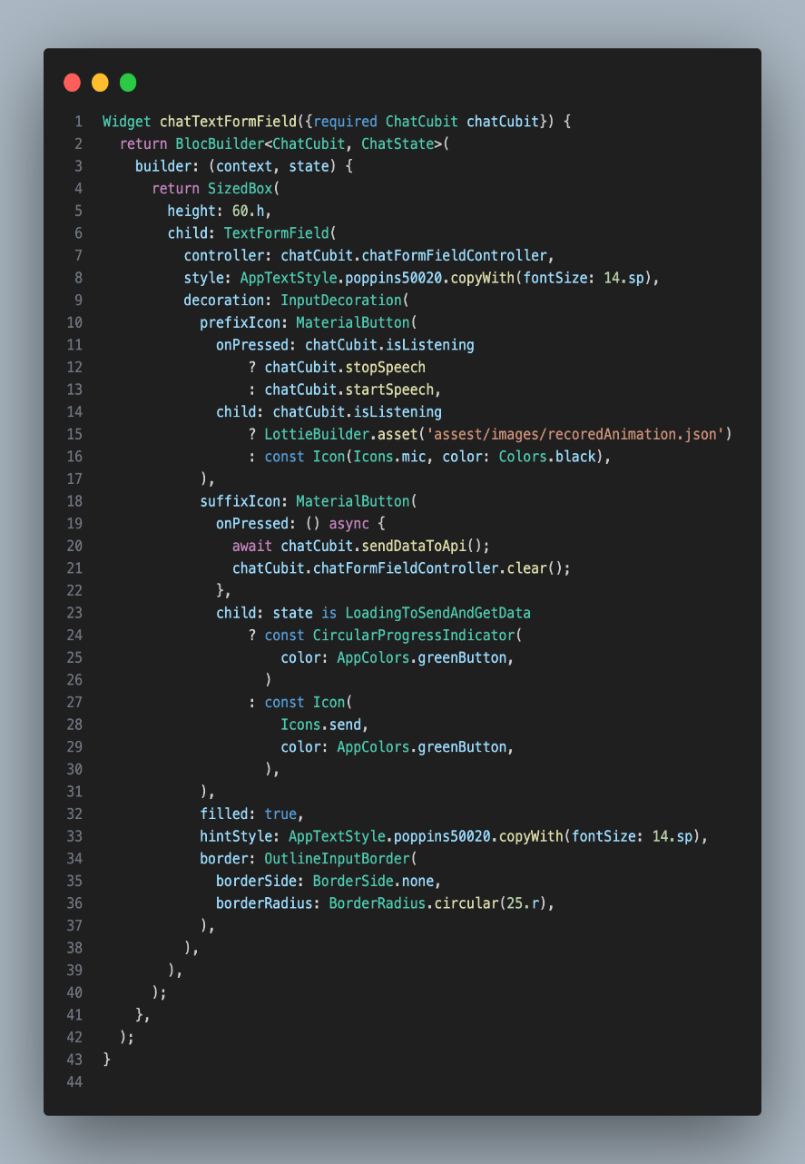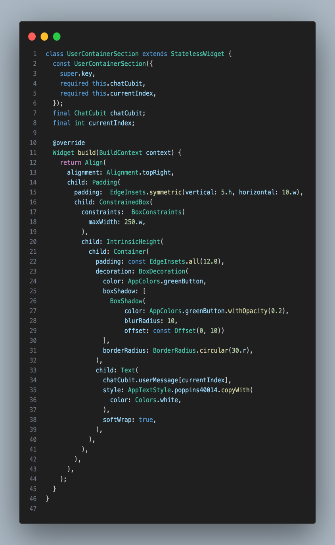

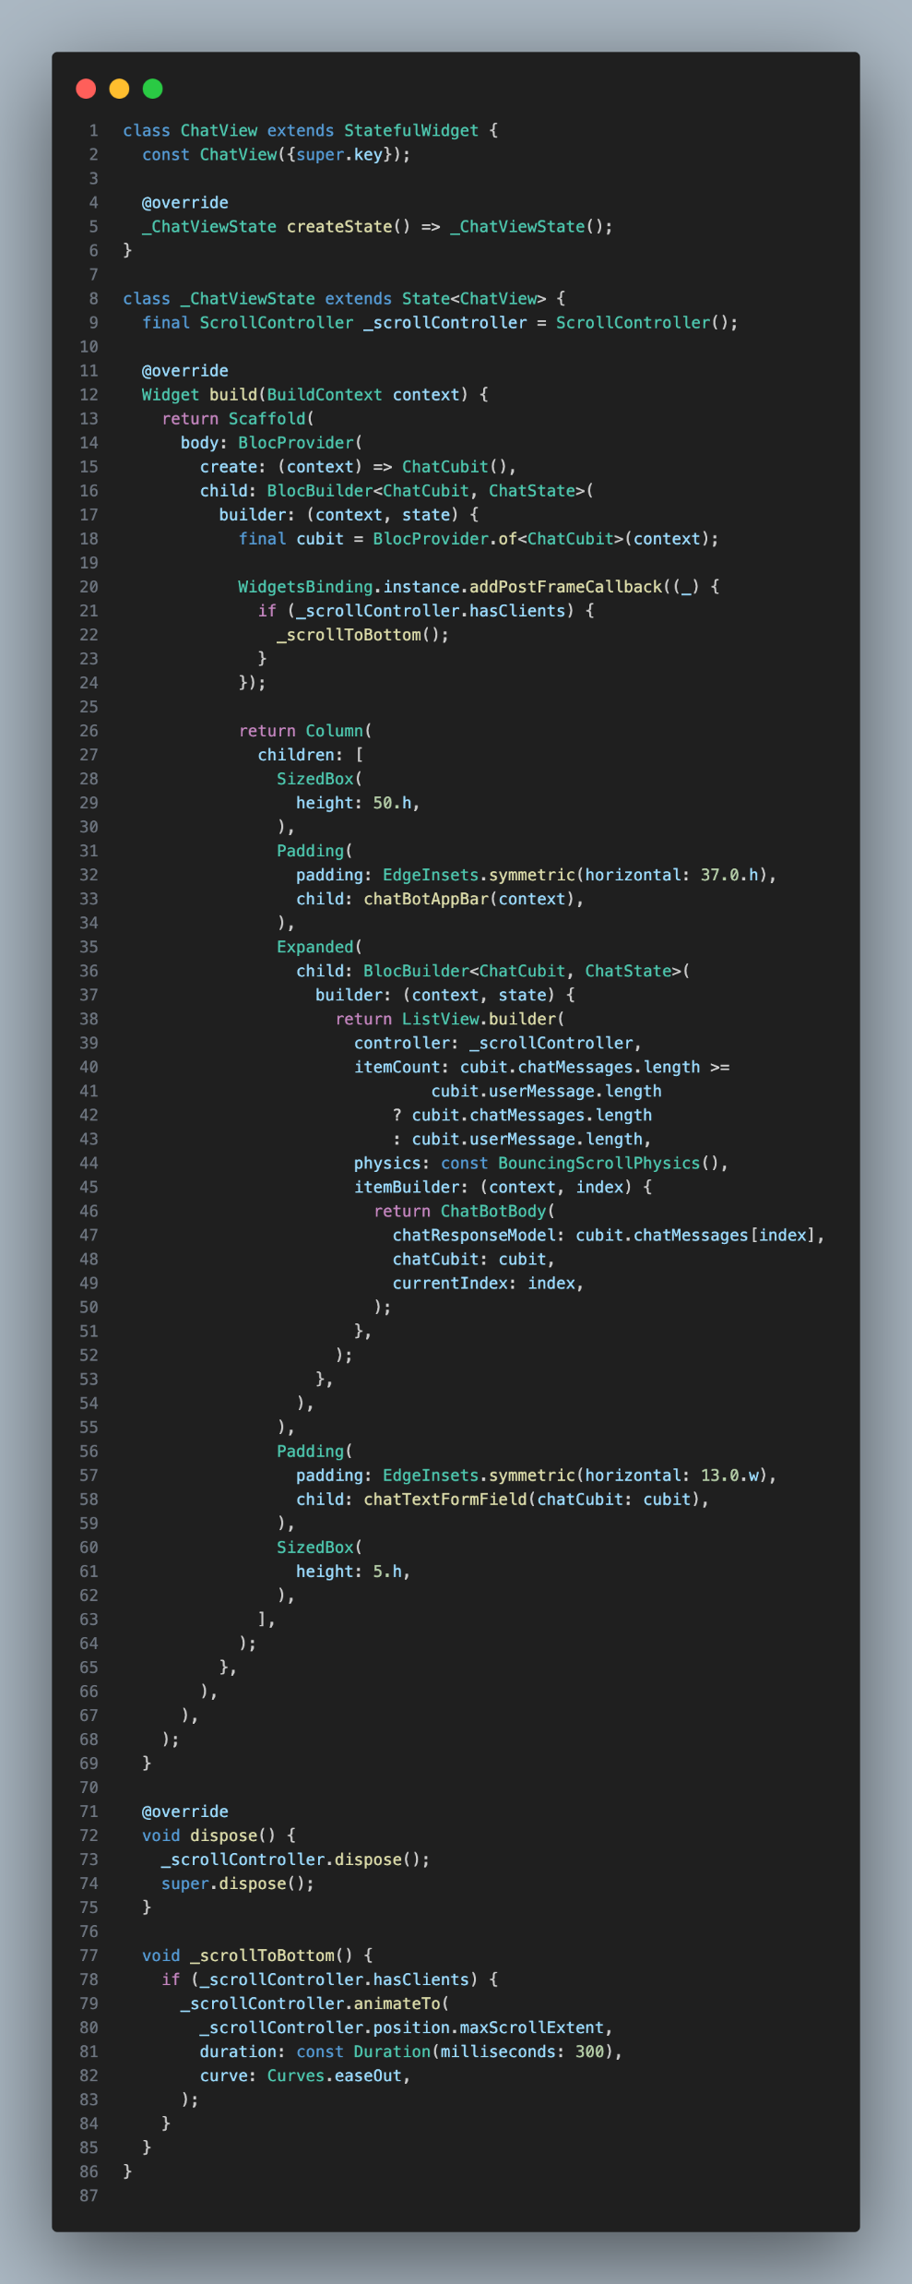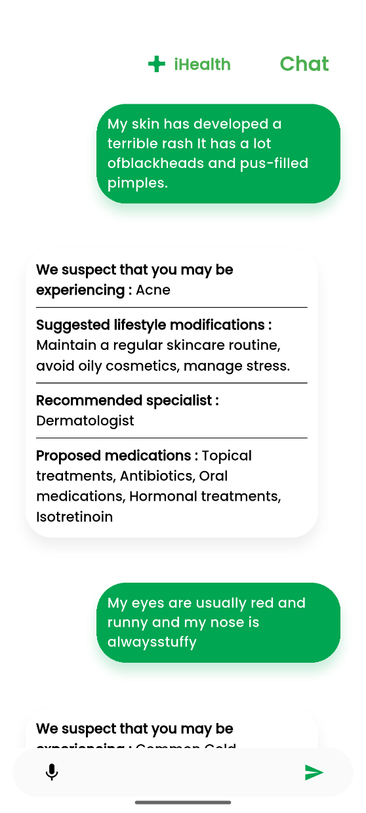

Summary of chat pot page

The Chatbot page allows users to describe their symptoms and receive instant medical guidance. Users can type or speak their symptoms, and the chatbot responds with possible conditions, suggested lifestyle modifications, recommended specialists, and proposed medications. This helps users quickly get relevant health information and advice based on their input.

Dictionary

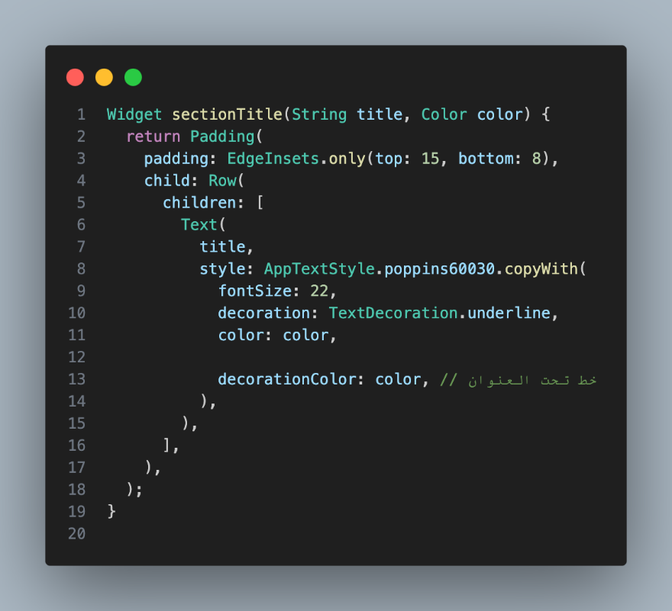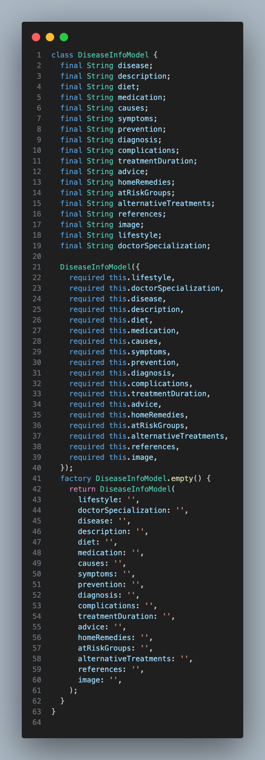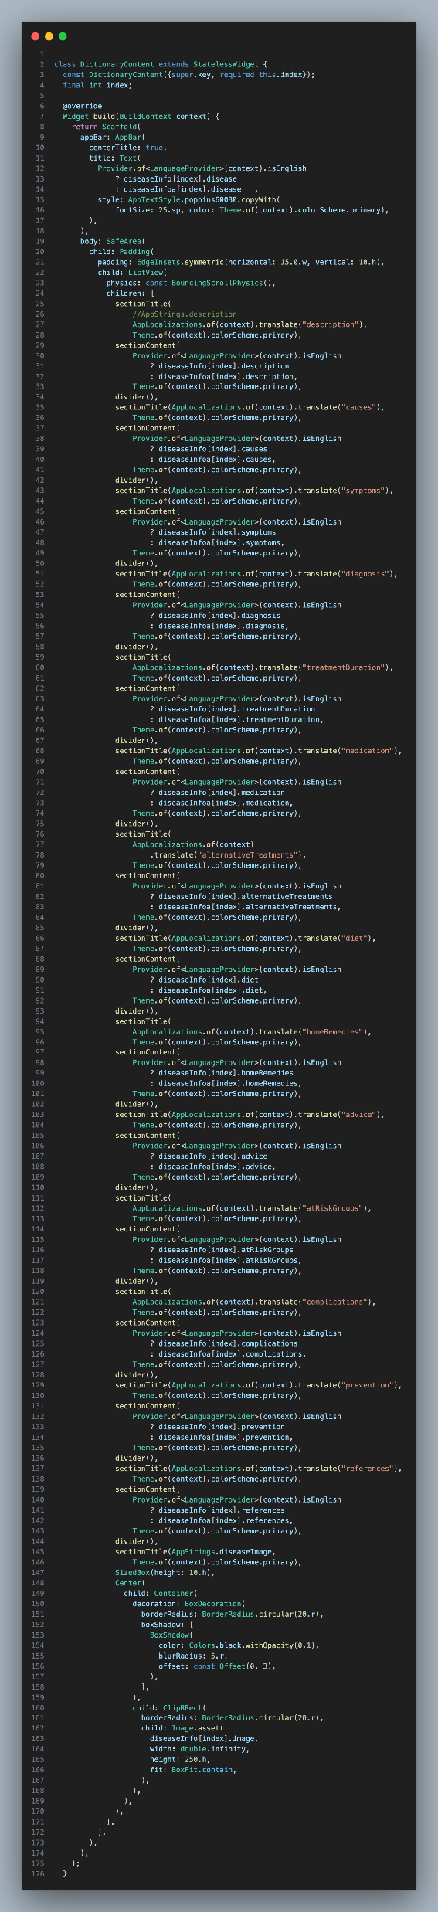

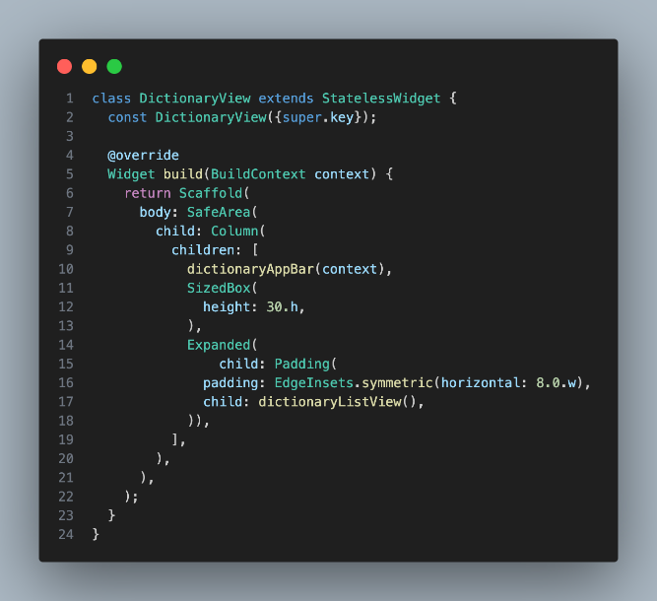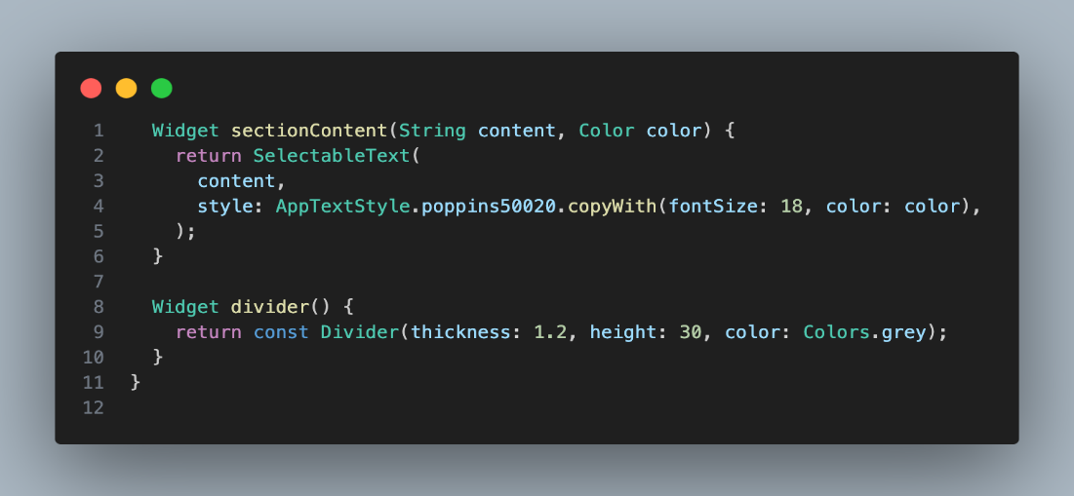

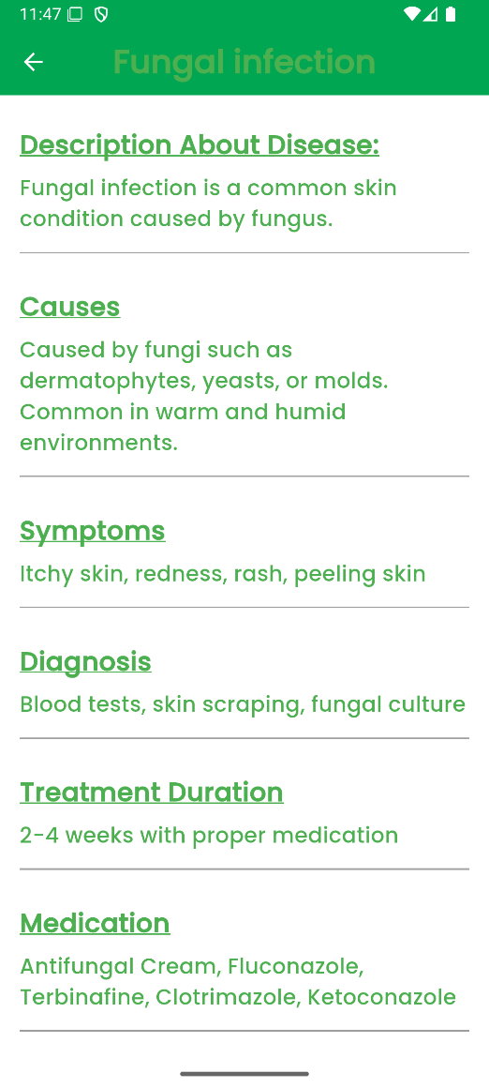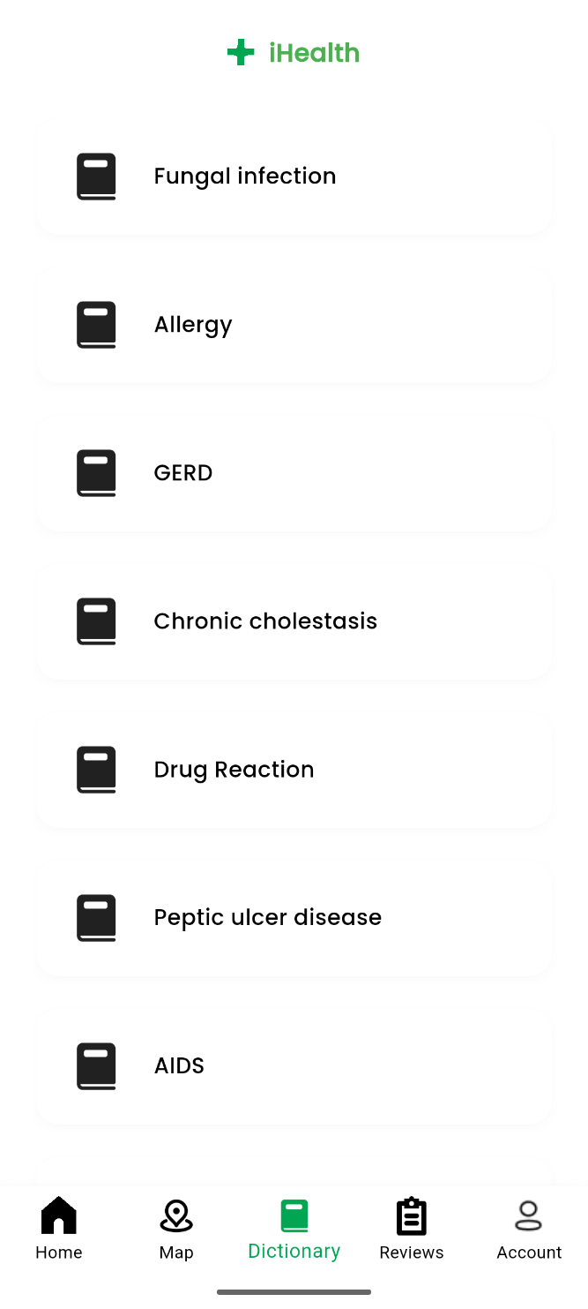

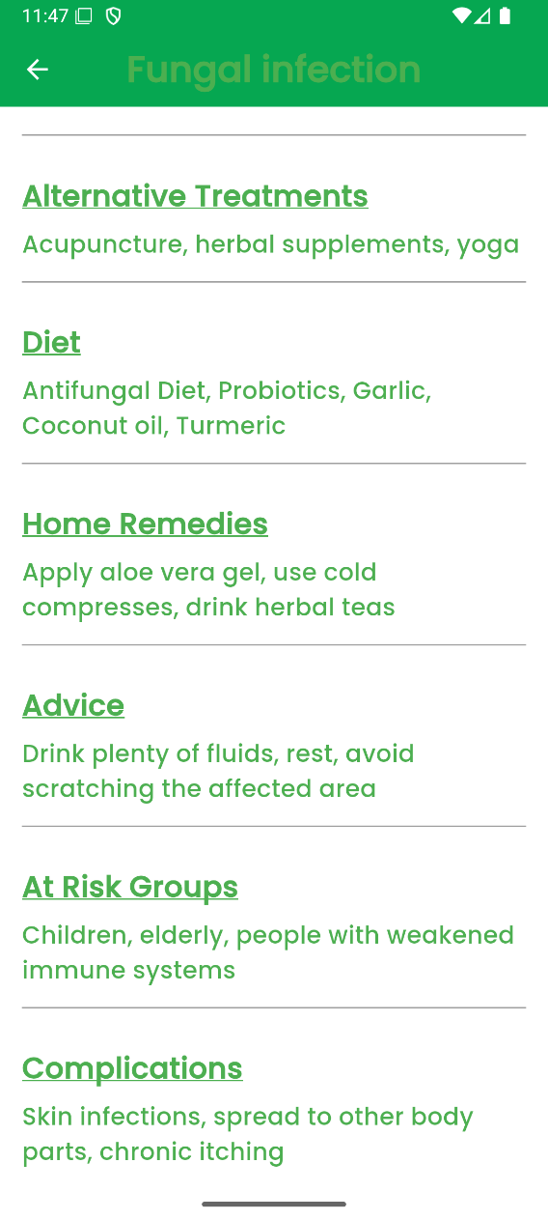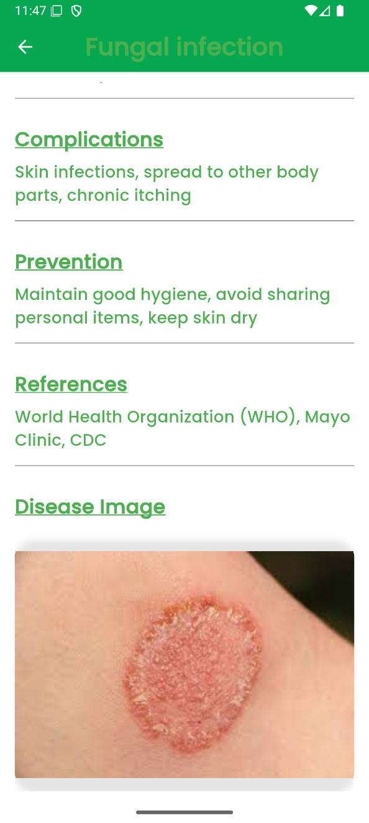

Summary of Dictionary

The Dictionary page in the app provides users with detailed information about various diseases and medical conditions. Users can browse a list of diseases and select any item to view its description, causes, symptoms, diagnosis, treatment options, home remedies, complications, prevention tips, and references. This helps users easily understand medical terms and conditions in a clear and organized

Sign in

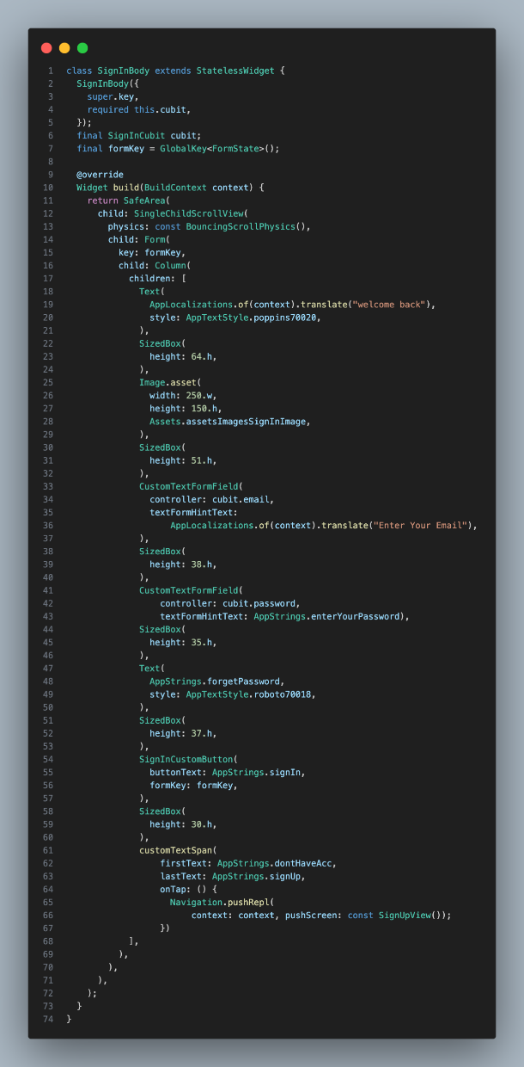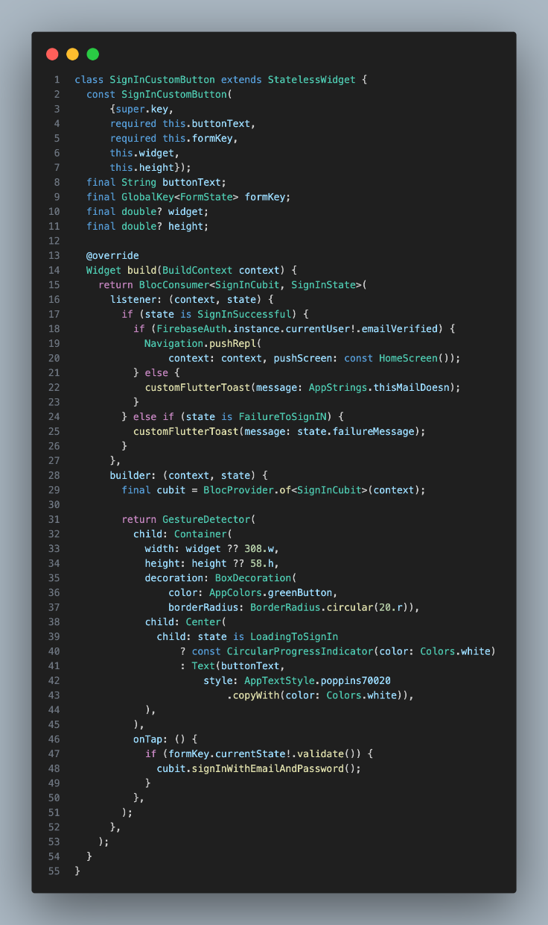

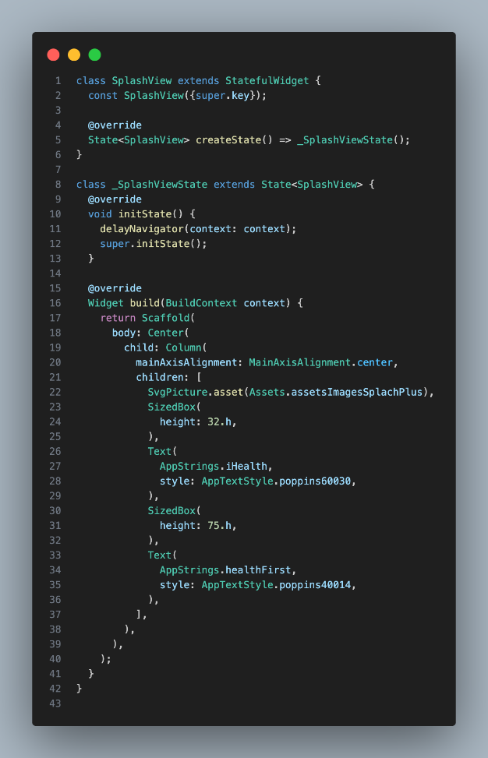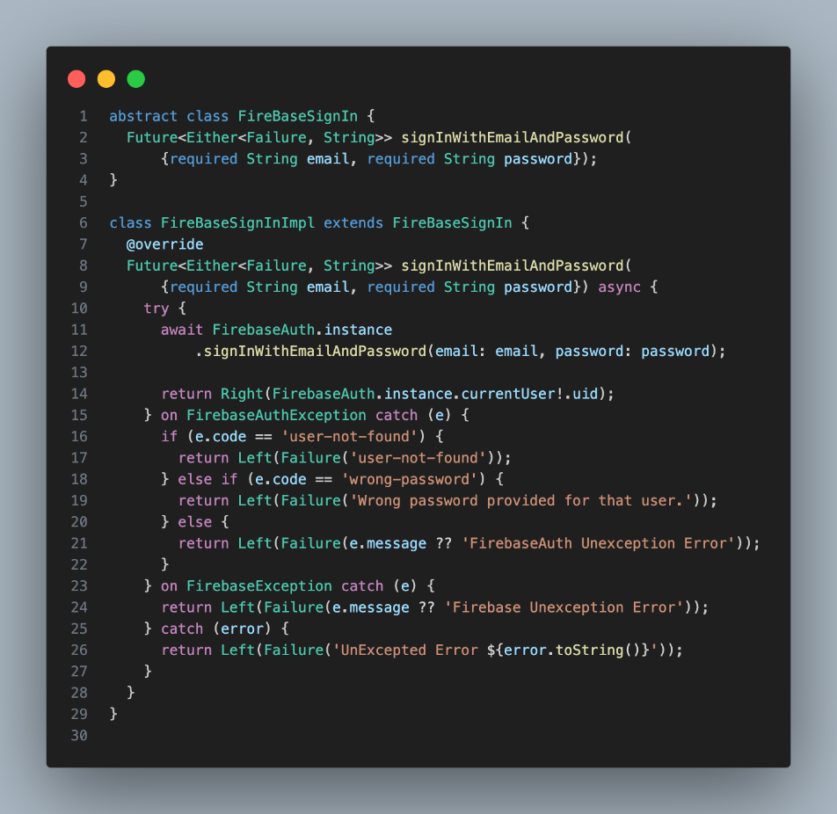

Summary of sign in



* User Authentication The central purpose of a login page is to authenticate users by verifying their identity through credentials such as username/email and password. This process ensures that only authorized users can access the application.

Sign up

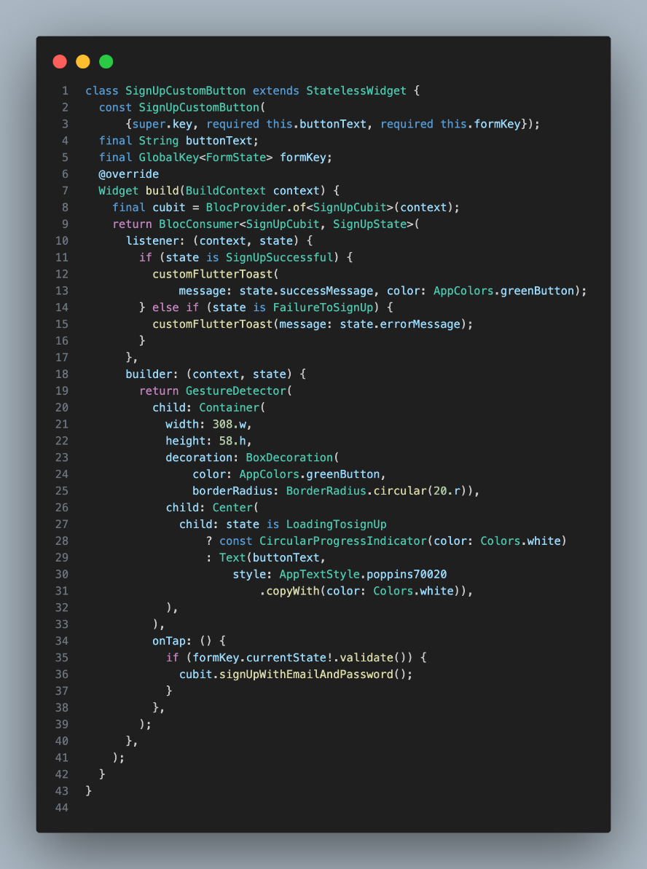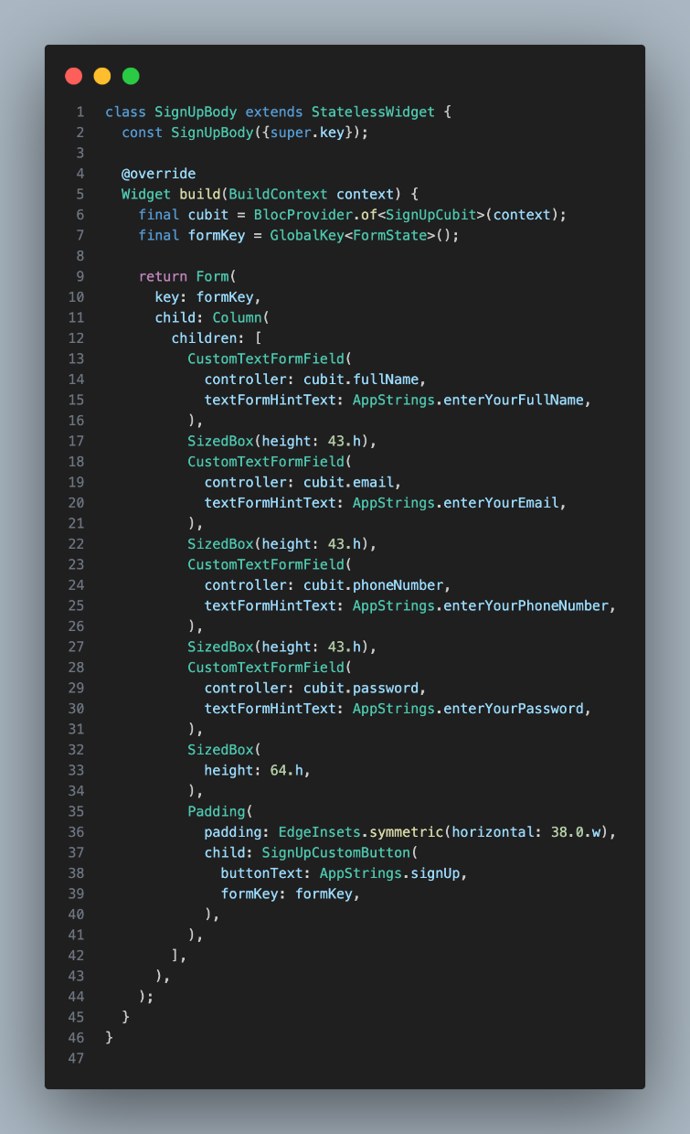

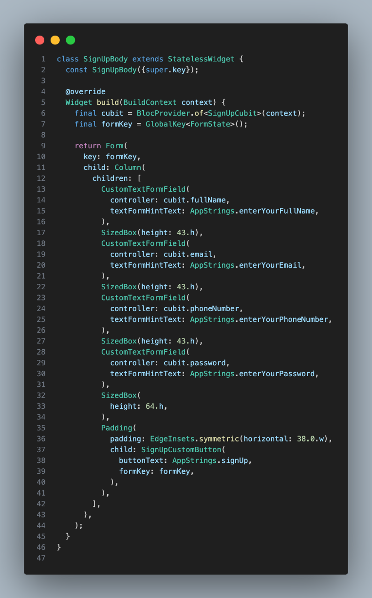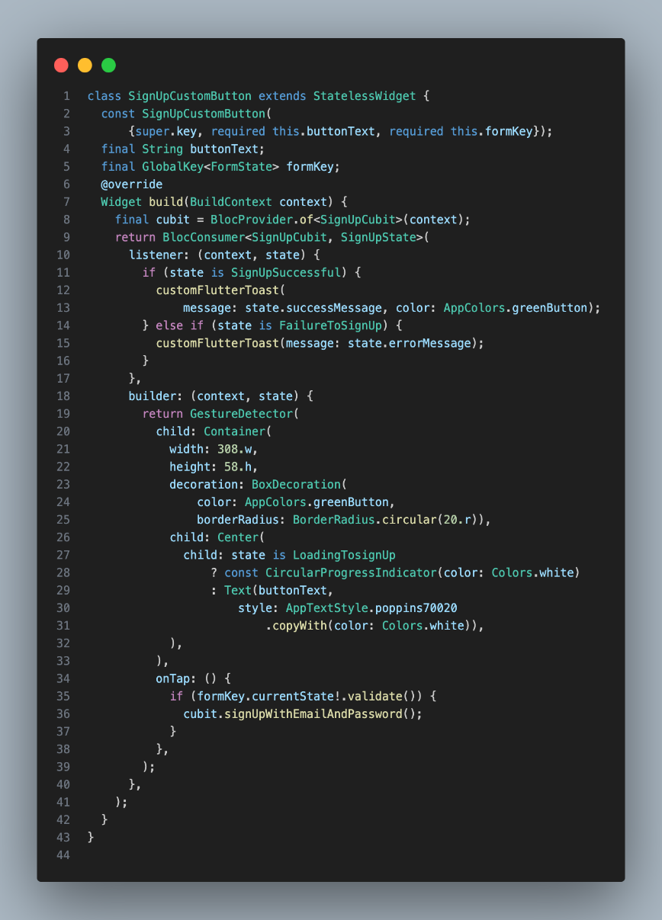

Summary of sign up

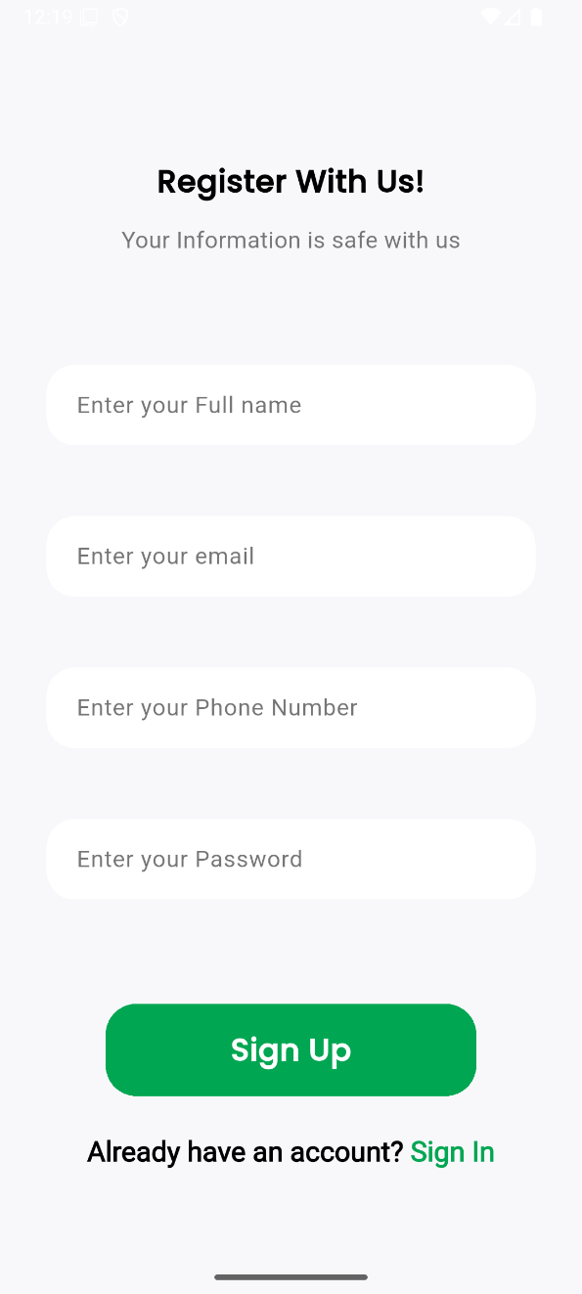

The primary function is to capture user information such as username, email, password, etc., and store it securely in a database. This information is typically used for authentication and personalization purposes and validate the user input to ensure that the entered data meets certain criteria, such as valid email format, strong password requirements, etc. This helps in maintaining data integrity and security

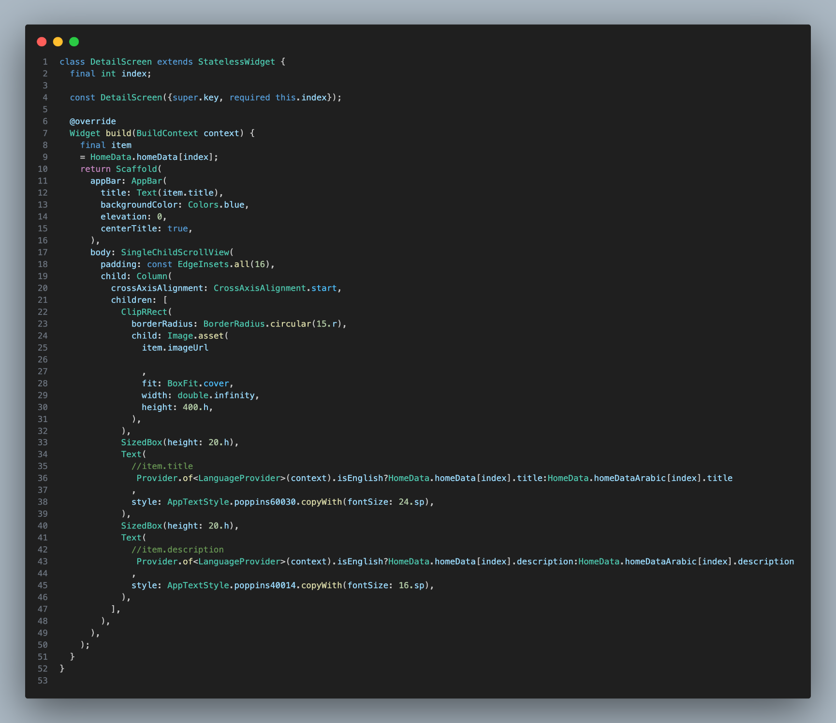Home page

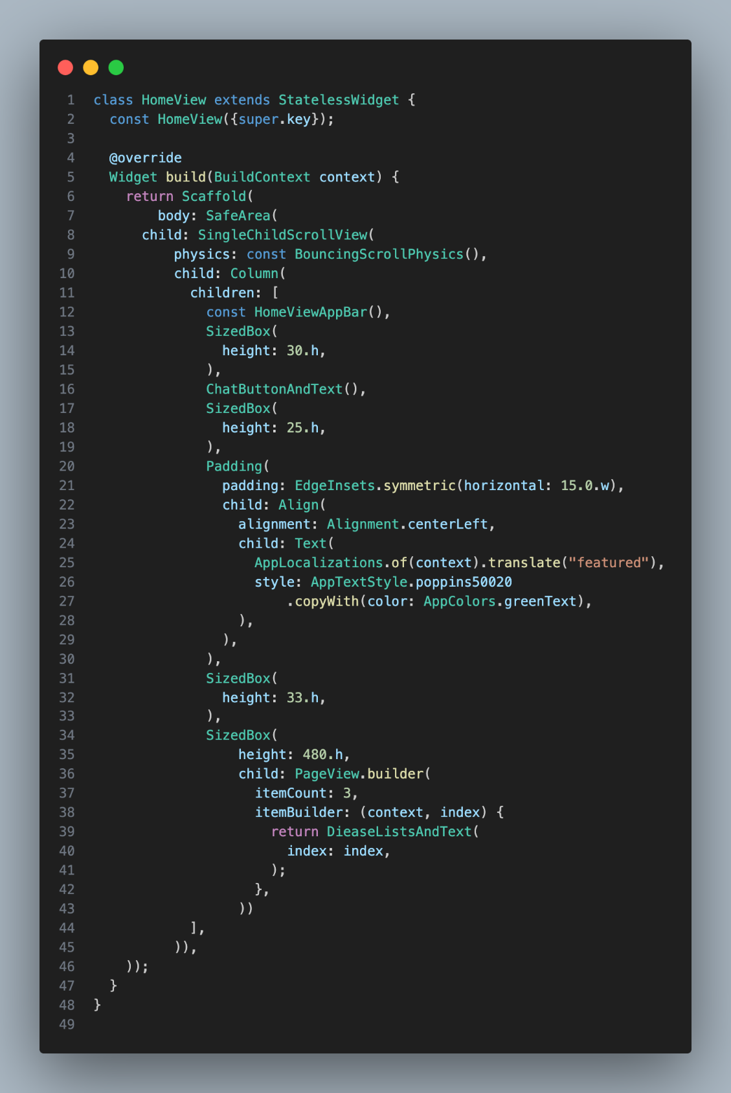

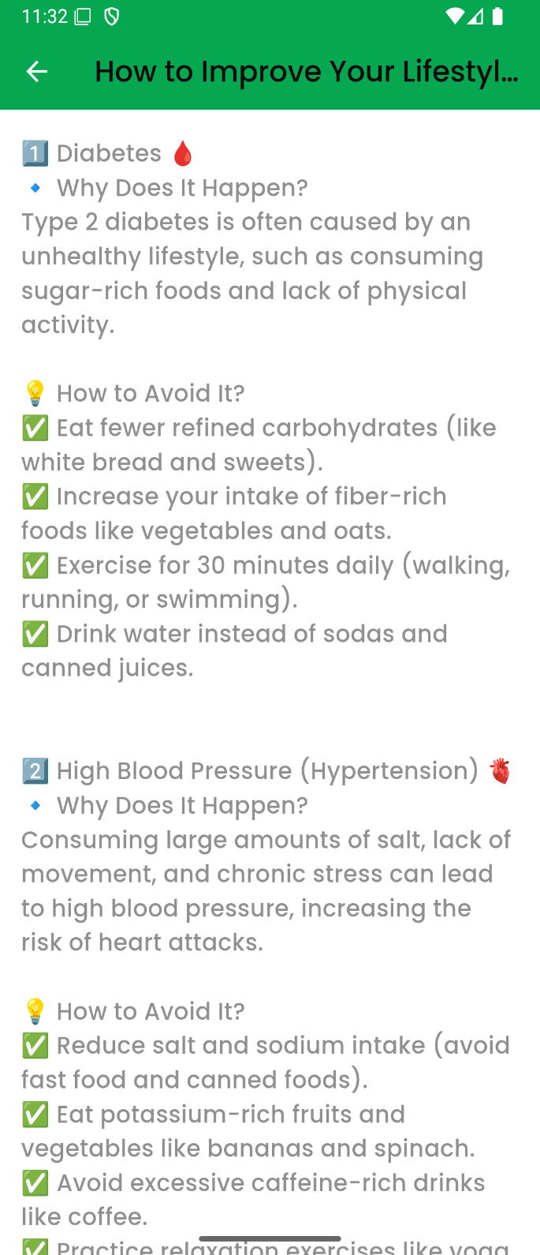

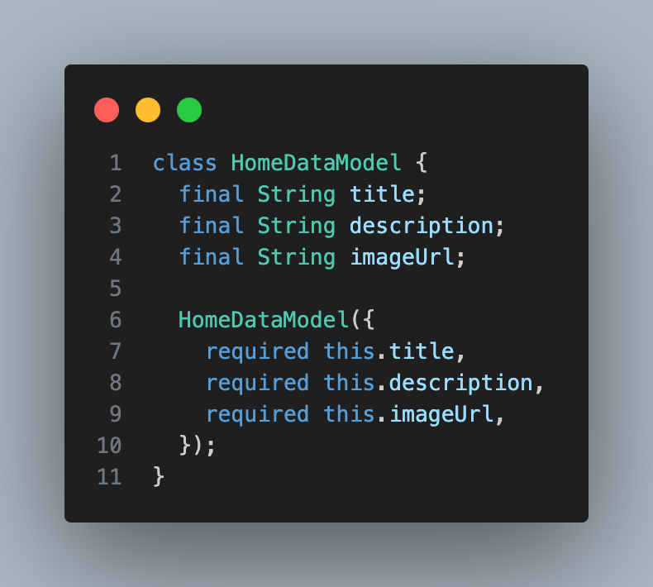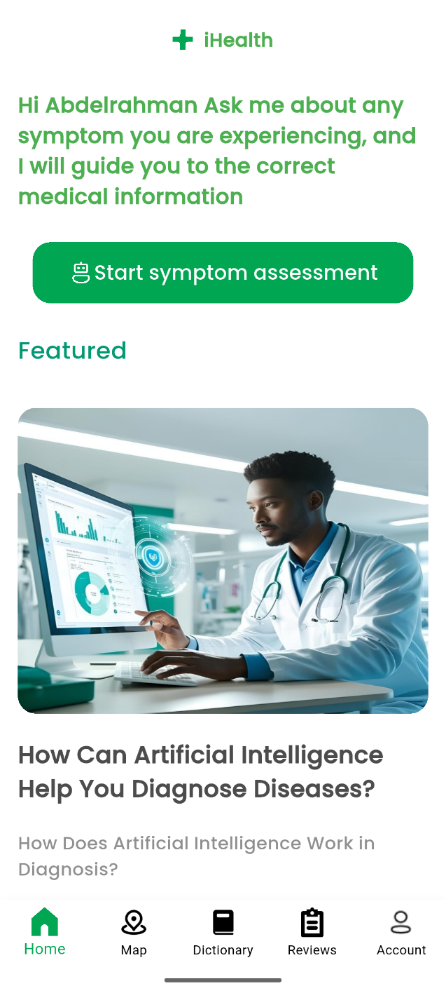

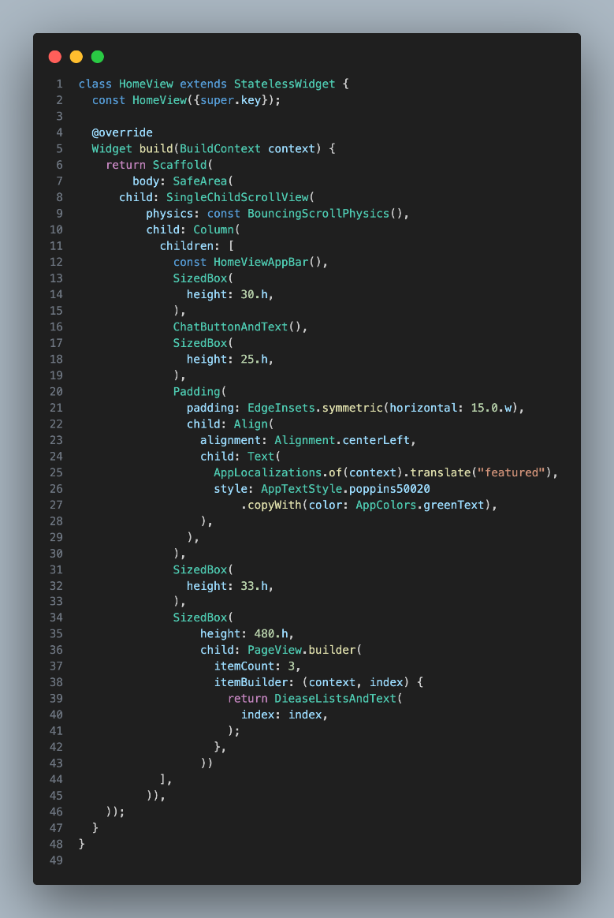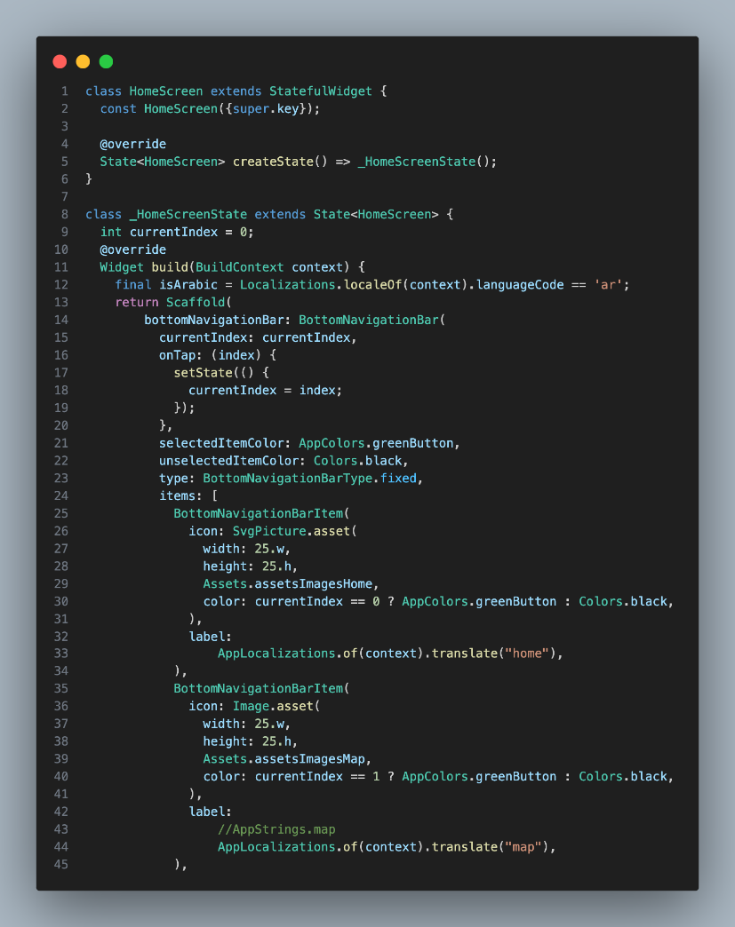

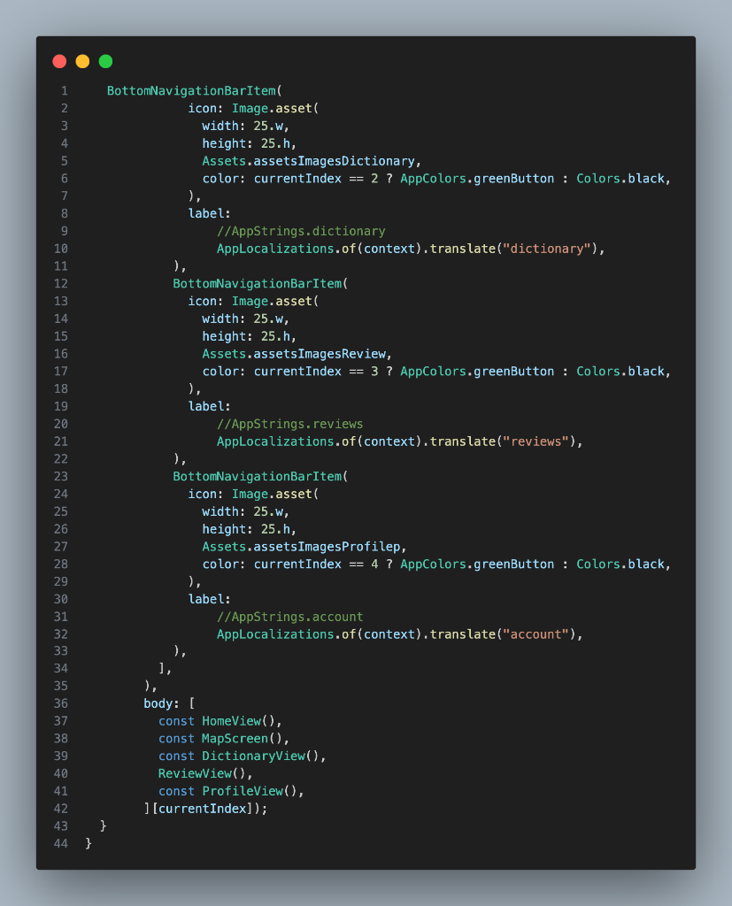

Summary of home page

* The Home page in the app serves as the main dashboard for users. It welcomes the user, offers a quick start for symptom assessment, and highlights featured health articles and tips. The page provides easy navigation to other sections like the map, dictionary, reviews, and account through the bottom navigation bar. It is designed to help users quickly access important health information and tools.

Map

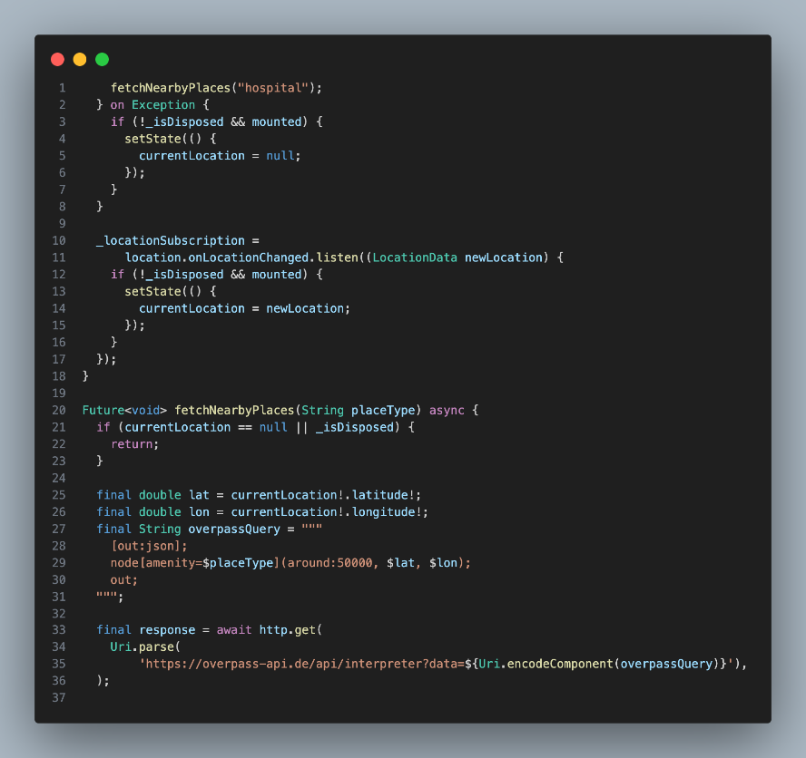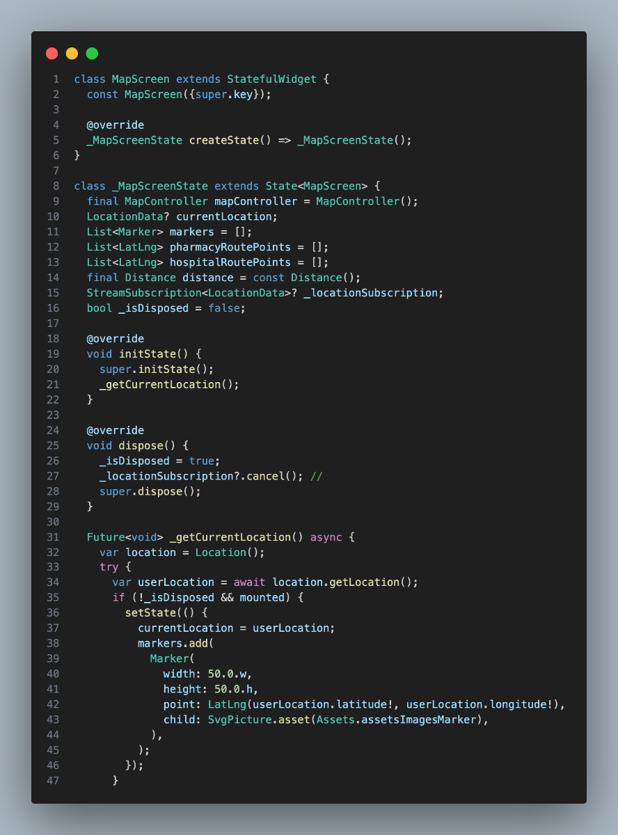

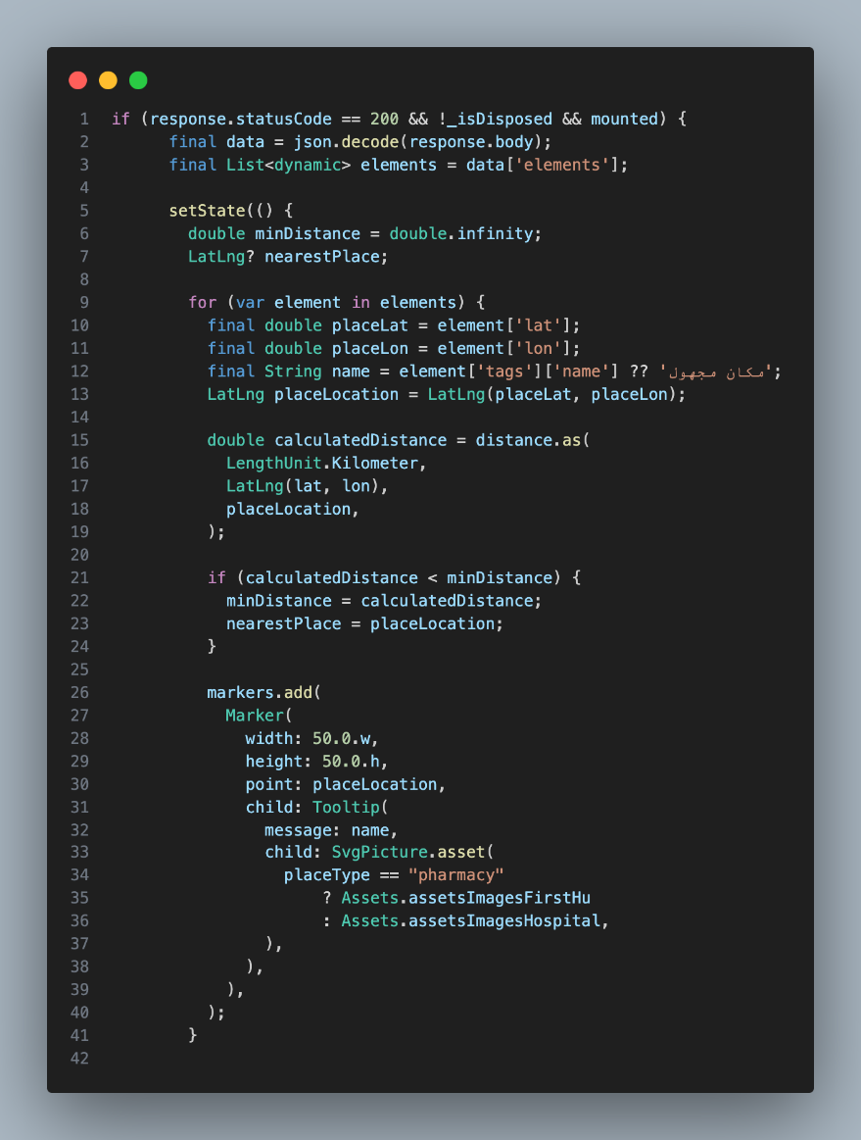

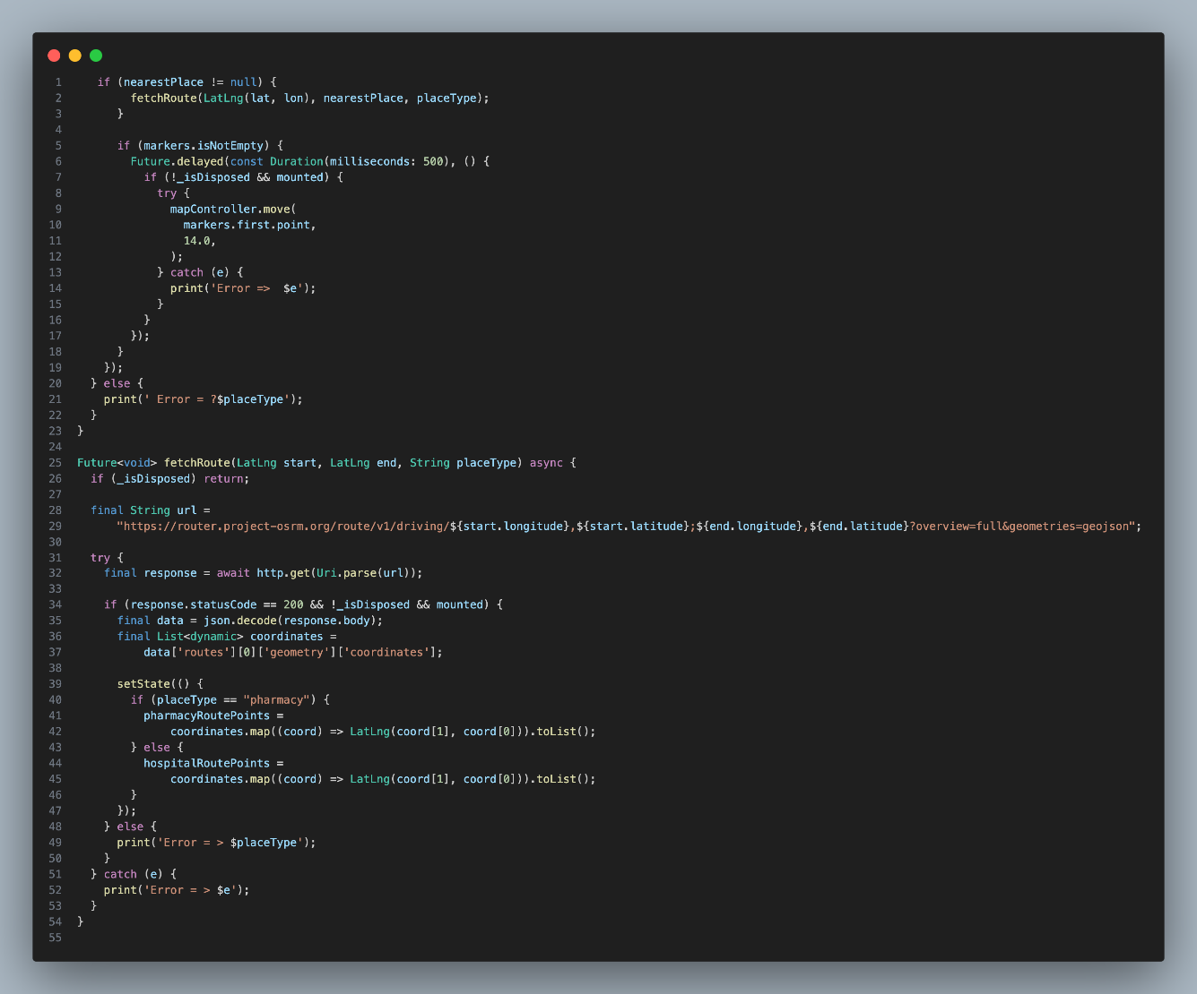

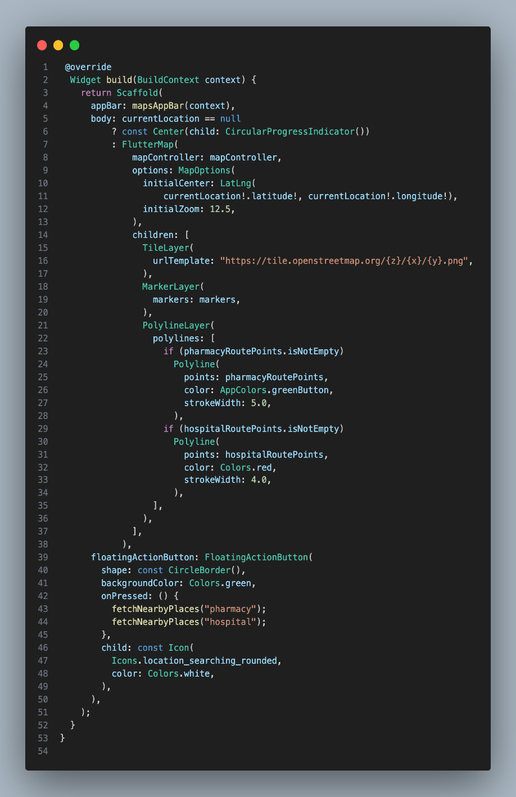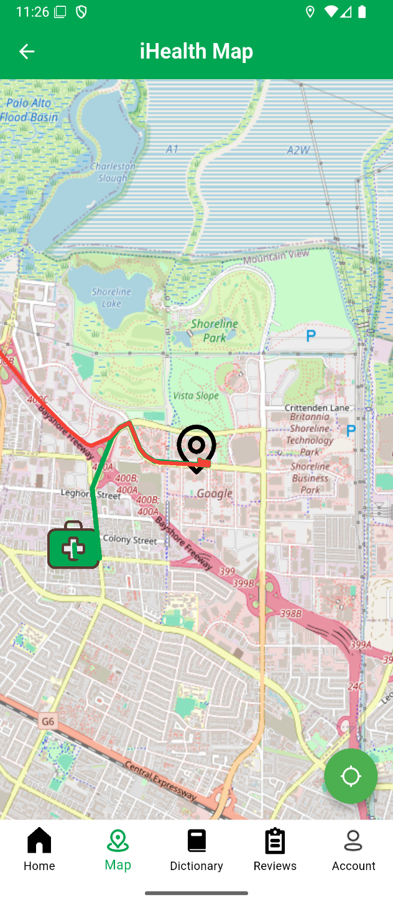

Summary of map

The Map page in the app helps users locate nearby healthcare facilities, such as hospitals and clinics. It displays an interactive map with markers for important medical locations, making it easy for users to find and navigate to the nearest healthcare services. The page also provides quick access to other main sections of the app through the bottom navigation bar.

Profile

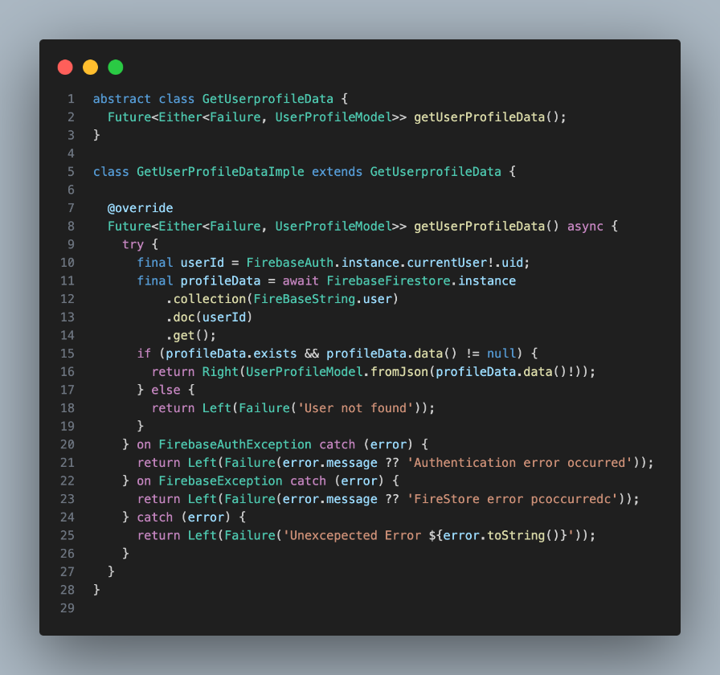

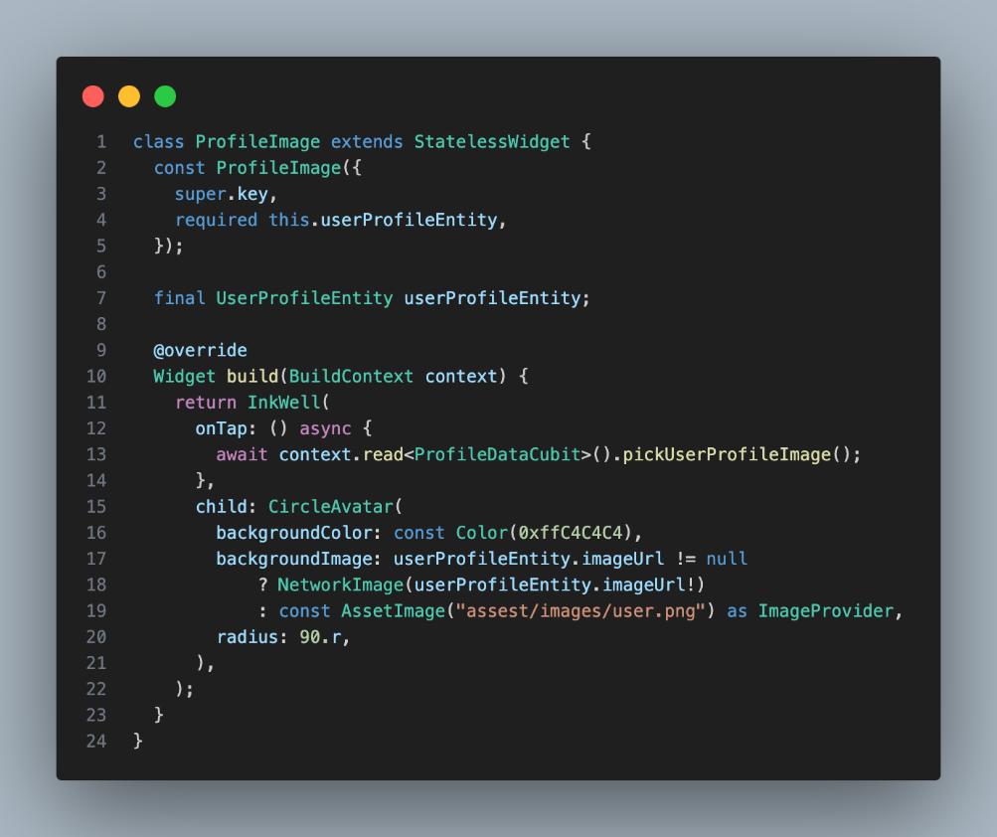

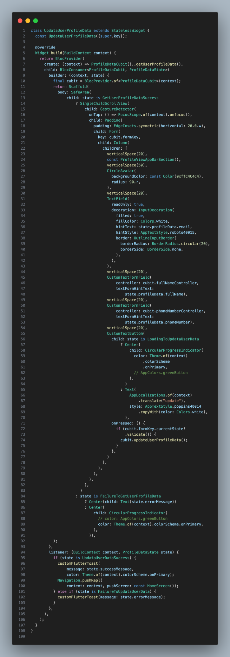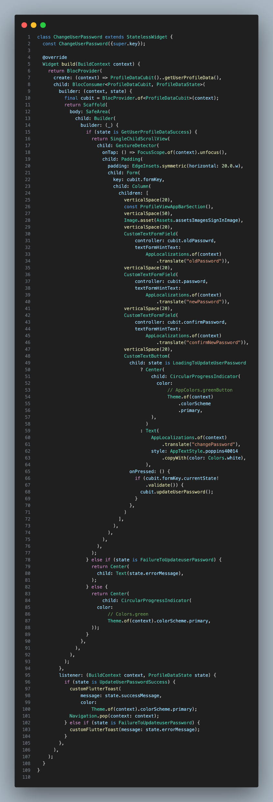

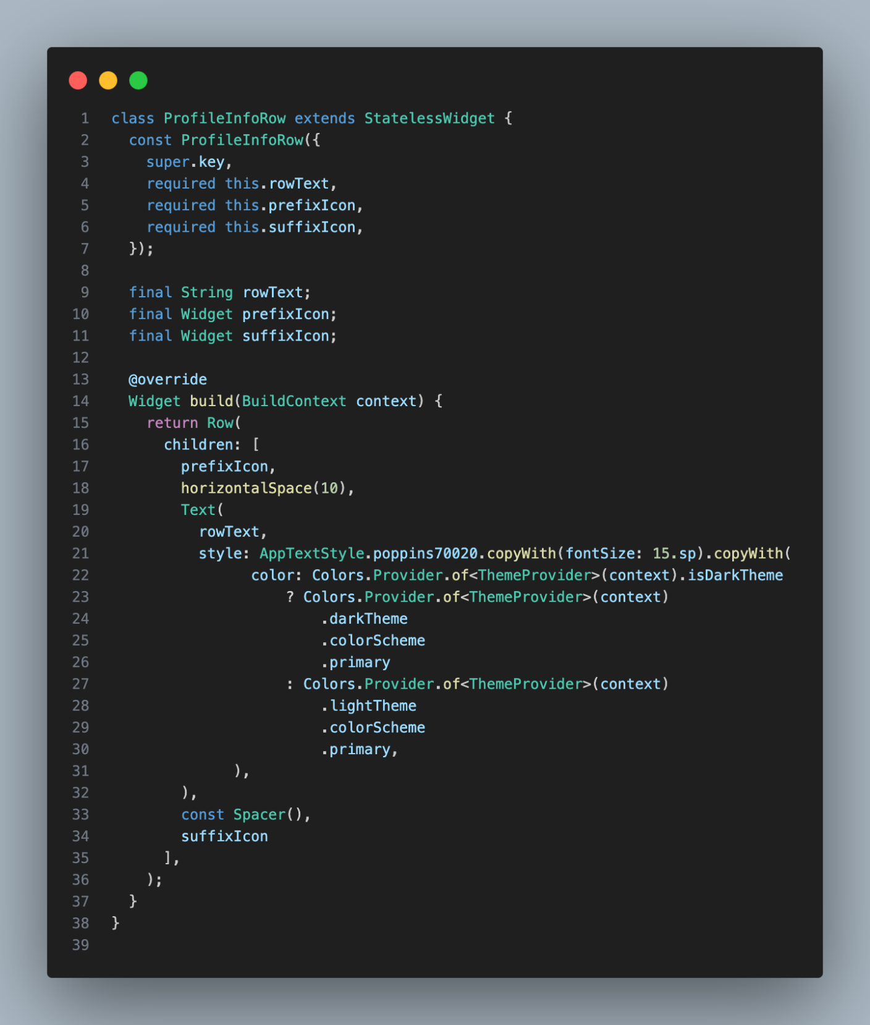

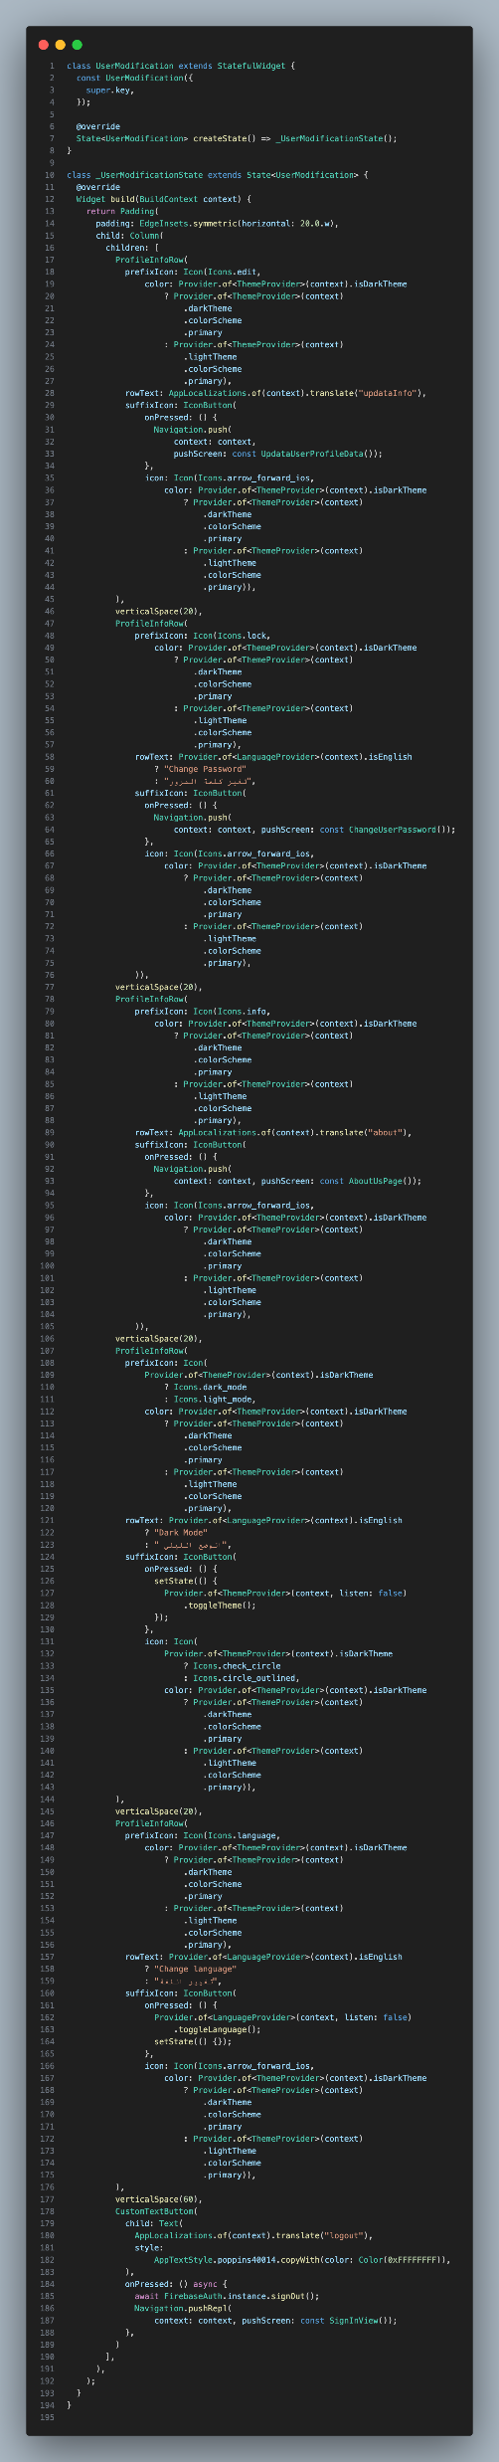

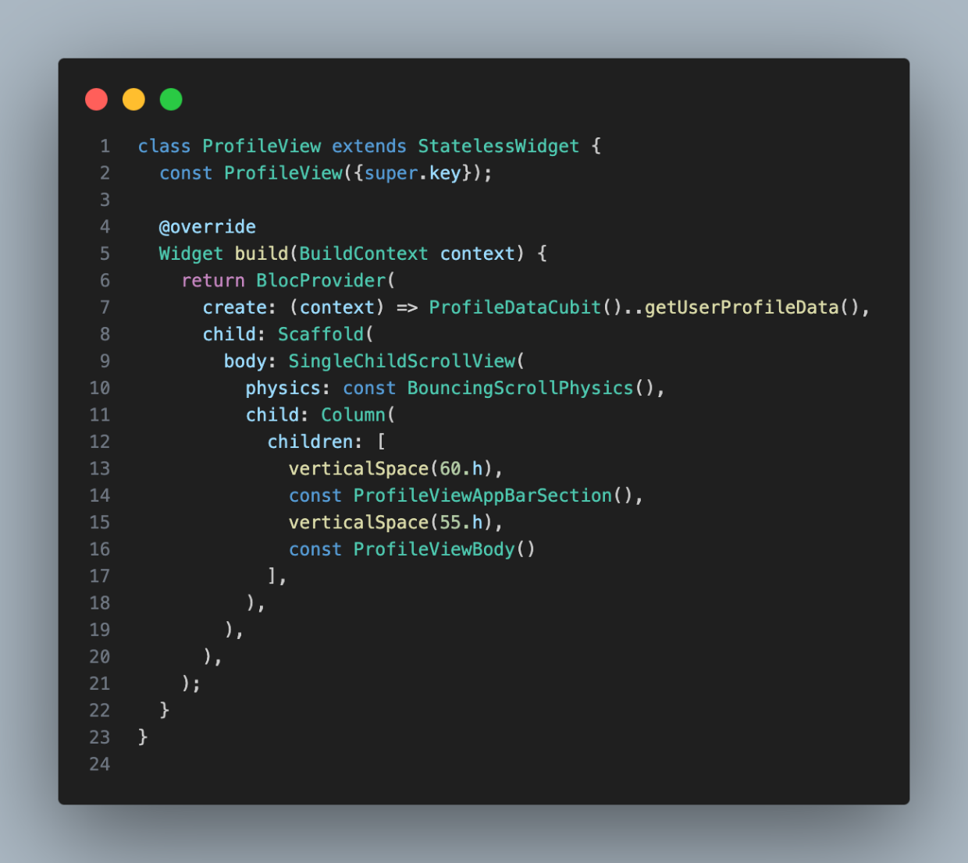



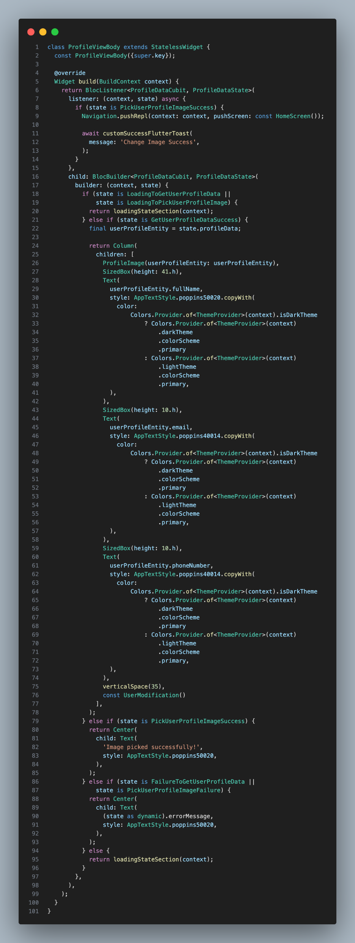

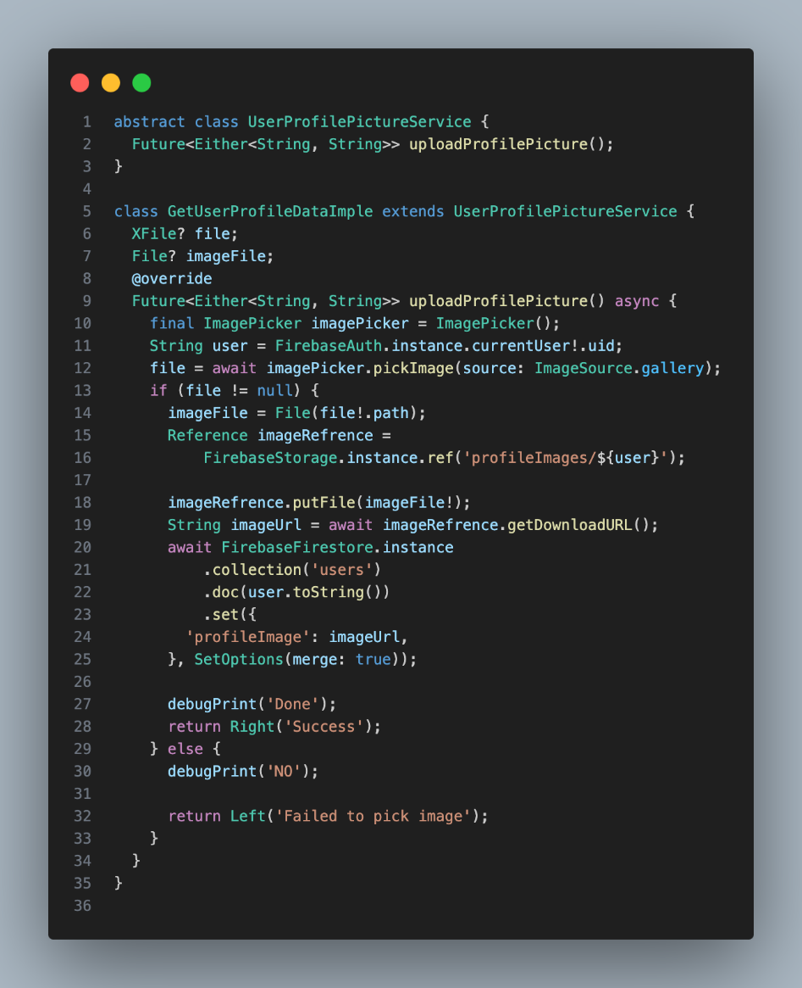

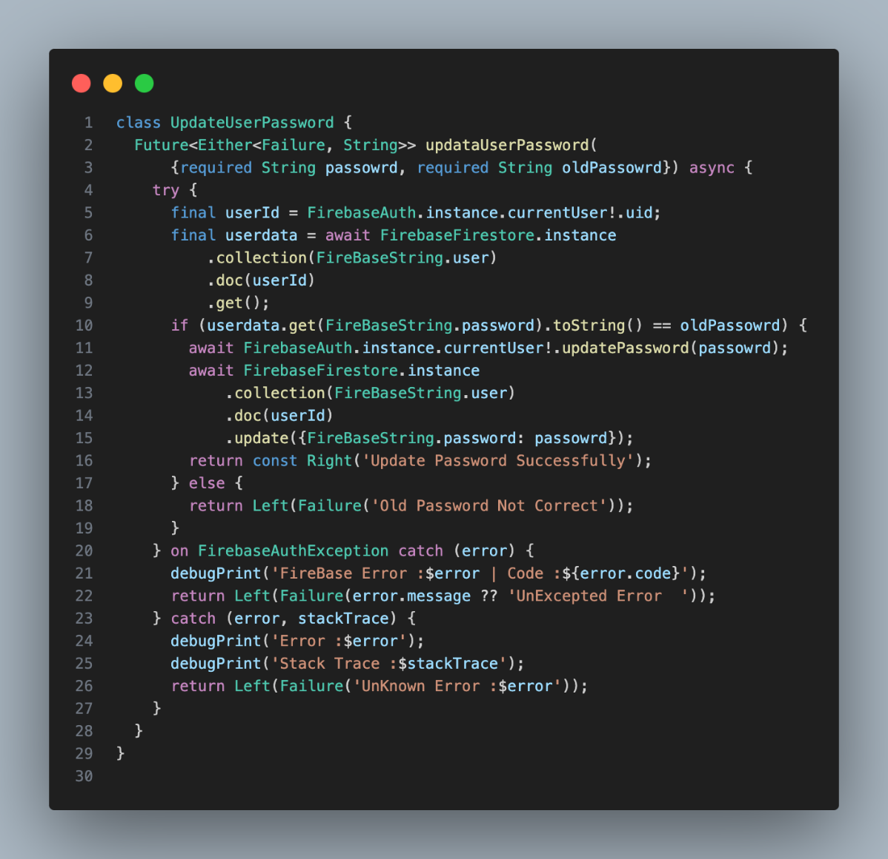

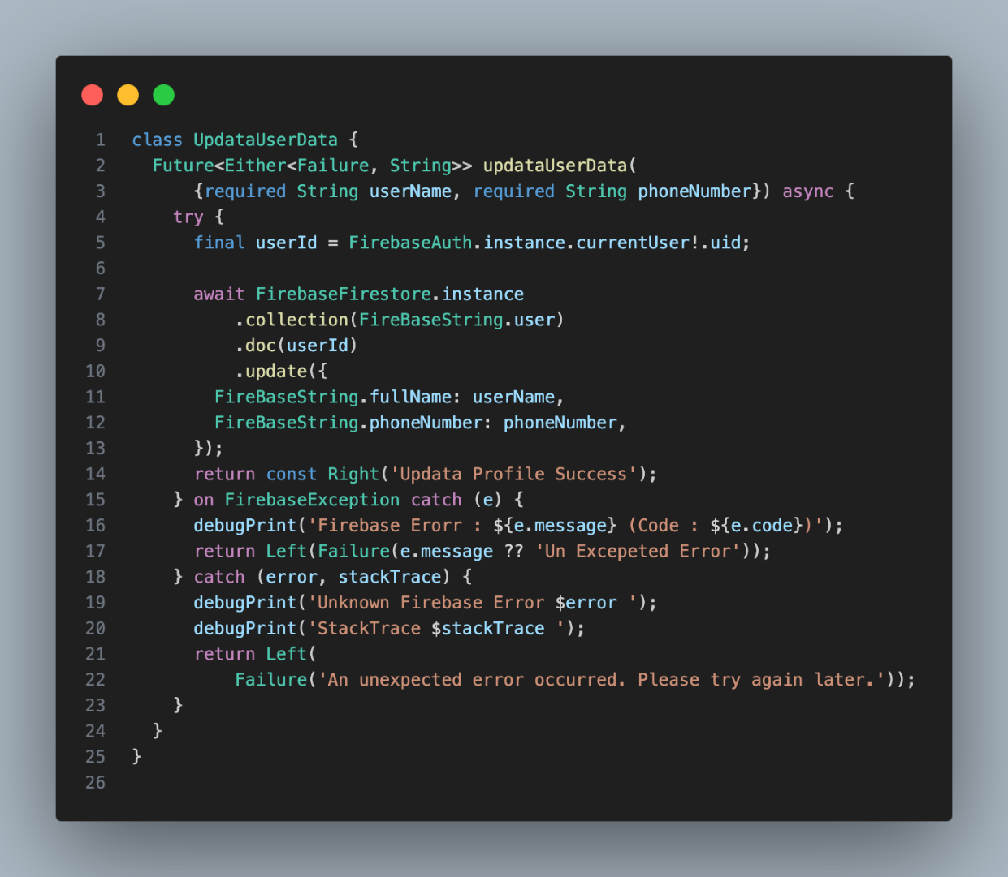

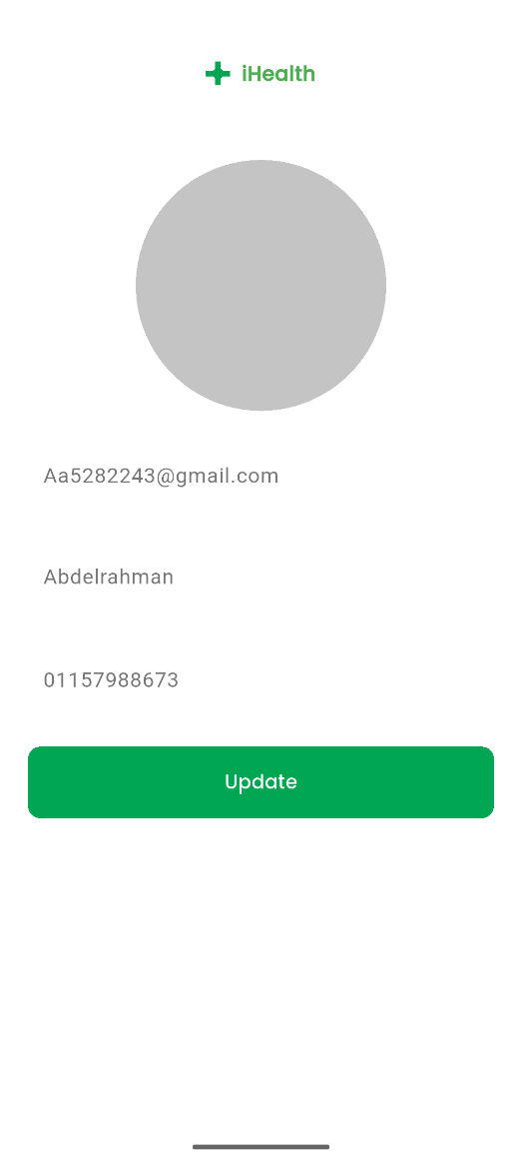

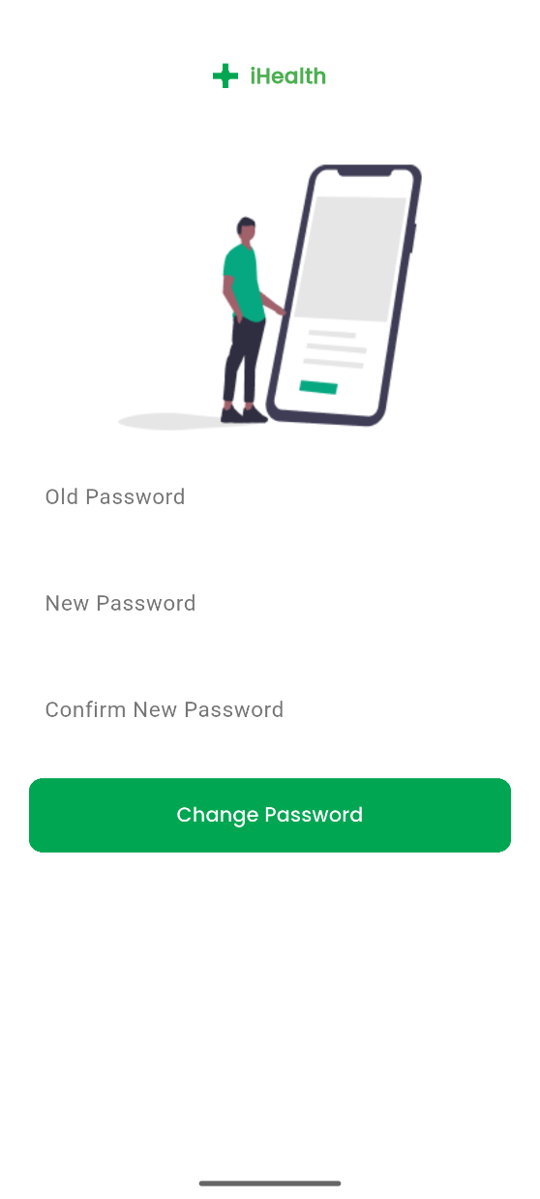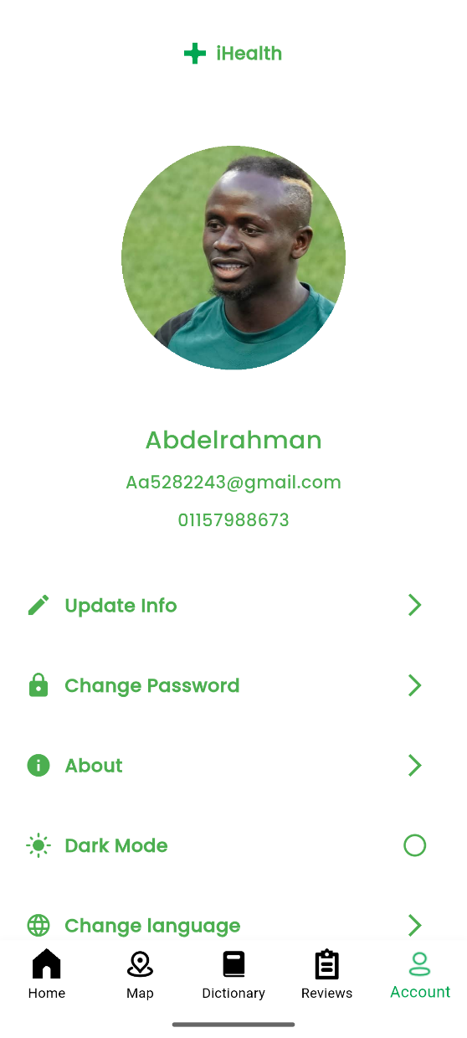

Summary of profile

* The Profile page allows users to view and manage their personal information, such as name, email, and phone number. Users can update their details, change their password, switch between dark and light mode, and change the app language. The page also provides access to additional settings and information about the app.

Review

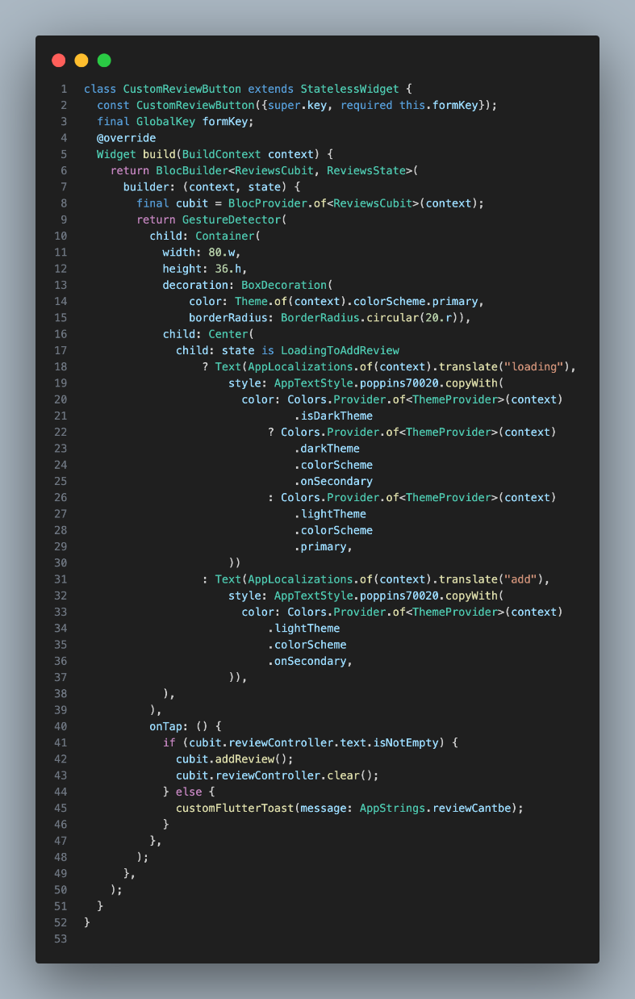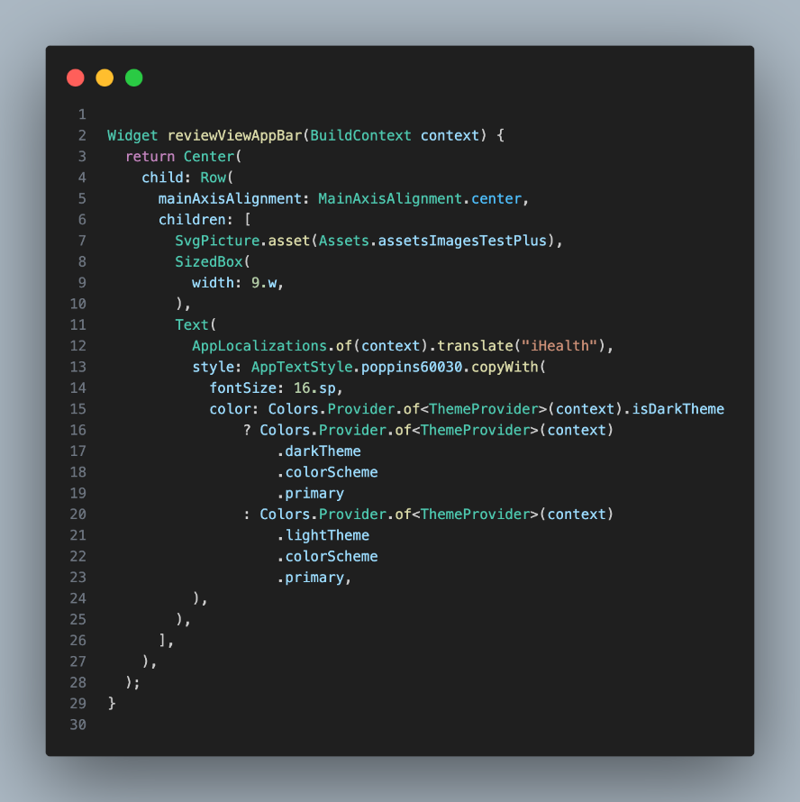

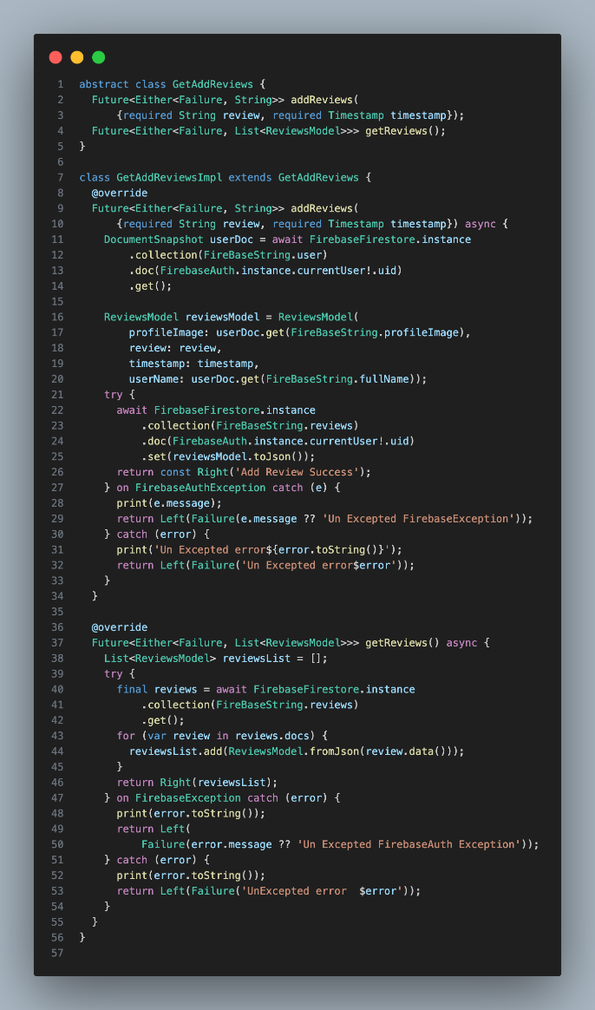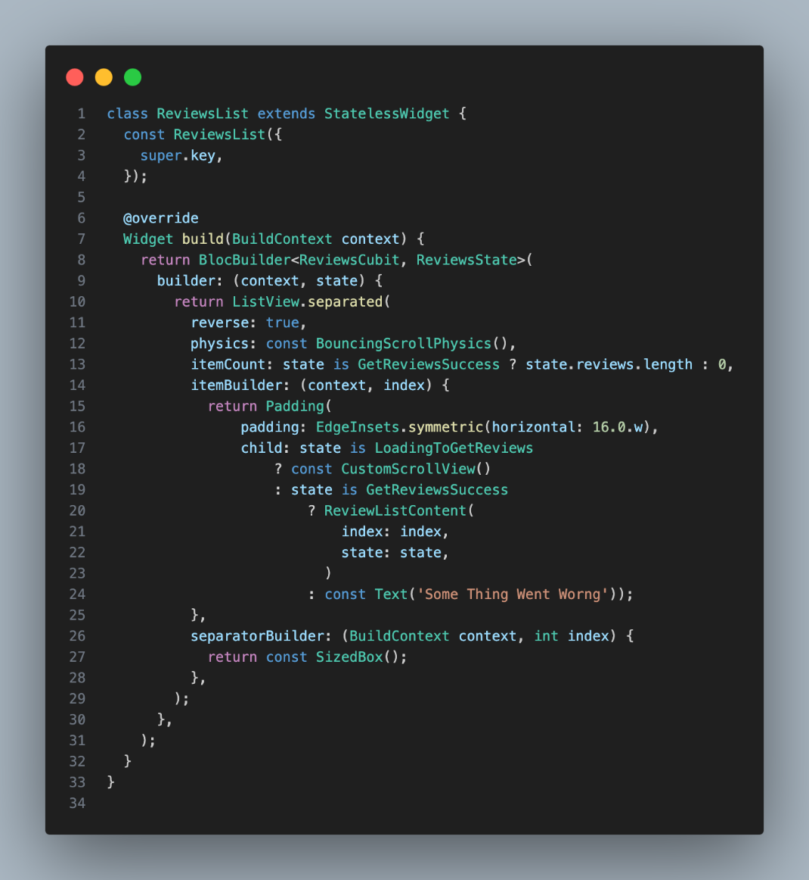

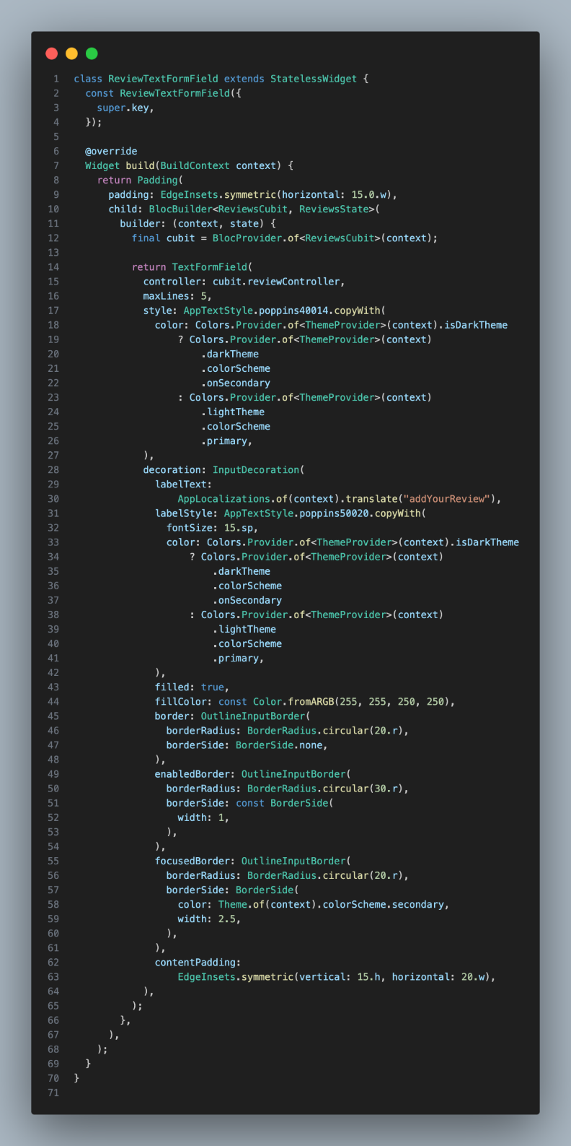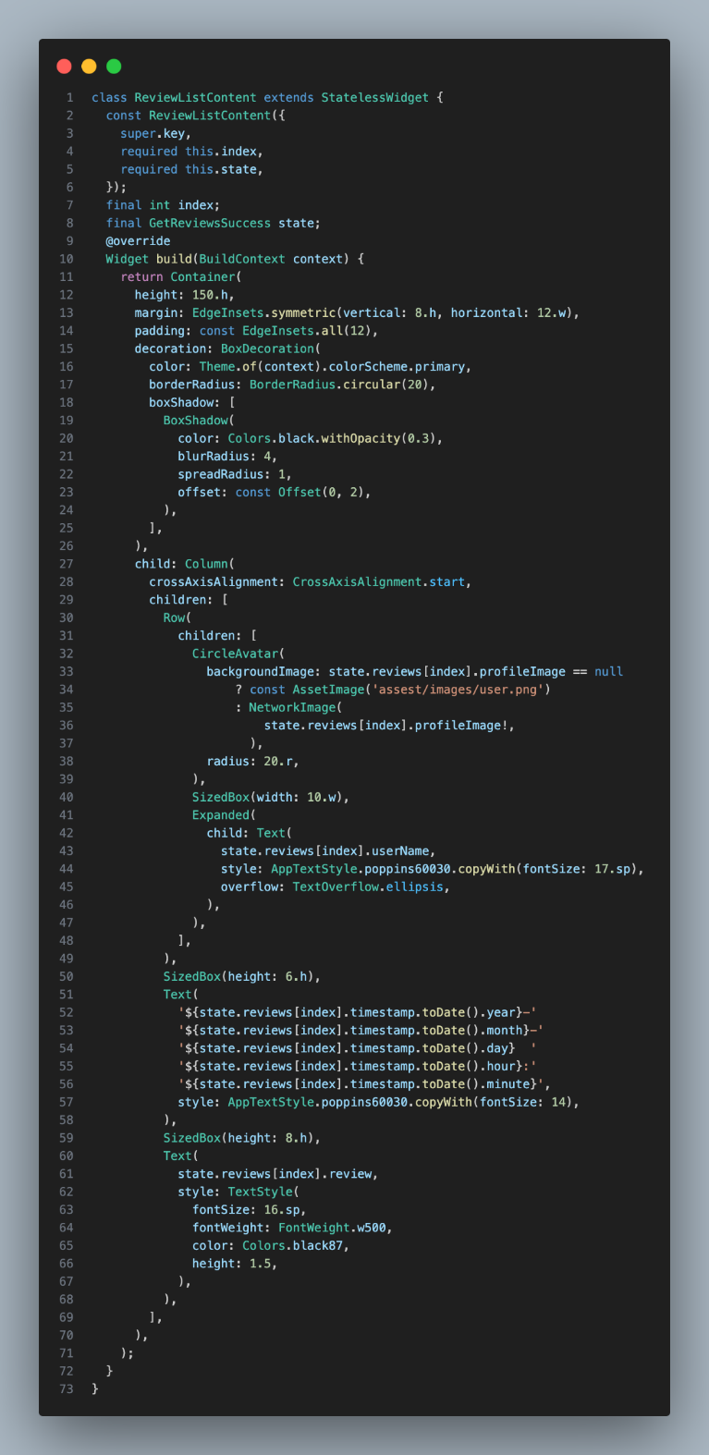

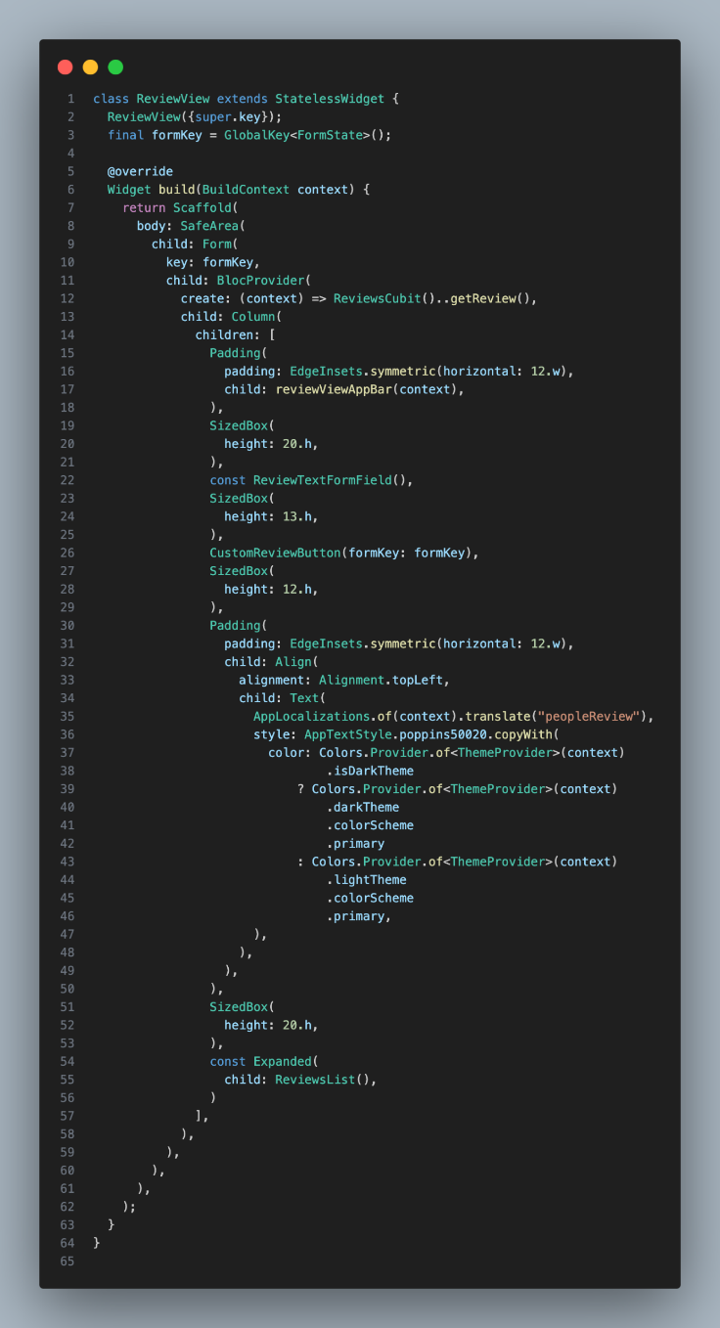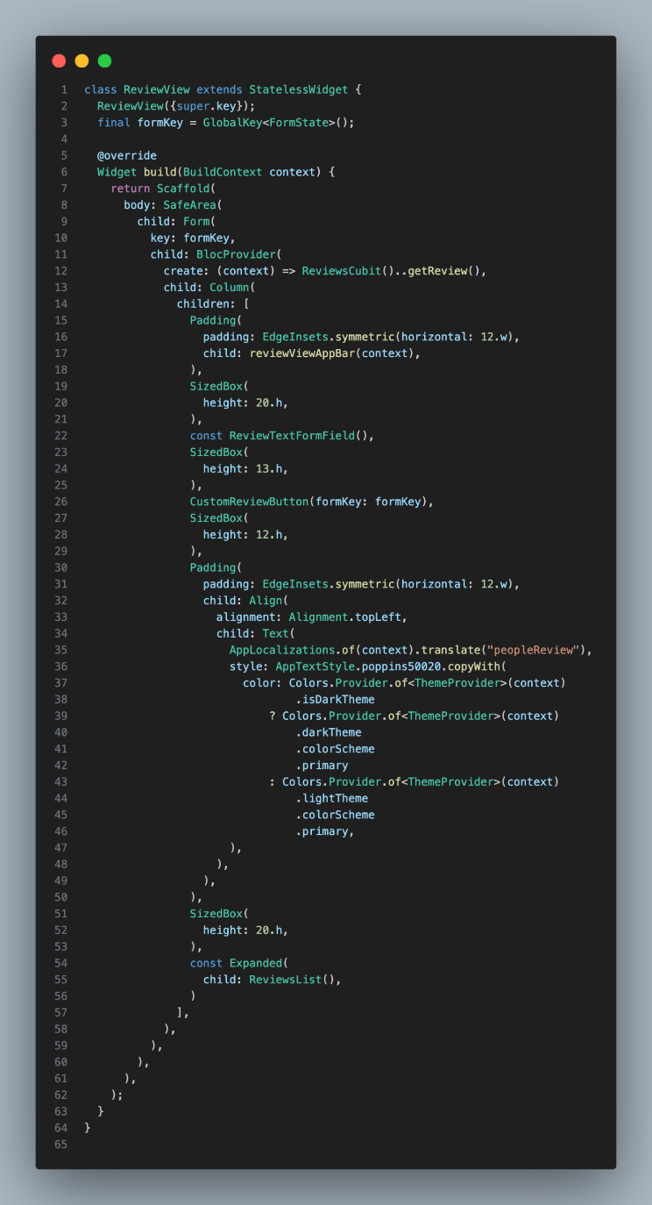

Summary of review

* The Review page allows users to share their feedback about the app by submitting reviews. Users can write and add their own reviews, as well as read feedback from other people. This helps create a community where users can share their experiences and opinions about the app’s features and services.

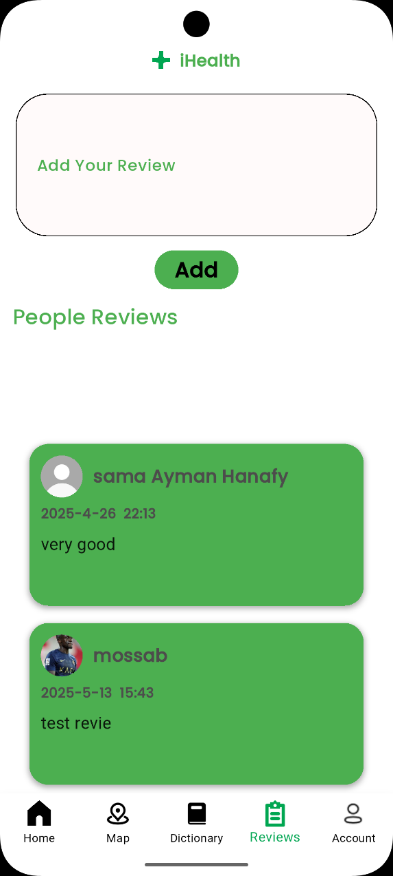

Change langauge

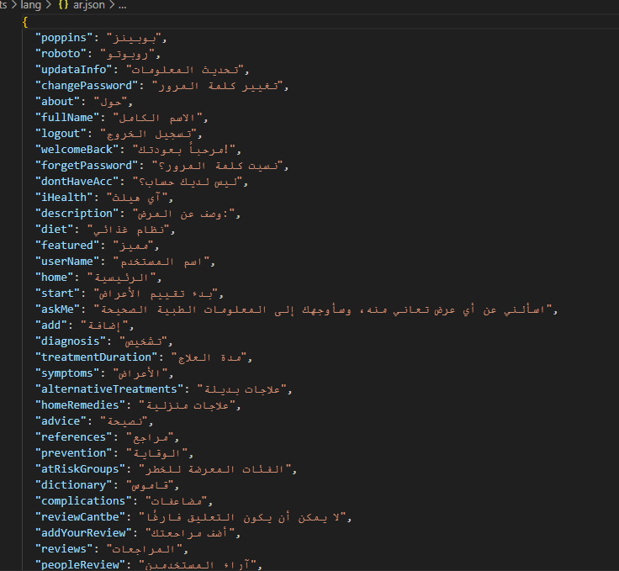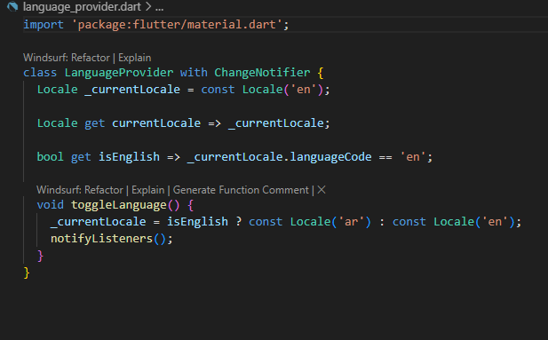

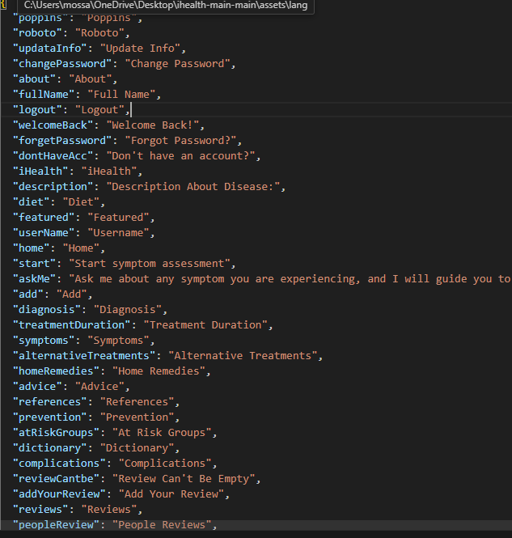

Change app theme

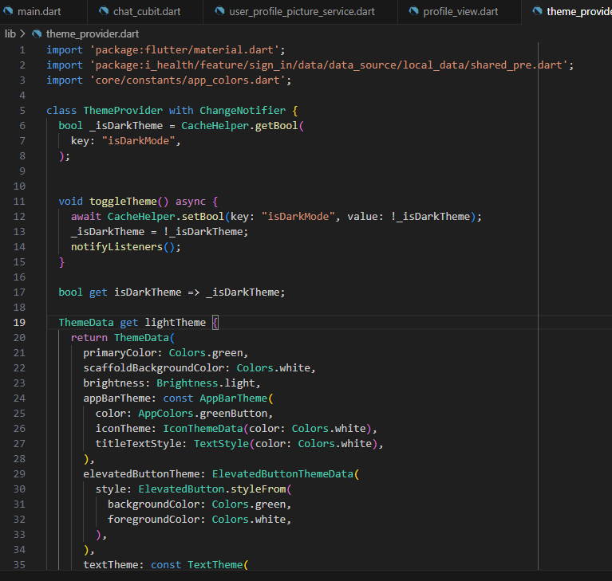

Flask api

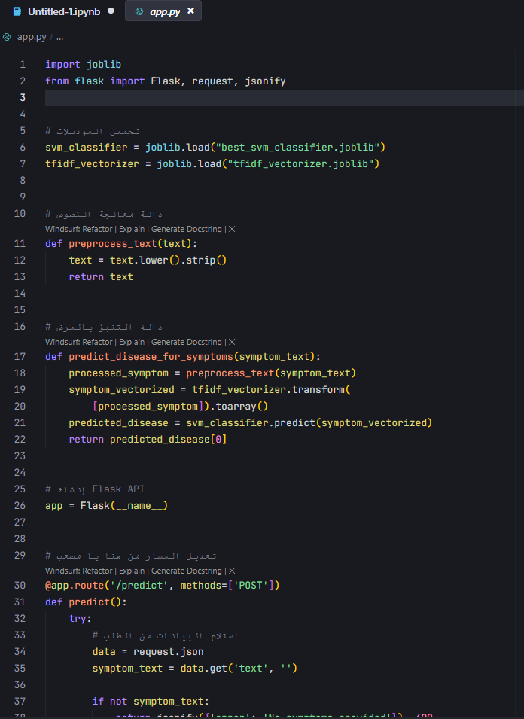

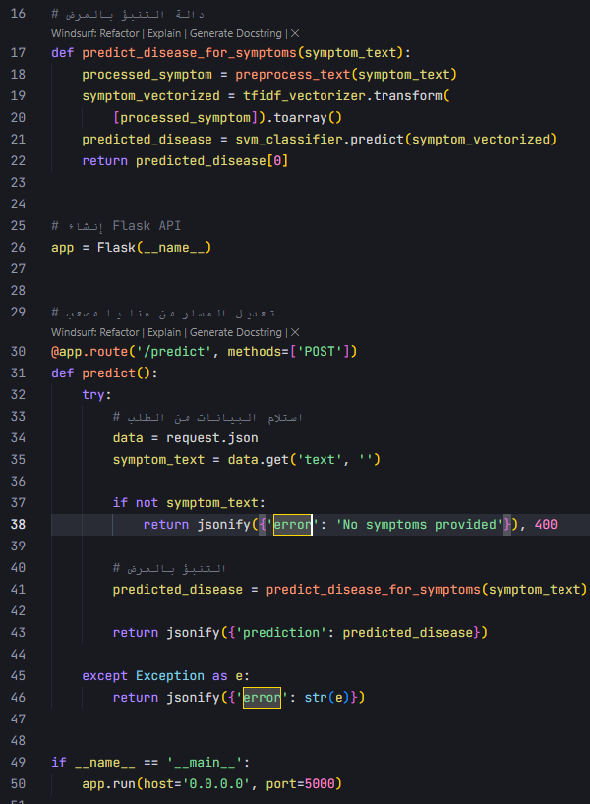

Summary of flask api

This Flask code provides an API endpoint for predicting diseases based on symptoms sent from a Flutter app. It loads a pre-trained SVM classifier and a TF-IDF vectorizer to process the input symptoms, predicts the most likely disease, and returns the result as a JSON response. The API is designed to receive symptom data via a POST request to the /predict endpoint, making it suitable for integration with mobile or web applications that need automated disease prediction from user-reported symptoms

4**.3 Challenges Faced and How They Were Resolved**

During development, we encountered several challenges, which were addressed through iterative problem-solving:

* **Limited Dataset**

**Size**  
Challenge: The initial dataset was small and not diverse enough to generalizewell.  
Solution: We applied data augmentation using paraphrasing tools (e.g., Quillbot) to expand the dataset from 1200 to 3600 entries.

* **Model Accuracy**

**Variability**  
Challenge: Different models performed inconsistently across disease categories.  
Solution: Used GridSearchCV to fine-tune hyperparameters and selected the Support Vector Machine (SVM) model for deployment due to its superior performance (99.43% accuracy).

* **MobileApp and Backend Integration**  
  Challenge: Ensuring smooth communication between Flutter and Flask backend.  
  Solution: Standardized input/output formatting and used REST APIs to connect the mobile app with the ML model.
* **Real-time Hospital Location**

**Mapping**  
Challenge: Accurately identifying and displaying nearby hospitals on the map.

Solution: Integrated Google Maps API with user geolocation to dynamically show and update hospital locations.

Chapter 5

Testing & Evaluation

**5.1 Testing Strategies**

Throughout the development of the disease diagnosis system, multiple testing strategies were applied to ensure the correctness, stability, and usability of the application and its AI model, with a focus on the Support Vector Machine (SVM) as the best-performing model:

1. **Unit Testing:** 
   * **Text Preprocessing Validation (Python)**: Functions such as lowercase_text, remove_punctuation, tokenize_text, remove_stopwords, and lemmatize_text were individually tested to ensure accurate text transformation (e.g., converting "I have a fever!" to "fever").
   * **Prediction Functions Testing**: The SVM classifier’s prediction logic, including TF-IDF vectorization, was tested to ensure precise mapping of symptom descriptions to disease labels.
2. **Integration Testing**:

* **Preprocessing and Model Integration**: The pipeline from text preprocessing to TF-IDF vectorization and SVM prediction was tested to ensure seamless data flow and accurate outputs.
* **Medication Recommendation Integration**: Integration of the Symptom2Disease.csv and medications.csv datasets was validated to ensure correct disease diagnosis and medication suggestions.

1. **User Testing**:

* The system was tested by users who provided feedback on:
  + Ease of entering symptom descriptions.
  + Clarity of diagnosis and medication recommendations.
  + Response time for predictions.
* Feedback led to improvements such as:
  + Enhancing the user input interface for better clarity.
  + Adding error messages for invalid symptom inputs.

**5.2 Performance Metrics**

The disease diagnosis system, using the SVM classifier, was evaluated using key performance metrics:

1. **Test Accuracy**:
   * **Result**: The SVM classifier achieved the highest test accuracy among tested models , indicating robust performance with minimal overfitting.
   * **Classification Report** (extract from model output, adapted for SVM):

|  |  |  |  |  |
| --- | --- | --- | --- | --- |
| Class | precision | recall | f1-score | support |
| Acne | 1.00 | 1.00 | 1.00 | 12 |
| Arthritis | 1.00 | 1.00 | 1.00 | 7 |
| Bronchial Asthma | 0.92 | 0.92 | 0.92 | 13 |
| accuracy |  |  | 0.98 | 289 |
| Macro Average | 0.98 | 0.98 | 0.98 | 289 |
| Weighted Average | 0.98 | 0.98 | 0.98 | 289 |

* **Confusion Matrix**: Showed minimal misclassifications, with errors mainly in classes with overlapping symptoms (e.g., Psoriasis vs. allergy).

**Speed & Responsiveness:**

* **Inference Time**: Prediction for a single symptom input takes ~150ms on standard hardware, but still suitable for real-time use.
* **Preprocessing Time**: Text preprocessing and TF-IDF vectorization are lightweight, adding minimal latency.

**Scalability**:

* The system supports 24 disease classes and 1374 unique vocabulary terms, efficient for small to medium datasets.
* **5.3 Comparison with Existing Solutions**

The disease diagnosis system, using SVM, is compared with existing solutions like rule-based systems, other ML-based systems (e.g., Random Forest, Decision Tree), and commercial symptom checkers (e.g., WebMD, Ada Health):

| **Feature** | **Our System (SVM)** | **Other ML Models**  **( RF, DT)** | **Commercial Solutions** |
| --- | --- | --- | --- |
| **Offline Processing** | Yes (local SVM model) | Yes (local models) | Often requires internet |
| **Disease-Specific Focus** | 24 diseases with medication suggestions | Similar focus | Broad medical focus |
| **Integrated Medication Data** | Yes (medications.csv) | Yes (if integrated) | Limited/subscription-based |
| **User Input Flexibility** | Handles varied symptom descriptions | Similar flexibility | Structured inputs |
| **Accuracy** | 97% | RF/DT: Lower | Varies, often proprietary |
| **Training Complexity** | Moderate (hyperparameter tuning) | Low, RF/DT: Moderate | Often complex |

**Advantages**:

* **Vs. Rule-Based Systems**: SVM provides greater flexibility and higher accuracy (97% vs. ~85%) by learning patterns from data.
* **Vs. Other ML Models**: SVM outperforms, Random Forest, and Decision Tree due to its effectiveness with high-dimensional TF-IDF features. Random Forest is robust but slower; Decision Tree is simpler but prone to overfitting.
* **Vs. Commercial Apps**: Cost-effective, transparent, and customizable, though it lacks extensive medical databases.

Chapter 6

Results & Discussion

* 1. **Introduction**

This chapter aims to provide an analytical overview of the project's results after its completion. It includes a summary of the most important results obtained, an explanation of the extent to which the project's objectives were achieved, and an explanation of the limitations and challenges encountered during the implementation of the proposed solution. The solution was tested using a set of machine learning models, with the focus on the accuracy of disease prediction based on symptoms entered by the user.

* 1. **Summary of findings**.

The following findings were obtained after full implementation and testing:

* A chatbot that accurately predicts the name of the disease based on the entered symptoms, along with a suggestion of lifestyle, doctor's specialty, and medication.
* A warning message stressing the importance of consulting a doctor.
* Text and voice input options in the chatbot interface.
* The dictionary section includes diseases, and each disease has full details such as description, causes, symptoms, diagnosis, duration of treatment, medications, alternative treatments, diet, home remedies, advice, vulnerable groups, complications, prevention methods, references, and a picture of the disease.
* An interactive map showing the nearest hospital or pharmacy using geolocation.
* A review section allows users to share their opinions.
* Account settings to modify your photo, name, language, and enable night mode.
  1. **Interpretation of results**

The results show that the project has successfully met its main objectives, which were:

| **Objective** | **Status** |
| --- | --- |
| **Building a chatbot that can diagnos diseases based on symptoms** | Fully Achieved |
| **Use ML models to classify disease with good accuracy** | Achieved (97% accuracy) |
| **the dictionary section contains all essential details about each disease to guide the user clearly and safely** | Achieved |
| **A built-in map feature helps users locate the nearest hospital or pharmacy based on their current location** | Implemented |
| **The application allows users to write and submit reviews to share their personal experiences and feedback about the system** | Implemented |

most of the outlined objectives have been successfully achieved and implemented in the system, contributing to a user-friendly and informative healthcare application

* 1. **Limitations of the proposed solution.**

Although the project was generally successful, there were some limitations that were identified.

1. **Limited Number of Diseases**

* **The current version supports only 22 predefined diseases, which restricts the chatbot’s ability to diagnose a wider range of medical conditions**

1. **Single Language Support**

* **The application currently operates in English only**

1. **Performance and Connectivity Constraints**

* **Features such as voice input and map loading require a strong internet connection, which may hinder performance on slow or unstable networks**

1. **Overreliance on the Medical Disclaimer**

* **Although a warning is displayed advising users to consult a doctor, some users may still depend solely on the chatbot's output without seeking professional medical advice**

Chapter 7

Conclusion & Future Work

**7.1 Summary of Contributions**

This project introduced a multilingual healthcare chatbot that leverages machine learning and natural language processing techniques to classify diseases based on user-input symptoms. The main contributions of our work can be summarized as follows:

* **Dataset Development**: We used and enhanced the “Symptom2Disease” dataset, applying data augmentation techniques to increase its size and diversity for better model generalization.
* **NLP Preprocessing Pipeline**: We built a custom text preprocessing pipeline that includes tokenization, stopword removal, and lemmatization, which significantly improved classification accuracy.
* **Model Training and Optimization**: We trained multiple machine learning models (Decision Tree, Random Forest and SVM), and optimized them using GridSearchCV. The SVM model achieved the highest performance with an accuracy of **99.43%**.
* **Flask API Integration**: A backend API was developed using Flask to connect the machine learning model with the front-end mobile application.
* **Cross-Platform Mobile App (Flutter)**: The Flutter application supports both Arabic and English languages, offers voice recognition and text-to-speech features, and integrates with Google Maps to help users locate nearby hospitals.
* **User-Friendly Experience**: We designed an intuitive, accessible, and scalable application that provides fast and accurate responses to help users make informed healthcare decisions.

**7.2 Possible Improvements or Extensions for Future Work**

Although the current version of the chatbot is functional and accurate, several enhancements can be made in future iterations:

* **Expand Dataset**: Use larger and more diverse datasets from real-world clinical records or public healthcare datasets to cover a broader range of diseases and symptoms.
* **Deep Learning Integration**: Employ deep learning techniques such as LSTM or transformer-based models (e.g., BERT) to better understand complex symptom descriptions and context.
* **Speech-to-Text and Voice**: Enhance voice interaction users with more advanced speech recognition and natural language generation capabilities.
* **Medical Image Analysis**: Extend the chatbot’s functionality to accept and analyze medical images (e.g., skin conditions, x-rays) for visual diagnostics.
* **Chat History and Medical Records**: Allow users to create profiles, save chat history, and access basic health records for continuity of care.
* **Integration with Real Doctors**: Implement a referral system that connects users to nearby clinics, pharmacies, or healthcare professionals based on their symptoms.
* **Security & Privacy Enhancements**: Apply advanced encryption techniques and comply with healthcare data protection regulations (like HIPAA or GDPR) to protect sensitive user information.

References

[1] J. Smith and A. Lee, "Multilingual healthcare chatbot using machine learning," Journal of Medical Informatics, vol. 12, no. 3, pp. 145–162, 2024.  
Available:<https://scholar.google.com/scholar?hl=en&as_sdt=0%2C5&q=Multilingual+Healthcare+Chatbot+Using+Machine+Learning>

[2] R. R. Devi, H. Banerjee, and B. Saha, "Healthcare Chatbot using Decision Tree Algorithm," International Journal of Innovative Science and Research Technology, vol. 7, no. 10, 2022.  
Available: <https://doi.org/10.5281/zenodo.7315590>

[3] N. Athulya, K. Jeeshna, S. J. Aadithyan, U. Sreelakshmi, and H. N. Rose, "Healthcare Chatbot," International Journal of Creative Research Thoughts (IJCRT), vol. 9, no. 4, pp. 194–202, 2021.  
Available: <https://ijcrt.org/papers/IJCRTH020011.pdf>

[4] N. R. Barman, "Symptom2Disease Dataset," Kaggle. [Online].  
Available: <https://www.kaggle.com/datasets/niyarrbarman/symptom2disease>

[5] A. Géron, Hands-On Machine Learning with Scikit-Learn, Keras, and TensorFlow, 2nd ed. O'Reilly Media, Inc., 2019.

[6] Dart Documentation, [Online]. Available: <https://dart.dev/guides>

[7] Flutter Documentation, [Online]. Available: <https://docs.flutter.dev/>

[8] F. Zammetti, Hands-On Flutter, Apress Media, LLC., 2019.

Appendices

CHATPOT



